Workplace adjustments request and plan template

Purpose
This form can be used by any employee in a Queensland public sector workplace to request a workplace adjustment in accordance with the Disability Discrimination Act 1992 (Cth) and the Anti-Discrimination Act 1991 (Qld).
It is not mandatory to use this form to request workplace adjustments or create an adjustment plan. It is optional. Your workplace may have a local adjustments policy, with a preferred request process and plan template.
This form can be used to support you and your manager to start a conversation about adjustments and supports, and turn a request into a plan. It considers the requirements of relevant legislation.
Read Workplace adjustments for employees to consider some information and practical advice about implementing adjustments.
Employees who are seeking to apply for a flexible work arrangement outside the scope of the Anti-Discrimination Act 1991 or the Disability Discrimination Act 1992, should use the Flexible work agreement request form or an equivalent form in your entity.

Key considerations
A good practice approach to workplace adjustments (also called ‘reasonable adjustments’) entails offering adjustments at all stages of employment. Sharing this template would occur:
- when an employee is offered employment or onboarded
- at cyclical times for a team, such as every 6 months
- at any other time or change to the individual’s work or work environment.
The plan invites employees to provide a reason for their request by describing how an adjustment may support them. This level of detail may suffice as evidence to access an adjustment. There is no standard requirement for further evidence, it is decided on a case-by-case basis.
Managers will need to consult with the person who made the request if they have questions, improvements or need further information. They may also need to discuss aspects with others who have operational responsibilities (e.g. a workplace health and safety officer, an IT officer or a facilities officer) related to the adjustment. Confidentiality principles must be applied.

Process overview
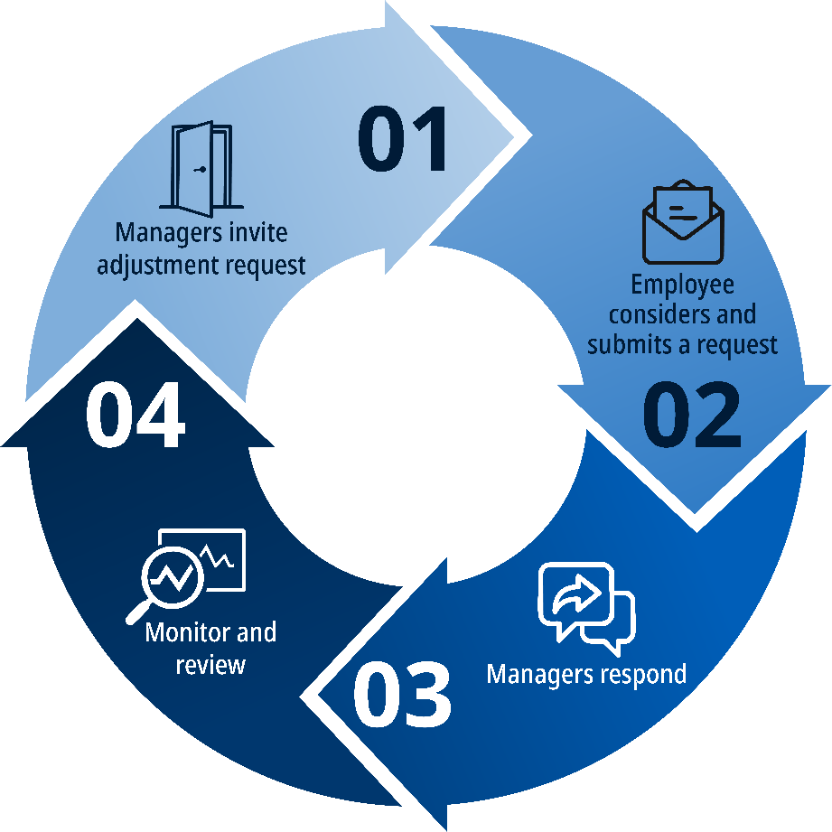

Step 1: Invite employees to consider adjustment needs
Managers would:
- encourage new and existing team members to consider if they would benefit from an adjustment and provide them with information and a request template—and ask again at routine intervals
- consider any previous or existing adjustments for replication in the new role or workplace—this promotes the portability of adjustments where practicable and enables career mobility in the sector.

Step 2: Employee considers and submits request
The employee reviews any information and templates, and submits a request if they seek an adjustment/s.

Step 3: Manager/s respond
Managers would:
- advise they have received the request and let the employee know when they will respond
- review the request
- determine funding if needed, following local procedures for accessing funds
- make a decision about the request (see the Decision table on ForGov if needed)
- provide a copy of the adjustment plan confirming if it can or cannot be facilitated
- store any documents or written information provided according to legislation and policy on storage of sensitive personal information.
The response would include:
- how and when the employee can expect the adjustments to be implemented
- advice on why any part was rejected, with evidence to support unjustifiable hardship and human rights considerations, and how the manager and employee may seek different support
- advice about what to do if the employee is unhappy with the outcome
- advice about how the workplace handles employee privacy, and
- who to contact if the employee has any questions or seeks to appeal the decision.

Step 4: Monitor and review
Managers and employees can monitor and review individual and operational needs over time or as circumstances change. This may result in additions, removals, or changes to adjustments.

Employee details

Your personal information is being collected by your employer to action your request for workplace adjustment as provided for in the Disability Discrimination Act 1992 (Cth) and
Anti-Discrimination Act 1991 (Qld). Information relating to privacy is provided below.
Employee name
Email
Position title
Business area
Organisation

Workplace adjustment request
[Describe the request and reasons for the request.
For example, accessible content and communications, types of assistive technology, type of flexible working arrangements.
Provide here some information about how the adjustment/s would support your experience at work and how it will help you perform your role or manage certain things. The information you provide can be general in nature. Avoid sharing sensitive personal information (such as medical or health information) about you or your associates or family in this form—consider discussing this verbally or showing supporting documents in person.
If you would like to undertake a workplace assessment to find more solutions and options, you can work with your manager to do this before finalising your request.]

☐ Tick this box if you have attached or plan to share any documents with this form to support the request.

Employee acknowledgement
In making this application, I acknowledge:
- My manager may need to discuss my request with other teams such as inclusion advisors, IT teams or health and safety – but won’t share my personal information without my consent to do so
- Everyone involved (including myself, support people, and my manager) must engage respectfully, with empathy, and participate proactively in good faith.
Employee signature: |  | Date:

Manager acknowledgement
In making this decision, I:
- have considered my organisation’s HR policy or process for adjustment requests where there is one
- have consulted with the employee throughout my decision-making process
- where required and with the employee’s consent, have consulted with internal and external specialist teams including IT to find suitable options (especially if there are constraints such as security restrictions)
- understand I need to regularly review the adjustment arrangements with the employee
- understand if an adjustment cannot be provided, I must organise a time to discuss alternative support that may meet the employee’s needs
- understand that if an adjustment cannot be provided, the refusal must take into account the relevant legislation including the Disability Discrimination Act 1992, Anti-Discrimination Act 1991 and Human Rights Act 2019
- understand I must give a written reason why it has been rejected in part or in full and detailing my proper consideration of human rights as an obligation under the Human Rights Act 2019
- have considered the privacy of the employee’s circumstances and reviewed any information provided in support of their application

☐ Approved

☐ Approved in part or with conditions.

☐ Not approved.

[Describe the conditions if approved with conditions and reasons for non-approval including unjustifiable hardship and consideration of human rights].

Manager signature: |  | Date:

Privacy
Queensland government agencies handle personal information in compliance with the Information Privacy Act 2009 (Qld). Personal information (like your name, email and business unit) is being collected on this form by your employer to consider and respond to your workplace adjustment request under the Disability Discrimination Act 1992, Anti-Discrimination Act 1991 and Human Rights Act 2019.
For details on how your employer handles personal information, or how you can access or correct personal information held by your employer, please refer to your employer’s Queensland Privacy Principles privacy policy.

Grievances and appeal rights
If an employee is dissatisfied with the outcome of their request for an adjustment, they can lodge an employee grievance. Employees should refer to their internal intranet and entity policies for further information about the grievance process.
After following the grievance process, if an employee is still dissatisfied with the outcome, they may be able to lodge a fair treatment appeal in the Queensland Industrial Relations Commission (QIRC).
Further information, including timeframes for starting appeals, can be found in the Public Sector Appeal Guide and Directive 04/23: Appeals. For information about the process for lodging an appeal, refer to the QIRC website or contact the QIRC registry on 1300 592 987.
If an employee believes they have been discriminated against or there has been a breach of their human rights, there may be external review avenues available through:
- Queensland Human Rights Commission
- Australian Human Rights Commission
Employees who are a member of a registered industrial organisation may wish to consider contacting their union representative who will be able to provide guidance and support throughout the grievance or appeal process. Union representatives will also be best placed to advise the employee on their external review avenues.

Review checklist
 | Task | Considerations
☐ | Creating a review procedure | We have considered how the adjustment will be reviewed (e.g. ongoing or periodic basis)  We have considered what success looks like for this adjustment/s  We have set timeframes for review and created reminders.
☐ | Making modifications to adjustment as needed | We know who to consult for support if it doesn’t work  We know we can make modifications to the adjustment/s along the way for it to be more effective.
☐ | Support at review time | At review time, we’ll consider:  - how the employee may be better supported in a different way  - how can the adjustment/s could be better implemented  - what has worked well.

Optional information

Things you need to know and ways you can support me
Complete this table if it may support you to share other information about what helps you perform. Items placed here are for a manager’s noting only, with the assumption they can support an ongoing conversation.
If you need a change to be more formally considered, managed and approved, include them in the request.
Instruction/Communication | Environment | Social/Emotional
E.g. the best way to provide instructions to/from you or to communicate with you.  E.g. I don’t always recognise sarcasm in conversation—please note I sometimes take things literally.  E.g. Having more than four video calls in a day is challenging for me—please note I may need to reschedule some calls. | E.g. The bright light of the windows can be a problem for me, so on my office days you may see me use the dimly lit library meeting room for my meetings. | E.g. Social demands like joining in on lunch outings or drinks after work can be difficult.  E.g. For consultation processes, I respond best with time to think and develop my ideas.

