|  |
| --- |
| Workplace adjustments plan template |
|  |
|  |

## Purpose

The purpose of this form is to create safe and respectful work environments for all, ensuring all employees can fully and equally participate in Queensland public sector workplaces throughout their career. This form sets out minimum considerations for a workplace adjustment request and agreement between an employee and manager. This form is not the process for workers compensation claims.

## Key considerations

A good practice approach to workplace adjustments (also called ‘reasonable adjustments’) entails offering adjustments at all stages of employment. This includes when people are invited to apply for a role or offered an interview or assessment. Sharing this template would occur:

* when an employee is offered employment or onboarded
* at cyclical times for a team, such as every 6 months
* at any other time or change to the individual’s work or work environment.

The plan invites employees to provide a reason for their request by describing how an adjustment may support them. This level of detail may suffice as evidence to access an adjustment. There is no standard requirement for further evidence, it is decided on a case-by-case basis.

Managers will need to consult with the person who made the request. They may also need to discuss aspects with others who have operational responsibilities (e.g. a workplace health and safety officer, an IT officer or a facilities officer) related to the adjustment. Confidentiality principles must be applied.

## Process overview

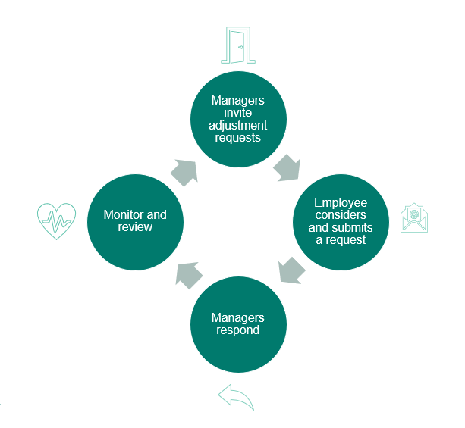

### 

### Step 1: Review guide and invite adjustments

Managers would review this guide and:

* proactively welcome all job applicants in a recruitment process to discuss adjustments requirements for the process or the role (noting that employees can request adjustments at any time).
* encourage new and existing team members to consider if they would benefit from an adjustment—and ask again at routine intervals (ideally not during performance improvement conversations)
* favourably consider existing adjustments with a view to promote the portability of adjustments and enable career mobility in the sector.

### Step 2: Employee considers and submits request

The employee reviews any information, including a plan template provided by the manager, and submits a completed adjustments plan if they seek an adjustment.

### Step 3: Manager/s respond

Managers would:

* advise they have received the request and let the employee know when they will respond
* review the request
* determine funding if needed, following local procedures for accessing funds
* make a decision approving or rejecting the request
* provide a copy of the adjustment plan confirming if it can or cannot be facilitated
* store any documents or written information provided according to state and/or federal legislation and the agency’s policy on storage of sensitive personal information.

The response would include:

* how and when the employee can expect the adjustments to be implemented
* advice on why any part was rejected, with evidence to support unjustifiable hardship, and how the manager and employee may proceed to seek different support
* advice about what to do if the employee is unhappy with the outcome
* advice about how the workplace handles employee privacy, and
* who to contact if the employee has any questions or seeks to appeal the decision.

If the request or part of the request cannot be supported, a File Note must be created to document the decision in keeping with the [Human Rights Act 2019](https://www.legislation.qld.gov.au/view/html/inforce/current/act-2019-005)(Qld).

### Step 4: Monitor and review

Managers and employees can monitor and review individual and operational needs over time or as circumstances change. This may result in additions, removals, or changes to adjustments.

|  |  |  |
| --- | --- | --- |
| Applicant details Your personal information is being collected by [entity name] to action your request for workplace adjustment as provided for in the [Anti-Discrimination Act 1991](https://www.legislation.qld.gov.au/view/html/inforce/current/act-1991-085?query=((Repealed%3DN%20AND%20PrintType%3D%22act.reprint%22%20AND%20PitValid%3D%40pointInTime(20240117000000))%20OR%20(Repealed%3DN%20AND%20PrintType%3D%22reprint%22%20AND%20PitValid%3D%40pointInTime(20240117000000)))%20AND%20Content%3D(%22anti-discrimination%22%20AND%20%22Act%22%20AND%20%221991%22)&q-collection%5B%5D=inforceActs&q-collection%5B%5D=inforceSLs&q-documentTitle=&q-prefixCcl=&q-searchfor=anti-discrimination%20Act%201991&q-searchin=Content&q-searchusing=allwords&q-year=&q-no=&q-point-in-time=17%2F01%2F2024&q-searchform=basic) (Qld). Without it, we may not be able to process your request. Ways to access your personal information and information about privacy can be found here [*link to entity's privacy policy*]. | | |
| Employee name |  | |
| Employee number |  | |
| Position title |  | |
| Business unit and division |  | |
| Department or entity |  | |
| Request  What adjustment/s do you require? | | |
| *[Provide here some information about how the adjustment/s would support your experience at work and how it will help you perform your role.*  *If you would like to undertake a workplace assessment* *to find more solutions and options, you can work with your manager to do this before finalising your request.]*  Tick this box if you have provided any documents with this form to support the request. | | |
| Employee signature: | | Date: |

## For the decision maker

In making this decision, I acknowledge the following:

I have sought advice and consulted with relevant parties, which may include:

* The applicant prior to formalising this response (required for all adjustment requests)
* ICT or other parties (internal or external to the entity), for advice on how the entity may support the adjustment/s
* Relevant workplace adjustment information [hyperlink to entity-specific policy and guideline]
* Relevant disability inclusion, human resource and health and safety specialists within my department or entity.

Where an employee already has adjustment/s in place in another sector entity, they should, where reasonably practicable, continue when the employee changes manager, works in another role or in another area of the entity or sector.

I will regularly review adjustment arrangements with the employee, and I have agreed on a timeline with the employee.

I understand if an adjustment cannot be reasonably provided, I must consult with the employee and other relevant parties to try to find an adjustment that can meet the employee’s needs. I must organise a mutually agreed upon time to discuss alternative supports.

I understand that any refusal of the request can only be made on reasonable grounds and having taken into account all relevant legislation, especially the [Disability Discrimination Act 1992](https://www.legislation.gov.au/Details/C2018C00125)(Cth)and the   
[Anti-Discrimination Act 1991](https://www.legislation.qld.gov.au/view/html/inforce/current/act-1991-085) (Qld), and any limitation on relevant human rights under the [Human Rights Act 2019](https://www.legislation.qld.gov.au/view/pdf/asmade/act-2019-005) (Qld) are reasonable and demonstrably justifiable.

I understand if I reject a request in part or in whole, or give approval subject to conditions, I need to give a written reason why it has been rejected *and* complete a File Note detailing my proper consideration of human rights as an obligation under the [Human Rights Act 2019](https://www.legislation.qld.gov.au/view/pdf/asmade/act-2019-005) (Qld). More information, including a template File Note about how to apply human rights to decisions is available on [ForGov.](https://www.forgov.qld.gov.au/__data/assets/word_doc/0019/436060/38201285f9f4e918d6fb17d6dce08d7cf7626f2e.docx)

I have taken into account the privacy of the employee’s circumstances and any information provided in support of their application.

|  |  |  |
| --- | --- | --- |
| Decision | | |
| Manager name |  | |
| Position title |  | |
| Business unit and division |  | |
| Department or entity |  | |
| Response | The application for an adjustment/s is:  **Approved**  **Approved in part** or subject to the following conditions.  Reasons for the decision and relevant facts are:  **Not approved** at this time.  Reasons for the decision and relevant facts are: | |
| Manager signature: | | **Date:** |

## Appeal rights

An employee who is the subject of a decision or action is entitled to lodge a grievance in accordance with the local [Individual Employee Grievance Management Policy and Procedure](https://desintranet.govnet.qld.gov.au/human-resources/managers-toolkit/conduct-complaints) should they feel that the decision or action is unfair, biased or limits their human rights.

Employees who are unsatisfied with the outcome of their employee grievance can also lodge:

* an appeal in accordance with [Public Sector Appeal Guide](https://www.qirc.qld.gov.au/sites/default/files/2023-03/Public_Sector_Appeal_Guide.pdf), or
* a complaint with an external oversight body; including but not limited to the [Queensland Human Rights Commission](https://www.qhrc.qld.gov.au/complaints).

For further information on lodging an appeal, refer to [Queensland Industrial Relations Public Service Appeals](https://www.qirc.qld.gov.au/public-service-appeals). For other external reviews, contact the relevant oversight body for information.

## Checklist to support the review process

|  |  |  |
| --- | --- | --- |
|  | Task | * Considerations |
|  | Creating a review procedure | * We have considered how the adjustment will be reviewed (e.g. ongoing or periodic basis) * We have considered what success looks like for this adjustment/s * We have set timeframes for review and created reminders. |
|  | Making modifications to adjustment as needed | * We know who to consult for support if it doesn’t work * Along the way, we have made any needed modifications to the adjustment/s for it to be more effective. |
|  | Support at review time | * At review time, we’ll consider:   + how the employee may be better supported in a different way   + how can the adjustment/s could be better implemented   + what has worked well. |

## Optional information

### Things you need to know and ways you can support me

Complete this table if it may support you to share other information about what helps you perform. Items placed here are for a manager’s noting only, with the assumption they can support a fulsome ongoing conversation. If you need a change to be more formally considered, managed and approved, include them in the adjustment request section—not here.

|  |  |  |
| --- | --- | --- |
| Instruction/Communication | Environment | Social/Emotional |
| *E.g. the best way to provide instructions to/from you or to communicate with you.*  *E.g. I don’t always recognise sarcasm in conversation—please note I sometimes take things literally.*  *E.g. Having more than four video calls in a day is challenging for me—please note I may need to reschedule some calls.* | *E.g. The bright light of the windows can be a problem for me, so on my office days you may see me use the dimly lit library meeting room for my meetings.* | *E.g. Social demands like joining in on lunch outings or drinks after work can be difficult.*  *E.g. For consultation processes, I respond best with time to think and develop my ideas.* |

**Developed by the Public Sector Commission**