

Agency procurement planning

Queensland Government Procurement

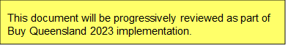

***Agency procurement planning****v1.1 June 2021*

**The State of Queensland (Department of Energy and Public Works) 2021**



<http://creativecommons.org/licenses/by/4.0/deed.en>

This work is licensed under a Creative Commons Attribution 4.0 Australia Licence. You are free to copy, communicate and adapt this work, as long as you attribute by citing ‘Agency procurement planning, State of Queensland (Department of Energy and Public Works) 2021’.

**Contact us**

Queensland Government Procurement is committed to continuous improvement. If you have any suggestions about how we can improve this guide, or if you have any questions, contact us at [betterprocurement@epw.qld.gov.au](mailto:betterprocurement@epw.qld.gov.au).

**Disclaimer**

This document is intended as a guide only. It should be read in conjunction with the Queensland Procurement Policy, your agency’s procurement policies and procedures, and any other relevant documents.

The Department of Energy and Public Works disclaims all liability that may arise from the use of this document. This guide should not be used as a substitute for obtaining appropriate probity and legal advice as may be required. In preparing this document, reasonable efforts have been made to use accurate and current information. It should be noted that information may have changed since the publication of this document. Where errors or inaccuracies are brought to the attention of the Department of Energy and Public Works, a reasonable effort will be made to correct them.

Table of Contents

Agency procurement planning 4

Minimum information requirements of an agency procurement plan 4

Procurement planning is part of the business planning cycle 5

Stakeholder consultation 6

Example agency procurement plan 7

Appendix 1 – Questions / content to consider 9

Table 1 – Questions / content to consider when preparing Part A – Alignment with agency and government objectives. 9

Table 2 – Questions / content to consider when preparing Part B – Procurement profile, practices and agency spend. 11

Table 3 – Questions / content to consider when preparing Part C – Procurement performance measures and risk management. 13

Table 4 – Questions / content to consider when preparing Part D – Improvement opportunities. 14

Appendix 2 – Example of a basic plan 15

Appendix 3 – High level communications and engagement strategy 17

Appendix 4 –References 18

# Agency procurement planning

The agency procurement planning guide (‘Guide’) is designed to help agencies understand how to develop an agency procurement plan. For this Guide an agency procurement plan will be referred to simply as a ‘Plan’.

A Plan is a strategic document that is developed as an output of an agency’s procurement planning process. In simple terms, the Plan shows how the agency intends to achieve procurement outcomes in support of the agency’s strategic plan. Primarily, the Plan must clearly and directly link an agency’s procurement activities to its service delivery and improve the way the agency procures in a manner that is consistent with the Queensland Procurement Policy (QPP).

A Plan needs to be clear and succinct so that any reader can understand the agency’s procurement objectives, how these link to its service delivery outcomes, what significant initiatives are planned, and how the agency will measure success.

**What about operational procurement planning?**

In addition to having a Plan, it is expected that agencies will also have an operational procurement plan (or plans) that provide much more detailed information about its planned procurement activities and projects; forecast savings and benefits; and performance measures relating to those activities. An operational plan should also be consistent with the agency’s category plans.

The amount of detail in an operational procurement plan will vary significantly between agencies, depending on the agency spend profile, access to data and analytics, and maturity of the procurement function. These operational plans should have a minimum forecast of one year, though ideally, they should have a three-to-four year rolling forecast that is regularly reviewed and updated. Guidance about preparing a detailed operational plan is outside the scope of this Guide.

|  |  |
| --- | --- |
| **TIP** | If your agency has never prepared a Plan before (or an operational procurement plan) contact Queensland Government Procurement or seek assistance from colleagues in other agencies that can offer guidance and support. |

# Minimum information requirements of an agency procurement plan

A Plan is an effective tool which at a minimum:

* outlines how the objectives of the procurement function will support broader agency objectives
* provides information about the agency spend profile, along with an analysis of savings and benefits opportunities (economic, environmental and social) and strategies to achieve these
* contains measures, targets and performance against targets (both financial and non-financial). This should be done against realistic timeframes and in a way that aligns with agency and whole-of-government category goals and objectives
* sets out the management and organisation of the procurement function within the agency, including an assessment of overall agency procurement capability and strategies for improvement
* outlines the agency’s approach to risk management for procurement
* aligns with the QPP, along with category strategies and plans
* confirms the agency’s use of existing whole-of-government common-use supply arrangements and describes other ways that the agency ensures it collaborates and supports a whole-of-government approach to procurement. Where an agency chooses to depart from using common-use supply arrangements this, along with strategies to deliver savings and benefits because of the agency’s decision, should also be documented.

**Requirement to have an agency procurement plan**

The QPP requires all agencies covered by the policy (i.e. budget sector agencies, statutory bodies, special purpose vehicles and government owned corporations) to have a Plan in place. The Queensland Audit Office[1] has also emphasised the importance of having a Plan in place to realise better procurement outcomes.

**Alignment with other agency plans**

The Plan should be consistent and integrated with all relevant procurement strategies and plans, including the Queensland Government Procurement Strategy – *Backing Queensland Jobs* – along with category strategies and significant procurement plans. The Plan should also be consistent with the agency’s strategic plan, operational plans, and [Service Delivery Statements](https://budget.qld.gov.au/budget-papers/) (as applicable).

The agency should be able to demonstrate how these plans relate to each other, including the relationship between objectives set in the Plan with other relevant strategies and plans, as well as the alignment of performance information.

**Timeframe for developing and reviewing an agency procurement plan**

It is recommended that a Plan is developed to align with the agency’s business planning cycle, and its strategic plan which is typically a four-year plan. Agencies are expected to review and update their Plan annually. While there is no obligation to publicly publish agency procurement plans, it is recommended that they be published on agency intranets and be made available to all staff. From time to time agencies may be asked to share their plans with lead agency category teams.

# Procurement planning is part of the business planning cycle

Agency procurement planning aligns with both the agency and program level activities of the government’s Agency Planning Requirements[2]. The Agency Planning Requirements broadly covers the strategic management of all resources to better match service delivery. The ‘Big Picture’ view of performance management, illustrated on the next page, summarises and defines the various processes that the Queensland Government and its agencies use to plan activities and services, allocate resources and report on performance.

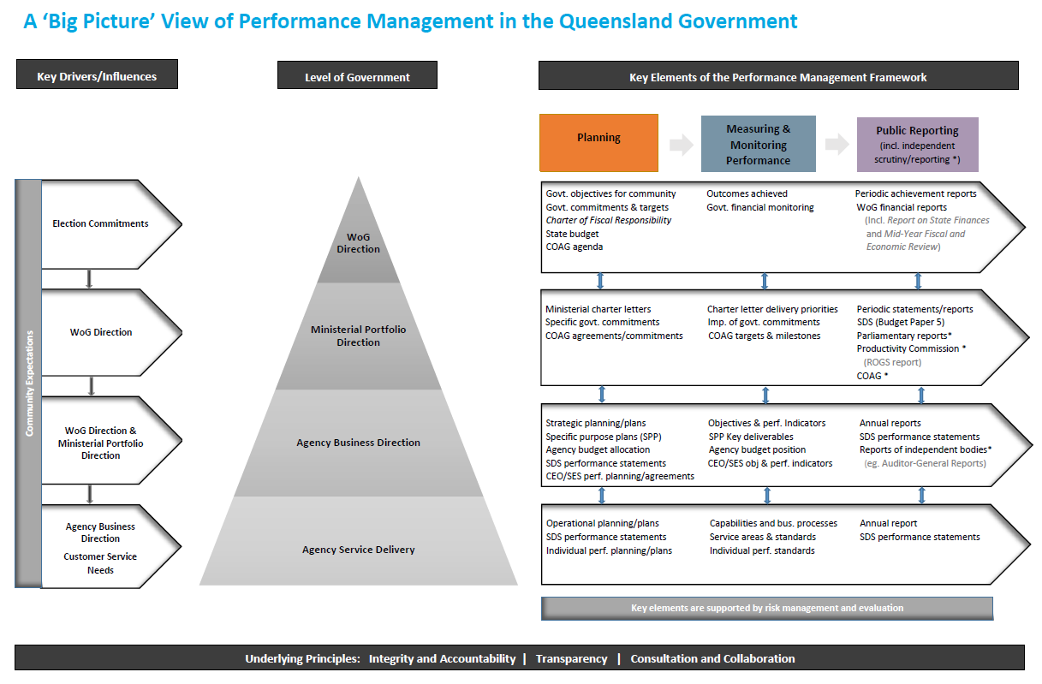

**Develop Operational Procurement Plan(s)**

**Develop Agency Procurement Plan**

**Ideas for improving an agency’s procurement outcomes**

There are many different initiatives that an agency may consider to help improve its procurement outcomes. Here are some concepts to consider as an agency determines what key initiatives will have a positive impact on outcomes:

**Supply market focused initiatives**

* develop a strategy / approach that encourages the use of local suppliers, small businesses and Aboriginal businesses and Torres Strait Islander businesses where appropriate
* know the marketplace (use market intelligence gained across whole-of-government categories and emerging technology)
* improve access for suppliers to compete for government business (e.g. improve competition and make it more efficient for suppliers to do business with you)
* choose suppliers based on value for money (this includes price and non-price factors)
* know which suppliers are critical to the agency’s operation (i.e. those suppliers, which, if their performance was substandard, would disrupt service delivery)
* measure and review supplier performance and manage relationships to improve service delivery.

**Internal agency focused initiatives**

* understand how procurement outcomes affect service delivery outcomes (having the right resources at the right time to deliver those service outcomes)
* consider future demand for goods / services based on changes in service delivery strategies
* assess and manage the risks of the different forms of procurement
* measure and review procurement performance and understanding the cost of procurement
* use whole-of-government standing offer arrangements / contracts managed by other agencies instead of creating new ones
* include procurement as a regular agenda item at executive meetings
* develop procurement skills of staff and leverage existing capability uplift programs available within government (e.g. “Skills2Procure”)
* communicate and share the benefits and experiences internally, and with other agencies through collaboration in whole-of-government category workgroups and category councils
* include a procurement page on the agency intranet (to share information within the agency and raise awareness of the procurement unit).

# Stakeholder consultation

When preparing a Plan, it is recommended that an agency consults with:

* business units within the agency that make a significant contribution to the agency’s procurement spend
* finance teams, policy teams (and other teams as required) within the agency, including those who are responsible for agency planning and performance
* category managers that are responsible for areas of spend relevant to the agency. For example, if an agency has a large amount of spend on ICT then engage with the relevant ICT category manager as part of the planning process
* contract management teams (if they exist) within the agency to identify any significant initiatives or areas of risk
* human resources or other persons (internal or external to the agency) who may have relevant information about the agency’s procurement capability (e.g. results of capability assessments or functional maturity assessments)
* Queensland Government Procurement if the agency requires guidance or direction on who to contact for further information or data.

This is not an exhaustive list. The extent of stakeholder consultation will vary depending on the size of the agency and the complexity of their procurement function and activities. Feedback should be incorporated in the agency’s Plan where relevant and appropriate.

|  |  |
| --- | --- |
| **TIP** | It is recommended that an agency also develops a communication plan detailing how it will inform staff, key stakeholders (both internal and external) and industry of the agency’s Plan once completed. |

**Appendix 3** contains a high-level communications and engagement strategy that an agency may consider when planning how it will go about engaging and communicating with stakeholders in the development and implementation of a Plan.

# Example agency procurement plan

There is no standard template for the layout of a Plan. The Plan should be developed in a way that best suits the business area responsible for delivering the Plan.

An example structure of a Plan is outlined in the table below. It is a suggestion only and agencies have discretion as to the extent that they use / modify it. **Appendix 1** contains suggested subheadings to use in a Plan, and questions to consider when developing each section of a Plan. The tables in **Appendix 1** also indicate whether the question / content is recommended for a ‘basic’ or ‘advanced’ Plan. A basic Plan may be appropriate for a small agency with little experience in developing a Plan, and limited maturity within the procurement function. An advanced Plan is likely to be developed by larger agencies who have experience in procurement planning and more mature procurement functions, with access to better quality data.

Also included in **Appendix 2** of this Guide is an example of how a Plan can be represented in a two-page PowerPoint format. Presenting a Plan in this format can be a very useful communication tool for agencies.

|  |  |
| --- | --- |
| **TIP** | Much of the information needed for a Plan can be collated from the agency's strategic and business unit plans, asset plans, financial system reports, previous procurement plans; and whole-of-government Category Plans. |

|  |  |
| --- | --- |
| **Part A – Alignment with agency and government objectives** | The first section is designed to provide an overview of the agency and its strategic objectives. It should also demonstrate how the procurement function will support delivery of the government’s objectives, agency’s strategic objectives and the principles of the QPP.  It is not a requirement for all the QPP principles to be referenced in the Plan – only those that the agency intends to directly contribute to.  This section is a critical part of the Plan and will be unique to each agency. It will determine whether stakeholders perceive the Plan as being ‘relevant’ to them and whether they ‘buy in’ to the Plan.  For suggested headings and questions to consider when developing *Part A – Alignment with agency and government objectives*, see Appendix 1, Table 1. |
| **Part B – Procurement profile, practices and agency spend** | This section looks at the status of the procurement function within the agency, including capability. It also includes some information about the spend profile of the agency. Before any improvements can be identified, the agency's current procurement practices, expenditure levels, purchasing patterns, and targets need to be understood.  For suggested headings and questions to consider when developing *Part B – Procurement profile, practices and agency spend*, see Appendix 1, Table 2. |
| **Part C – Procurement performance measures and risk management** | This section builds on the agency's current procurement practices and is where the various risks are identified as well as how procurement performance will be measured.  If an agency has a prior Plan in place, then it is appropriate to review past performance and comment about what progress has been made against performance measures in the prior plan.  For suggested headings and questions to consider when developing *Part C – Procurement performance measures and risk management,* see Appendix 1, Table 3. |
| **Part D – Improvement opportunities** | This section builds on the agency's current procurement practices and is where the initiatives and areas identified for improvements are outlined. This may include finding better linkages between procurement and agency objectives, developing significant procurement strategies, enhancing procurement capability, and identifying improvement opportunities.  An agency may also choose to include a high-level roadmap of its key initiatives and improvement opportunities.  For suggested headings and questions to consider when developing *Part D – Improvement opportunities*, see Appendix 1, Table 4. |

# 

# Appendix 1 – Questions / content to consider

## Table 1 – Questions / content to consider when preparing Part A – Alignment with agency and government objectives.

Below are suggested headings for Part A in a Plan. You can delete, change or add to these headings. They are intended to be a guide only.

1. Agency objectives and challenges.
2. How procurement will support the delivery of agency objectives and Queensland Government procurement objectives.
3. How we collaborate with lead agency category teams and other agencies.

|  |  |
| --- | --- |
| **TIP** | Ensure you show a clear linkage between the agency’s and government objectives, and your key procurement initiatives/approach to supporting these. Review each of the QPP principles and think about how your agency can contribute to achieving those outcomes. Explain the ‘how’ in Part A of the Plan. |

|  |  |  |  |
| --- | --- | --- | --- |
| **Questions / content to consider** | | **Basic** | **Advanced** |
| A.1 | Include a brief overview of the agency, such as its role, size, financials and locations. | ü | ü |
| A.2 | Outline the agency's service delivery objectives then explain how your procurement objectives and initiatives will support them. | ü | ü |
| A.3 | The QPP of contains economic, environmental and social objectives, targets and commitments of the government which are relevant to procurement. These are to prioritised in decision making and pursued wherever possible. Outline the agency’s approach to and outcomes achieved for economic, environmental and social objectives in its procurement. | ü | ü |
| A.4 | Identify any key focus areas regarding strategic and high priority procurement initiatives for your agency and the government. | ü | ü |
| A.5 | Provide an overview of (or list) the significant procurement initiatives as determined by your agency and covered either in its contribution to each category’s forward procurement pipeline (for budget sector agencies) or notice of potential future procurements (for statutory bodies, special purpose vehicles and government owned corporations). | ü | ü |
| A.6 | For the significant procurement initiatives referenced in the Plan, if available include some information on how they link to the agency's objectives and value for money objectives, the anticipated benefits to be gained, timing, performance measures, targets and whether the agency is working with other agencies. |  | ü |
| A.7 | Are there any key challenges the agency is facing that has an impact on procurement or industry? | ü | ü |

|  |  |  |  |
| --- | --- | --- | --- |
| A.8 | How does the agency support a whole-of-government approach to procurement? For example:   * participating in whole-of-government committees, working groups etc. * operating as, or collaborating with, lead agency category teams for whole-of-government categories * using whole-of-government common-use supply arrangements. | ü | ü |

## 

## Table 2 – Questions / content to consider when preparing Part B – Procurement profile, practices and agency spend.

Below are suggested headings for Part B in a Plan. You can delete, change or add to these headings. They are intended to be a guide only.

1. How procurement is structured in our agency.
2. Procurement practices.
3. Agency spend profile.

|  |  |
| --- | --- |
| **TIP** | Spend profile data (if not available through an agency’s own financial systems) may be available from category councils or category managers. Contact Queensland Government Procurement if you are unsure of who to ask for this data. |

| **Questions / content to consider** | | **Basic** | **Advanced** |
| --- | --- | --- | --- |
| B.1 | How is the procurement function co-ordinated and managed within the agency? For example:   * is it centralised or decentralised? * is a senior manager or executive responsible for strategic guidance and oversight? * are there clearly defined roles, responsibilities and delegations? * who is currently involved in purchasing operations and decision-making and what are their responsibilities? | ü | ü |
| B.2 | If there have been any changes to the structure of your procurement function, or policies or procedures since the last Plan was developed, then make a brief comment about the changes. | ü | ü |
| B.3 | What has the agency done to assess its procurement capability? What does it tell you about the current state? Has there been any impact on the structure of procurement, or positioning of procurement in the agency as a result? |  | ü |
| B.4 | Do you prequalify suppliers and if so, how does this work? | ü | ü |
| B.5 | How does your agency approach contract management and supplier performance management to ensure agency and procurement objectives are met? |  | ü |
| B.6 | Does your agency have a contract register? How is this monitored and managed to ensure effective outcomes and alignment with the QPP? | ü | ü |
| B.7 | Does your agency use common-use supply arrangements (whole-of-government, multi-agency, or within the agency)? How is this monitored and managed to ensure effective outcomes and alignment with the QPP? | ü | ü |
| B.8 | What was the agency's operating expenditure for the last fiscal year? Break this down by major categories of goods and services if possible. | ü | ü |
| B.9 | Forecast the agency’s estimated annual operating expenditure for the next financial year, broken down by major categories of goods and services if possible. |  | ü |
| B.10 | Compare the past year’s expenditure (by category) with forecast spend for current and future years (e.g. three to five years). |  | ü |
| B.11 | Identify any goods / services that are critical to the agency’s service requirements. |  | ü |
| B.12 | Assess the impact of the agency’s purchasing activities on its largest supply markets. |  | ü |
| B.13 | Provide a more detailed breakdown of the supply market, such as the number of service providers the agency transacts with in each category (note: this is optional – not all agencies may know this information). |  | ü |
| B.14 | What percentage of the agency's expenditure was made under either whole-of-government arrangements or the agency's own arrangements? |  | ü |

## 

## Table 3 – Questions / content to consider when preparing Part C – Procurement performance measures and risk management.

Below are suggested headings for Part C in a Plan. You can delete, change or add to these headings. They are intended to be a guide only.

1. Measuring performance of the procurement function.
2. Indicators of success.
3. How we manage procurement risk.

|  |  |
| --- | --- |
| **TIP** | Defining measures of performance and monitoring progress across key focus areas, help to demonstrate alignment with agency and government objectives, for example:   * report engagement of local suppliers on regional projects to maximise positive impact to the community * measure and increase use of Indigenous businesses * record procurement training that staff complete/participate in * report on any procurement savings or other benefits delivered.   Agency performance reporting should align where possible, with the whole-of-government procurement performance management framework. |

|  |  |  |  |
| --- | --- | --- | --- |
| **Questions / content to consider** | | **Basic** | **Advanced** |
| C.1 | How is the performance of the procurement function assessed? What are your targets (financial and non-financial), and when and how will they be measured?  *Note: the more mature the agency’s procurement function, the more sophisticated the performance measures may be.* | ü | ü |
| C.2 | Review the agency’s existing Plan and outline progress on meeting the targets and performance measures in the plan. Include information on the areas in which the agency has achieved improvements, benefits gained, and lessons learnt. Where targets were not achieved, consider why this was and what strategies need to be put in place to address it. |  | ü |
| C.3 | If applicable, comment on the agency's performance against any performance targets and strategies identified in previous Plans. | ü | ü |
| C.4 | What strategies will the agency implement to achieve the savings / benefits (financial and non-financial) that have been forecast? |  | ü |
| C.5 | Do you have detailed internal policies, processes, manuals, standard templates and / or systems in place? Are they kept up to date and aligned with the QPP? Do you provide training to staff in how to use them? | ü | ü |
| C.6 | Explain the circumstances when your agency will prepare a significant procurement plan (e.g. high value procurement when the agency is spending more than $XXXX, or a procurement initiative that has been identified as high-risk according to an internal risk assessment). | ü | ü |
| C.7 | Is there anything else that your agency does to manage procurement risk? | ü | ü |

## 

## Table 4 – Questions / content to consider when preparing Part D – Improvement opportunities.

Below are suggested headings for Part D in a Plan. You can delete, change or add to these headings. They are intended to be a guide only.

1. Enhancing systems.
2. Developing capability.
3. Improving process.

|  |  |
| --- | --- |
| **TIP** | Describe (at a high level) your agency’s roadmap to make improvements that will positively impact delivery of procurement and outcomes, such as:   * reviewing or streamlining processes and tools to improve efficiencies in procurement (e.g. reduced cycle time for tendering) * commence or continue with procurement training participation and completions reporting (e.g. XXX participants by July 18) * develop tools to assist with deploying innovative strategies for non-traditional and high value / high-risk procurements. |

|  |  |  |  |
| --- | --- | --- | --- |
| **Questions / content to consider** | | **Basic** | **Advanced** |
| D.1 | What areas for improvement have been identified with respect to procurement practices within the agency? Include background information and information about what will change. | ü | ü |
| D.2 | How does the agency plan to increase knowledge, skills and capability in procurement? | ü | ü |
| D.3 | If your agency is responsible for category management, are there any category plans you intend to develop? Are there any other improvements you plan to introduce to improve category management? |  | ü |
| D.4 | Are there any projects planned to improve procurement efficiency? Have any such projects already commenced, or have been implemented? | ü | ü |
| D.5 | What will the agency be doing to reduce cycle times for releasing and finalising tenders? For example:   * increasing the number of e-procurement initiatives * greater use of electronic tendering (e.g. QTenders) or electronic marketplaces * online project management. | ü | ü |
| D.6 | Are there any systems improvements planned that will have a positive impact on procurement within the agency? (e.g. integrating procurement, financial and accounting systems?) | ü |  |
| D.7 | Are there any initiatives to improve the recording and analysing of procurement data to support better decision making (data led)? |  | ü |
| D.8 | Is there an intention to develop improved performance measures for procurement? | ü | ü |
| D.9 | Does the agency intend to benchmark itself against industry or a best practice agency? |  | ü |
| D.10 | Does the agency intend to develop strategic alliances with service providers in a particular market? |  | ü |

# Appendix 2 – Example of a basic plan

|  |
| --- |
| **This is an example only.  Agencies have discretion to design a Plan using language, sub-headings, images and formats that will best engage their audience.** |

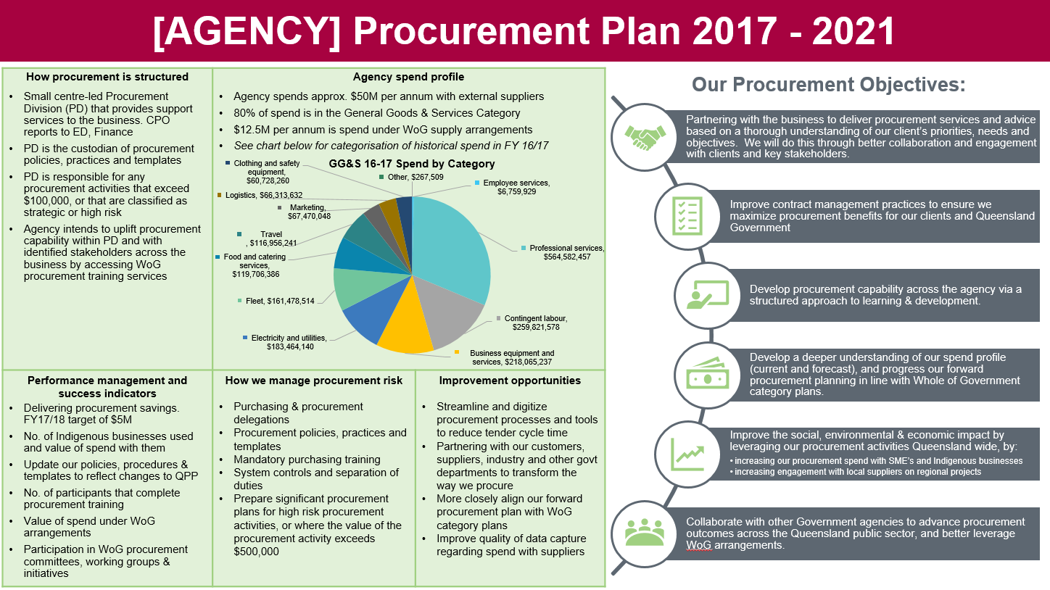

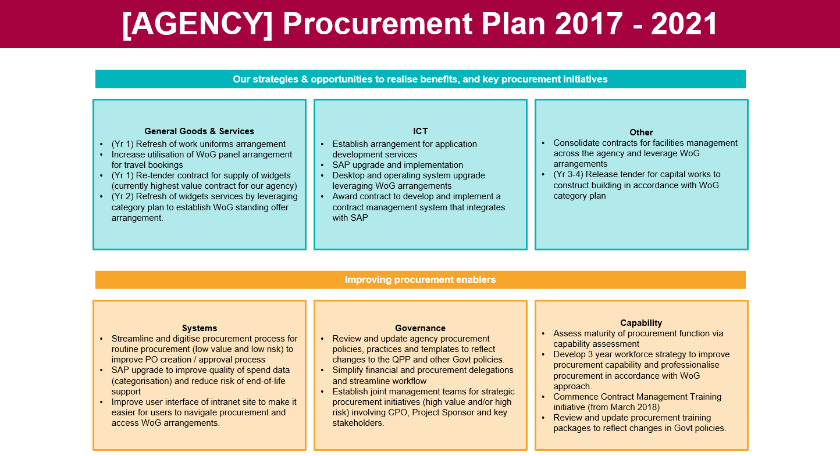

# Appendix 3 – High level communications and engagement strategy

|  |
| --- |
| **Suggested high-level approach for an agency to develop and implement a Plan.** |

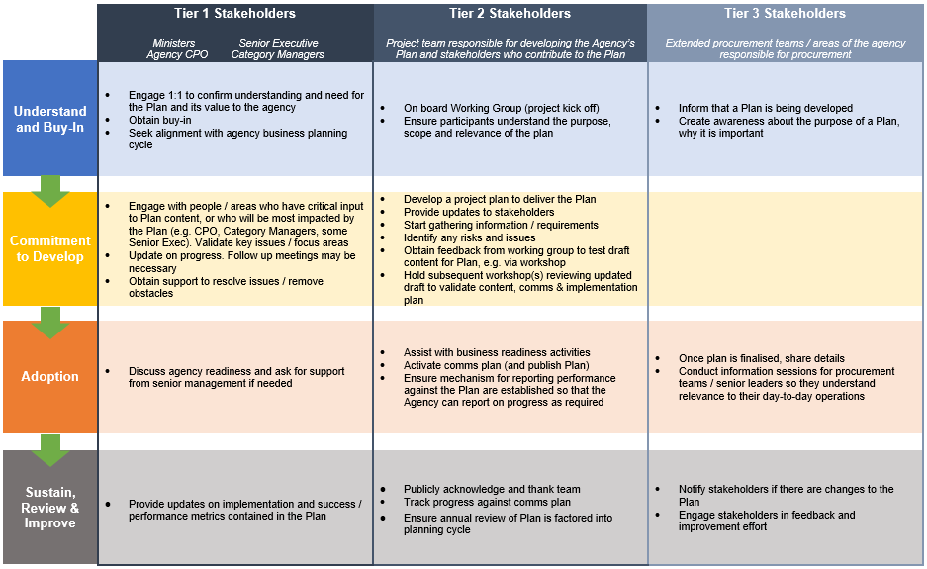

# Appendix 4 –References

* Queensland Procurement Policy

Department of Energy and Public Works

<https://www.forgov.qld.gov.au/procurement-policy>

* Procurement guidance

<https://www.forgov.qld.gov.au/procurement-guides>

* Agency planning requirements (requirements for the 2017 planning period)

Department of the Premier and Cabinet

<https://www.premiers.qld.gov.au/publications/categories/plans/assets/agency-planning-guidelines-2017.pdf>

* [Performance Management Framework Policy and related material](https://www.forgov.qld.gov.au/working-in-the-public-service/about-the-public-service/manage-government-performance)

Department of the Premier and Cabinet

* Social procurement guide - Adding social value when buying for government

Department of Energy and Public Works

<http://www.hpw.qld.gov.au/SiteCollectionDocuments/SocialProcurementGuide.pdf>

* Sustainable procurement guidance

<http://www.hpw.qld.gov.au/SiteCollectionDocuments/ProcurementGuideIntegratingSustainability.pdf>

|  |
| --- |
|  |

1. *Strategic procurement (Report 1: 2016-17)*. Queensland Audit Office. September 2016.
2. *Agency Planning Requirements - Requirements for the 2017 planning period.* Department of the Premier and Cabinet. October 2016.