# Purpose

What do you want to learn from your research? Why is this information important and what will it inform? This will guide what data we collect and the questions we ask.

|  |  |
| --- | --- |
| User need |  |
| Business need |  |

# Participants

Who will receive this survey? Will it be public on the *For government* website or sent to all Queensland Government employees on the [Wired discussion list](https://www.slq.qld.gov.au/about/news-and-media/queensland-government-email-discussion-lists/wired-discussion-list)? Do you have an existing mailing list of people opted in for research or will you need to create a new list of recipients?

|  |  |  |  |  |
| --- | --- | --- | --- | --- |
| Recipients | For gov website | Wired | Existing list | New list |
| List |  | | | |
| Participant identifier | Anonymous | Email | Other (Please specify) | |

# Title

Maximum of 55 characters (including spaces).

|  |
| --- |
|  |

# Questionnaire

Ask questions that collect accurate and relevant data. Use different question types to engage your participants. See Appendix for an explanation of question types. Follow the Queensland Government Style Manual.

## Introduction text

|  |
| --- |
|  |

## Question 1

|  |  |  |  |  |
| --- | --- | --- | --- | --- |
| Question |  | | | |
| Type | Short answer text | Long answer text | Radio button | Checkbox |
| Dropdown | Ranking | Matrix | Likert scale |
| Options |  | | | |
| Extra information | Optional | Random order | Logic (Please specify) | |

## Question 2

|  |  |  |  |  |
| --- | --- | --- | --- | --- |
| Question |  | | | |
| Type | Short answer text | Long answer text | Radio button | Checkbox |
| Dropdown | Ranking | Matrix | Likert scale |
| Options |  | | | |
| Extra information | Optional | Random order | Logic (Please specify) | |

## Question 3

|  |  |  |  |  |
| --- | --- | --- | --- | --- |
| Question |  | | | |
| Type | Short answer text | Long answer text | Radio button | Checkbox |
| Dropdown | Ranking | Matrix | Likert scale |
| Options |  | | | |
| Extra information | Optional | Random order | Logic (Please specify) | |

## Question 4

|  |  |  |  |  |
| --- | --- | --- | --- | --- |
| Question |  | | | |
| Type | Short answer text | Long answer text | Radio button | Checkbox |
| Dropdown | Ranking | Matrix | Likert scale |
| Options |  | | | |
| Extra information | Optional | Random order | Logic (Please specify) | |

## Question 5

|  |  |  |  |  |
| --- | --- | --- | --- | --- |
| Question |  | | | |
| Type | Short answer text | Long answer text | Radio button | Checkbox |
| Dropdown | Ranking | Matrix | Likert scale |
| Options |  | | | |
| Extra information | Optional | Random order | Logic (Please specify) | |

# Subject matter expert (first level approval)

The person who provides the information and reviews the accuracy of the content.

|  |  |
| --- | --- |
| Name |  |
| Date |  |
| Position |  |
| Organisation |  |

# Editor (second level approval)

The person who provides the editorial advice and approves the content ready for publishing online.

|  |  |
| --- | --- |
| Name |  |
| Date |  |
| Position |  |
| Organisation |  |

# Director or equivalent approval (third level approval)

The person who approves the content to be published online.

|  |  |
| --- | --- |
| Name |  |
| Date |  |
| Position |  |
| Organisation |  |

# Appendix

## Logic

Adding logic to your survey allows a participant to skip a question based on their answers to a previous closed-ended question. You can skip to another question or to the end of the survey.

## Question types

### Short answer text

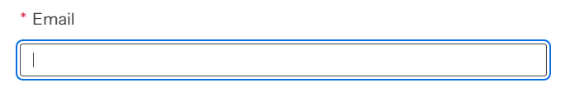

### Long answer text

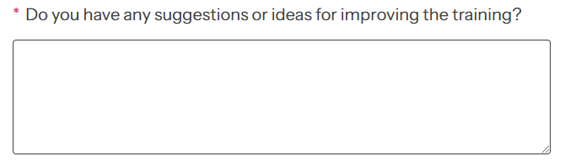

### Radio button

Use when a participant can only select one item. Use a dropdown when you have a list longer than 5 items.



### Checkbox

Use when a participant can select more than one item.



### Dropdown

Use when you have a list longer than 5 items and when a participant needs to select only one item.



### Ranking

Use when participants need to prioritise or order a list of items.

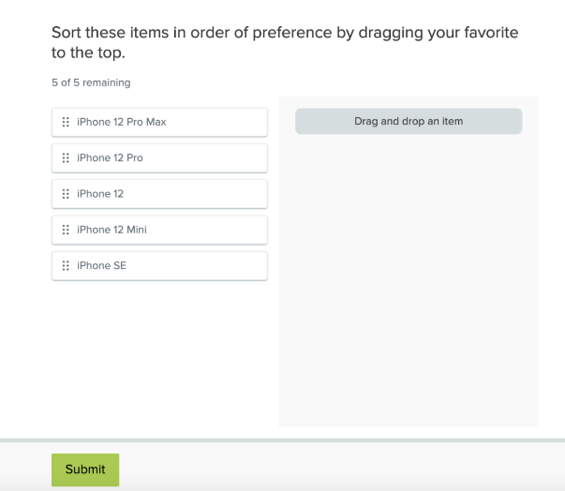

### Matrix

Use to evaluate multiple items using the same set of response options.

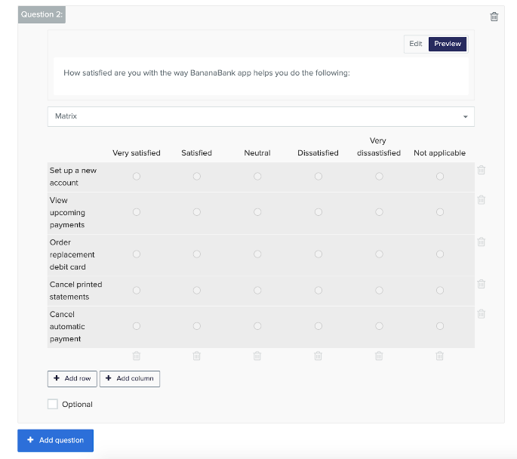

### Likert scale

Use to gauge opinions across a spectrum.

