Document details
Software Asset Management (SAM) Guideline
Final
March 2010
v1.0.0

PUBLIC
Security classification | PUBLIC
Date of review of security classification | January 2010
Authority | Queensland Government Chief Information Office
Author | Queensland Government Chief Information Office
Documentation status |  | Working draft |  | Consultation release | ☑ | Final version
Contact for enquiries and proposed changes
All enquiries regarding this document should be directed in the first instance to:
Queensland Government Chief Information Office
qgcio@qld.gov.au
Acknowledgements
This version of the QGEA was developed and updated by the Software Licence and Management Unit, Queensland Government Chief Information Office.
Feedback was also received from a number of staff from various agencies, which was greatly appreciated.
Copyright
Software Asset Management (SAM) Guideline
Copyright © The State of Queensland (Department of Public Works) 2008–2009
Licence
Software Asset Management (SAM) Guideline by QGCIO is licensed under a Creative Commons Attribution 2.5 Australia Licence. It is based on, and supersedes, the QGCIO Best Practice Guide for Third Party Software Licence Management (ver2.01.00 October 2007). Permissions may be available beyond the scope of this licence. See www.qgcio.qld.gov.au.
Information security
This document has been security classified using the Queensland Government Information Security Classification Framework (QGISCF) as PUBLIC and will be managed according to the requirements of the QGISCF.

Contents
1 Introduction 4
1.1 Purpose 4
1.2 Audience 4
1.3 Scope 4
2 Background 4
3 Implementation 5
3.1 Preparation and planning 5
3.2 Developing an implementation plan 6
3.3 Assigning roles and responsibilities 6
3.4 Developing policies and procedures 7
3.5 Auditing deployed software 8
3.6 Development of a software asset register 8
3.7 Determine licence types 9
3.8 Catalogue media 10
3.9 Gap analysis 10
3.10 Determine software use 10
3.11 Purchase, pool or uninstall licences 10
4 Ongoing Maintenance 10
4.1 Ongoing compliance review 10
4.2 Review licensing agreements 11
4.3 Audit and metering 12
4.4 Software pooling 12
4.5 Software asset register and definitive software library 12
4.6 Software procurement 12
4.7 Strategic SAM vendor management 13

Introduction

Purpose
A QGEA guideline provides information for Queensland Government agencies on the recommended practices for a given topic area. Guidelines are generally for information only and agencies are not required to comply. They are intended to help agencies understand the appropriate approach to addressing a particular issue or doing a particular task.
This guideline specifies a consistent approach for the management of third party software licences and associated media purchased by Queensland Government agencies.

Audience
This document is primarily intended for Queensland Government agency staff or external consultants (contracted by Queensland Government agencies) who perform the following functions:
- Chief Information Officers
- software licence managers
- information managers
- software procurement officers
- auditors

Scope

In scope
This guideline supports the QGEA policy and position on Software Asset Management (SAM).

Out of scope
The following is out of the scope of the current guideline:
- in-house developed software.

Background
The Queensland Government is expected to be an example of good practice in adhering to the requirements of the law. The Financial and Performance Management Standard 2009 outlines the requirement for agencies to manage strategic and operational risks. Computer software is an intangible asset protected by copyright and contract law, and as such must be managed to mitigate risks (including damaged reputation) and control costs.
The purpose of this guideline is to provide practical assistance to Queensland Government agencies in maintaining a framework for the management of software licences and associated media. Implementation of the guideline will provide assurance to agencies and the Queensland Government that:
- the risks associated with the use of illegal software are being effectively managed
- compliance with software licence conditions is being adequately monitored
- there are the appropriate number of licences for each item of software in use
- the agency is not paying for licences it does not need
- effective controls are in place for the physical security of software media.

The QGEA Software Asset Management Position states the Queensland Government’s direction in regard to the management of all third party software licences and associated media purchased by Queensland Government agencies. The QGEA Software Asset Management Policy states the Queensland Government’s minimum policy expectations in relation to the management of software licences and associated media within agencies.

Implementation
The implementation of an effective SAM framework will provide agencies with a structured approach to controlling and managing risks while maintaining this business critical asset.

Preparation and planning
There are a number of key issues that will guide the initial planning and implementation of a SAM framework that should be addressed before developing an implementation plan. These include, but are not limited to:
- Gaining senior management support: commitment and support from agency senior management to sound governance and planning practices for software licences and associated media is critical in establishing and maintaining a successful licence management framework.
- An assessment of the risks involved in not implementing a framework: over-licensing, under-licensing, increased expenditure, security breaches, software compatibility issues, lost time and lack of technical support and product upgrades.
- An assessment of benefits of implementing a framework: savings through purchasing only what is needed when it is needed, employees being able to work more efficiently, assists with the compilation of an accurate budget, ability to manage and monitor usage to link with ICT planning.
- The development of a business case to gain support for the framework: an example of a business case for software asset management is included in the SAM toolbox.
- Consideration of what functions may be centralised: for example, licence management, procurement and software asset registers.
- Resourcing and funding: it is critical to secure funding for both the establishment and maintenance of the framework.
- Long term management: including continuous improvement, compliance and monitoring.

Developing an implementation plan
To assist agencies in the planning and implementation of a framework it is suggested that the following processes be followed:

Assigning roles and responsibilities
As highlighted previously, commitment from senior management in both ICT and the business areas of the agency are key to the success of software asset management. However, for a framework to work effectively, employees from all areas of the agency should have various roles and responsibilities in its implementation and ongoing management. The types of roles and levels of contribution will be dependant on the complexity of the agency software environment. The roles outlined below can be used as a guide to key roles and responsibilities:
- Legal: review and manage legal aspects of contracts and licence agreements.
- Software and ICT Asset Managers: establish and maintain software licence database.
- Helpdesk/Support Managers: report all unapproved or unauthorised instances of software.
- Security Managers: establish processes to minimise software security exposures.
- Auditors: review and audit framework and processes.
- Procurement Managers: work with ICT Managers to ensure that software procurement decisions are managed.
- Central Software Administrator: record licensing details within the Software Asset Register (SAR).
- Sponsor/Champion: promote the use of the framework and review policies and procedures.
- Definitive Software Library Manager: manage and track all media within the agency.
- Manager/Process Owner: responsible for overall management, review, reporting and monitoring of the effectiveness of the SAM framework.
- Further information on Roles and Responsibilities is provided in the SAM toolbox.
.

Developing policies and procedures

Policies
Agencies are required to develop an overarching policy for their approach to software asset management to ensure consistent practices in the use and management of software licences and associated media within the agency.

Procedures
Software needs to be controlled throughout its entire lifecycle, form the initial request to de-installation from a machine. The Lifecycle diagram below outlines all of the key procedures that should be established to support and maintain a successful framework.

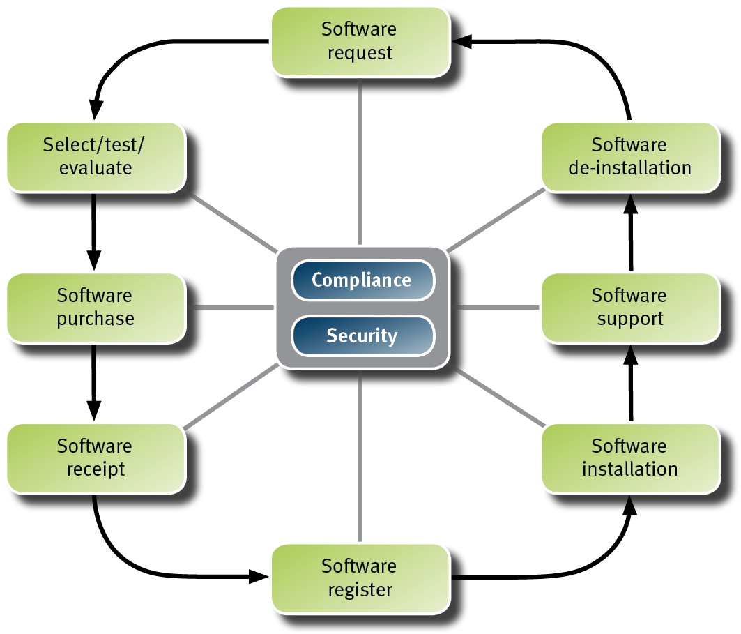
At a minimum, agencies should have the following procedures documented:
- Software Request Procedure: outlines the process to be followed when employees request software to be deployed on a device.
- Technical Evaluation Procedure: details the process for software to be selected, tested and evaluated by the agency.
- Software Purchase Procedure: details the process to be followed for software to be purchased within an agency. This is usually previously defined in agencies and linked to general ICT purchases.
- Software Receipt Procedure: details the process to be followed when software is received by an agency and receipted against its accounting systems. This is usually previously defined in agencies and linked to general ICT purchases.
- Software Register/Inventory Procedure: details the information required and the process to be followed when recording software licences in the SAR.
- Software Installation Procedure: details the process to be followed when installing software.
- Software De-Installation Procedure: details the circumstances and the process to be followed when software is to be uninstalled from a device.
- Templates for suggested Software Asset Management policy and procedure documents have been included in the SAM toolbox.
In addition to these, agencies need to consider where linkages exist to other procedures within an agency. For example, agencies may already have a number of security procedures that may have direct links to software asset management.
Procedures for audit and gap analysis should form part of the compliance schedule to ensure the effectiveness of the framework. These procedures should detail the process to be followed to ensure the agency is compliant and that the policies and procedures listed above have been implemented and are working.

Training and Awareness
Communication is a key factor in the successful implementation of a framework. Agencies are required to implement programs to promote the importance of software licence compliance across the agency.
A communication resources pack, including a communication plan and other materials, has been included in the SAM toolbox.

Auditing deployed software
An audit of the agency’s deployed software should be undertaken to ascertain what software is installed on its computer networks and devices.
The initial audit should provide an accurate report of the quantities of software products deployed within the agency.
Once collected the key information should then be collated into a SAR to assist in matching software in use with agency licence details. Information should include:
- product name
- product edition
- product version
- number of deployments
- where the product is deployed (eg. PC asset number, named user).

Development of a software asset register
A central SAR is one the most important components within the agency framework, as it is the definitive repository of the agency’s software licensing details.
This step takes the information collected from the software audit and expands upon it to include detailed licence information, including:
- software vendor
- quantity of licences
- type of licence
- licence purchase date
- maintenance purchased
- maintenance expiry date
- retired licence (when a licence is used to cross-grade to another licence it needs to be retired – the original licence must be kept for the cross-grade to be valid)
- licences deployed or available.
The register/inventory should also detail all volume licensing agreement information including:
- volume licensing agreement
- agreement/contract number
- expiry date
- reseller
- end user licence agreement (EULA)
- licence confirmations.
Licences such as Client Access Licences, that have no deployment record, also need to be tracked within the SAR.
The SAR can also be used to record the deployment of in-house developed software applications.

Determine licence types
The SAR also needs to be populated with the agency’s licensing details. Types of licences include:
- full licence
- upgrade licence
- cross grade licence
- concurrent licence
- named user licence
- perpetual licence
- subscription licence
- site licence.
Licence information can be ascertained from the EULA for each product. It is important to read the terms and conditions of the EULA to understand what constitutes the licence for each particular product. For example, some products may just require the EULA whilst others may require the media as well.
Other documentation useful in determining licence ownership includes:
- software vendor consumption reports
- internal purchase records
- software vendor licensing web sites
- reseller purchase records
When collating licensing information, an agency will need to understand the licensing rules of the licences owned. This information may be obtained from:
- EULAs
- volume licensing agreements
- product use rights document
- licensing briefs
- product home pages
- software vendors and their authorised resellers.

Catalogue media
Cataloguing media is often difficult due to the large amounts of CDs/DVDs purchased/received. However, software media management is a fundamental element of software licensing management best practice. The implementation of processes to track agency software media will ensure that when software media is borrowed, a licence is always supplied and that the software and licence will be tracked and returned. Software media management will also ensure that when a software licence is retired, the physical media is destroyed so that it cannot inadvertently be installed without a licence.
Further information on software media management is available in the SAM toolbox.

Gap analysis
A gap analysis is performed after an audit has been undertaken comparing licences owned to software deployed. The aim of the gap analysis is to identify licensing deficiencies and/or excesses.
The deployment of software, minus the total number of licences, will give an agency the licence excess/deficiency.

Determine software use
An auditing package with software metering capabilities will assist an agency in locating software deployed but not currently being used. The metering software will audit the agency’s environment and ascertain how often an application is being used.
Software identified as not being used should be assessed to see if it could be removed. These licences may then be pooled within the SAR so that they may be reassigned as required.

Purchase, pool or uninstall licences
As a result of conducting the gap analysis and determining what software is needed the agency should now compile a report which includes:
- the number of licences to be purchased
- the number of excess licences to be pooled or re-distributed within the agency
- software to be uninstalled.

This report will enable the agency to promptly carry out the necessary actions to be compliant and will provide greater accuracy in the procurement of licensing.
- A best practice software procurement has been provided in the SAM toolbox to ensure that agency procurement takes into account the specific issues that relate to software licences.

Ongoing Maintenance

Ongoing compliance review
It is important to realise that software asset management is a continuing process and not a one-off event. To ensure that the agency continues to manage its software licences in an accountable and efficient manner, the agency should develop review processes which will not only audit compliance, but continually review its framework and environment.
If the policies and procedures are operating effectively, then very few anomalies should be detected at each audit. Employees with the appropriate training and knowledge should be allocated to this task. Where there is non-compliance identified during an audit, it will be necessary to review the agency’s software policies and procedures to ensure that these do not occur again.
The processes that should be reviewed on an ongoing basis include:
- policies and procedures
- ongoing training and awareness programs
- regular audit of software deployments including a gap analysis on types and numbers of licences required
- maintenance of SAR system
- audit of software requirements – including current numbers of licences in use and projected future needs based on the agency ICT plans and strategies
- regular review of licence agreement including types and status.
- A self-assessment maturity tool has been included in the SAM toolbox to assist agencies to implement SAM continuous improvement into their planning processes. The SAM toolbox also provides further assistance with an internal audit checklist.

Review licensing agreements
It is important to review any volume licensing agreements regularly to ensure purchases provide the best return on investment, since the same licence may be purchased under multiple programs. For example, in some situations a site licence may provide the best return on investment, as it ensures compliancy for the designated site while providing economies of scale with minimal administrative intervention.
To ascertain the best volume licensing agreement/s an agency should consider the following:
- the terms and conditions of each volume licensing program, to determine if the agency qualifies
- the agency’s purchasing history and environment (ie. how many licences of each product the agency purchased last financial year) and if it is possible to consolidate purchases
- a cost analysis of the different programs to see which offers the best value
- assistance provided by the vendor to address software asset management issues.

It is also important to note that a volume licence agreement may have licensing instructions that take precedence over the EULA.
It is important that an agency’s volume licensing agreement information is recorded by their Software Administrator. As most agreements differ, the information to be recorded will differ. The following is an example of data to be recorded:
- purchase date
- expiry date of agreement
- technical support
- maintenance
- products covered
- purchase.

Audit and metering
Auditing and metering processes are integral to an effective software management system. It is through the auditing and metering processes that an organisation is able to ascertain what software is installed on its computer networks and devices, whether the software is appropriately licensed and whether the use of the software that is installed is being optimised.
Auditing tools should be used periodically as part of an agency’s verification processes to ensure continued compliance.
Metering tools are intended to measure the active usage of a software application, so that usage of available licences can be optimised. Metering software use allows an agency to analyse and determine the levels of use of software applications and future software needs of users. Maximum benefit can be achieved by agencies metering applications that are identified as Tier Two (ie. applications deployed to a large number of desktops on an as required basis).

Software pooling
Maximum benefit can be derived from software metering if software licences are centrally managed within an agency, which will allow the development of a software pool to be developed. This activity provides a benefit to agencies through ensuring that software deployed is meeting business needs. Tracking software procurement and pooling then provides agencies with information to guide future software procurements and assists with decisions on consolidation and retirement.

Software asset register and definitive software library
For the SAR and definitive software library (DSL) developed during the implementation phase to be effective, they must be updated on an ongoing basis. Detailed procedures and work instructions should be developed to support updating and maintaining the data within the register/library. It is critical that the register and library are maintained by staff with appropriate skills to ensure that all information is accurately captured and recorded.

Software procurement
The most significant difference between software procurement and purchases of other items is that in most cases of software acquisitions you do not ‘own’ your purchase. With the majority of software purchases you acquire the right to use the software under conditions defined by the vendor.
It is important to recognise that the ‘licence cost’ should not be the sole consideration when considering the procurement of licences. For example, the vendor may offer value add services such as training, licence support or maintenance services.
Purchasing practices which are well constructed and approach industry best practice will help ensure Queensland Government agencies achieve a software management model where costs and waste are reduced, risk is minimised and service to internal and external customers is planned and optimised.
When considering undertaking software licensing arrangements, it is important to understand which other Queensland Government agencies may be using, or have a requirement for, the software so that a whole-of-Government approach may be taken. Where software licensing procurement arrangements are developed, it is important to ensure that other government entities are able to leverage the arrangements. Agencies should list the arrangements on the Queensland Government Marketplace, and may also consider adding information on the SAM collaborative workspace.
A number of SAM procurement tools, including a best practice guide to software procurement have been included in the SAM toolbox. The guide has been developed to provide a more in depth understanding of the unique issues of software procurement, to assist agencies to achieve best value for purchases and provide a better level of service to their internal and external customers.

Strategic SAM vendor management
Generally speaking, vendors have a better understanding of the total cost of ownership of their software than customers and as a consequence are able to leverage this information to ensure vendor profits are maximised.
Strategic management of software licensing vendors focuses on building a long term relationship with vendors who have a significant impact on the operations of an agency, and gathering sufficient information to effectively negotiate with key vendors and help ensure maximum value at minimum expense.
More information on managing software vendors in a strategic and systematic manner is under development by the QGCIO and will be available in the SAM toolbox when finalised.

