A guide to human-centred design procurement in the Queensland Government
A companion guide for the Queensland HCD Toolkit to help in the procurement of design resources for projects.

Why this guide?
This guide aims to assist public servants who are looking to engage HCD (human-centred design) vendor resources and services.

Our focus is to help support better engagement between public sector agencies and external vendors, and ultimately deliver great customer services.

A refresher - HCD in Queensland Government
HCD, as we apply it in government, is a three-phased approach to problem-solving that places the needs of people at the centre of the process.

HCD involves people in all stages of the process – gathering insights, customer research, exploring many ideas through testing and refining possible solutions and the evaluation of the effectiveness of the outcome.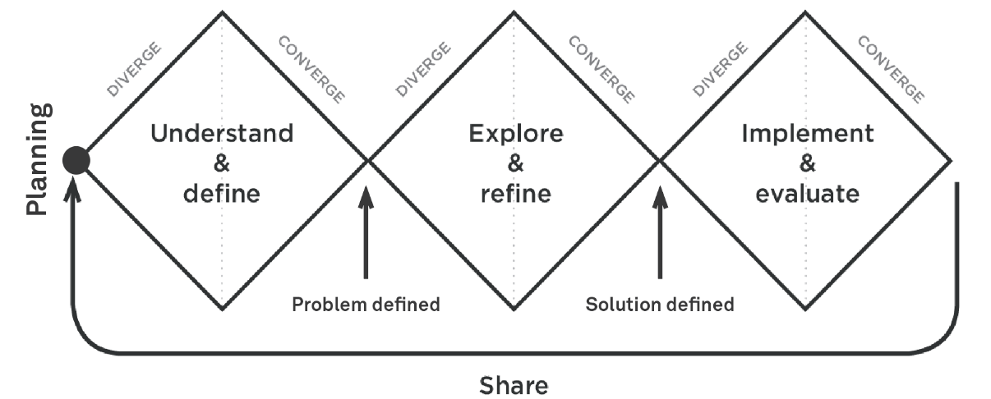
Planning is critical to getting the team set up for success and making sure you have an idea of the goals and purpose of your HCD process:
- What is the problem you are trying to solve?
- Who will be involved in the project and when?
- Timelines, key milestones and activities.
- Plan share back sessions with sponsors.
Having executive sponsorship, governance and procurement approaches in mind will make the overall process much smoother.

Three diamonds and procurement
Traditional procurement is often focused on a pre-determined deliverable or defined solution, for example, a new website, a building, an order of stationery. Using a HCD approach, the aim is to explore what the problem is with customers, which supports developing the right solution.
To support the shift in culture away from defining the solution prior to the procurement, a two-part procurement process can be used:
- Procure the for first two phases of design and prototyping which can be tested with customers.
- Procure for the implement and evaluate phase afterward, once you know you have a potential solution.
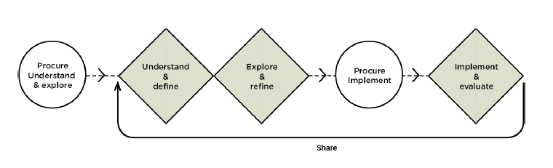You do not necessarily need to separate your procurement into two phases, but this may be helpful if you are not sure about the budgetary implications of potential solutions and /or you need to satisfy internal governance stage gates.

Let’s get started
To help set your team up for success and get the best match of HCD services for the problem you want to solve, some of the things you may consider in your preparation may be:
- gather a general overview of your business and services delivered to your customers
- try to understand the problem/s and customer pain points
- resources that you can commit to the process
- potential budget for the work
- governance approach and sponsorship.

What skills do you need?
The following roles are commonly a part of the mix for HCD:
- Executive sponsor (internal to government)
- Project lead (internal to government)
When you procure HCD services you may need the following (or you might have all or some of these skills in house):
- Customer experience (CX) lead
- User experience (UX) designer
- Insights analyst
- Business/technical analyst
- User interface designer
- Solution architect
- Content designer/writer
- Developer
- Tester
- Change manager

Procuring through panels for vendors
If you have identified your teams current HCD capability and the type of service you think will meet your requirements, it’s time now to engage with vendors.
There are multiple whole-of-government panels that can be used depending on your project needs—let’s look at three key ones.

- The Digital Capability development partnership agreement offers vendors that can assist in the capability uplift throughout the end-to-end HCD services.
SOA name | Digital capability development partnership agreement
SOA number | TMRICT18070
Keywords | Services include, but not limited to:  Agile, customer journey mapping, human-centred design (HCD), design thinking, user experience (UX)
SOA type | Common use supply arrangements
Department | Department of Transport and Main Roads
Expiry date | 18 February 2024

- The Market and Social Research Services SOA focuses on a range of research and related supporting services.
SOA name | Market and social research services
SOA number | QGP0075-21
Description | Services include, but not limited to:  - advertising, audience evaluation,  - business to consumer, business to business, business to government,  - behaviour change,  - brand and communication, brand strategy,  - community attitudes,  - customer experience, customer personas, customer insights, customer satisfaction,  - employee and stakeholder,  - innovation,  - market segmentation, market trends, marketing science, - member satisfaction,  - mystery shopping,  - packaging research,  - profiling research,  - statistical consulting,  - thematic mapping,  - usage and attitude,  - web usability.
Department | Department of Energy and Public Works
Expiry date | 30 June 2029

- The ICT Services panel can be used for CX, HCD and UX consultants.
SOA name | ICT Services (Pre-Qualified Suppliers Panel)
SOA number | ICTSS.1303B previously ICTSS.13.03B
Description | The ICT services offered by pre-qualified suppliers are based on the Skills Framework for the Information Age (SFIA v5). Agencies are advised to check the listed documents regularly as it is probable their composition will change over time. For Program and Project Gated Assurance refer to ICTSS.1303A.
Department | Department of Communities, Housing and Digital Economy
Expiry date | 31 December 2023

These panels can all be found on The Queensland Contracts Directory (QCD) - an online service that provides information on procurement arrangements available across the Queensland Government and is hosted by the Queensland Government Procurement.

How do I access a panel?
You will need to liaise with your agency procurement team and highlight your intention to utilise a standing offer arrangement. You will need to identify a funding source before you approach the market by completing a request for quote (RFQ) form.
In your agency you will have an RFQ template, which will typically have a section called “requirements” that asks you to describe the goods or services you are seeking from a vendor. The description or “mandatory and desirable requirements” is critical to getting a good response and service.
We have provided some examples of what you might ask for in Appendix A.

Appendix A – Example requirements for a Concession Service RFQ

Goods and/or services requirement

Background | (State the reason your agency wants to undertake this work)  E.g. We want to make it easy for our customers to understand if they are eligible for this concession. Currently we have a lot of information online with multiple steps. Our customers tell us they don’t really understand what it means, so they either don’t apply or call the contact centre for help.
Vision | (Provide context about the problem you want to solve)  E.g. We want to make it easier for citizens to identify their eligibility for our concession, so they don’t miss out on the financial assistance for which they are entitled.
Business driver | (State why is this important to your agency)  E.g. We think that vulnerable people are missing out on assistance and it’s a key pillar of our customer strategy that we simplify the process for application and fulfilment.
Business objective | (State the outcome you are seeking)  E.g. To obtain research and insights to improve the customer experience when applying for our concession.
Business requirements | (State your requirements)  E.g.  Milestone 1 (2 to 6 weeks engagement)  - Deep customer understanding – leverage and review existing research to understand customer needs and pain points for key customer types:  - new qualitative/quantitative research to deepen understanding of customer needs and pain points for customer types and segments  - consider what improvements could be made to the process of applying for and getting a concession which would address pain points and encourage use of the concession.  - Map key customers journeys end-to-end, across service delivery channels, define the moments that matter and success criteria for key customer tasks. At minimum the journey maps will consider these audience personas:  - concession applicant  - government agency staff  - community organisation staff/third party provider.  - Map key “back end” business process that support the “front stage” activities that the customer undertakes and present how they can be improved.  Milestone 2 – (up to 8-week engagement)  Digital clickable prototype/s, tested with real concession customers that bring to life the future stage journey.
Functional and non-functional requirements | Add in the functions and or features you need to have - if known)  E.g.  The following requirements have been given a priority rating Mandatory, Highly Desirable or Desirable. Below are some descriptors associated with the priorities that will assist in measuring the importance of each requirement.  - Mandatory (M)—the solution is not acceptable unless these requirements are satisfied.  - Highly Desirable (HD)—preferred, however not compulsory. Inclusion of the requirement within the solution is favoured, alternative similar solutions may be provided.  - Desirable (D)—the solution is acceptable without the requirement however, it would be of use.  Required deliverables  - End-to-end journey maps, which describe the typical interactions and experiences of concession customers, agents and users. Including touchpoints and interfaces with government and nongovernment services, needs, pain points, challenges and what’s working well. The journey map(s) will include both current and future state.  - Insights and opportunities report that summarises findings from contextual and secondary research. The report will include key insights, including methodology, definitions, research outcomes, process mapping, i.e. business processes as well as customer processes, learnings and recommendations.  - Journey mapping activities should include:  - primary research with representative samples from various cohorts to understand their needs  - integration of existing secondary research  - synthesis of research and development of insights  - empathy mapping for various cohorts as required  - the development of design criteria (by which any future possible solution may be critiqued against for evaluation against the customer need)  - confirmation or iteration of supplied problem statement (based on and supported by research)  - creation of customer journey maps  - final report and presentation of the first phase – ‘understand and define’ stakeholder engagement  - fortnightly showcases during the 12-week project and final showcase presentation to key stakeholders  - Digital clickable prototype/s, tested with real concession customers that bring to life the future stage journey.  Milestone 1 requirements  - End-to-end journey maps—priority M  - Insights and opportunities—priority M  - Journey mapping—priority M  Milestone 2 requirements  - Digital clickable prototype/s—priority M  Acceptance criteria for all deliverables:  - Fortnightly showcase delivered to stakeholders (agile)  - All defined customer cohorts covered and included as required  - All deliverables within approved timeframes  - Delivery must be an agreed format  - Including final PDFs, final working files (e.g. Word, PowerPoint, Excel or similar), any design files (e.g. Adobe Illustrator, Photoshop, Sketch, InDesign, Figma, Acrobat or similar).
Assumptions | E.g.  The following assumptions have been made during the planning of this project:  - delivery timeframes can be met by the vendor  - we will have access to Subject Matter Experts on the selected transaction or use case.
Constraints | (Add in your known constraints)  E.g. The work must be completed before xx date.
Delivery address of goods and/or services | (Add in where the vendors perform the work – your location or theirs.)
Delivery period | (Add in the total engagement period here)  E.g.  Milestone 1 – 2 to 6 weeks from contract execution date, in line with direction from the Program Director.  Milestone 2 – 8 weeks from contract execution date, in line with direction from the Program Director.
Insurance requirements | (Seek advice from your procurement team on this section)  E.g.  - Workers’ Compensation Insurance in accordance with the Workers’ Compensation and Rehabilitation Act 2003 (Qld)  - Public Liability insurance for a minimum of $10 million in respect of each claim.

