Conceptual capability architecture

<Agency/Responsible entity>

Date

|  |  |
| --- | --- |
| Security classification |  |
| Owner |  |
| Contact details |  |
| Division/Unit |  |
| Document status |  |

Document history

|  |  |  |  |  |  |
| --- | --- | --- | --- | --- | --- |
| Version | Date | Status | Key changes | Author/s | Reviewer/s |
| 0.0.1 |  |  |  |  |  |
|  |  |  |  |  |  |

Endorsements

|  |  |  |  |
| --- | --- | --- | --- |
| Name | Position | Signature | Date |
|  |  |  |  |
|  |  |  |  |
|  |  |  |  |
|  |  |  |  |
|  |  |  |  |

Glossary

|  |  |
| --- | --- |
| Term | Definition |
| Capability | Abilities required by an agency to deliver public services. Capabilities represent a common grouping of process, information, insights, technology, mission, people and governance. Capabilities can be provided by any combination of business, technology, partners or vendors. |
| Capability group | A group of capabilities aligned to a common rationale that represents the highest level of capability within an agency, identified with a label (e.g., A). |
| Conceptual capability architecture | A structured view of particular abilities that an agency possesses to achieve its specific vision and strategy. |
| Level 1 capability | Indicates the next level of capabilities after a capability group and represents a group of capabilities, identified with a label (e.g., A1). |
| Level 2 capability | Capabilities encompassed in the decomposition of the respective level 1 capability, identified with a label (e.g. A1.1) |
| Level 3 capability | Capabilities encompassed in the decomposition of the respective level 2 capability, identified with a label (e.g. A1.1.1) |
| Level 4 capability | Capabilities encompassed in the decomposition of the respective level 3 capability, identified with a label (e.g. A1.1.1.1) |

* The number of levels of decomposition is limited only by the degree necessary to communicate the information required by the intended audience or to enable the agency to make informed decisions about capability gaps.

`

Capability Grouping

L1 Capability

L2 Capability

**B <Capability Grouping>**

B3 <L1 Capability>

B3.1 <L2 Capability>

B3.1.1 <L3 Capability>

B2.1.1.1 <L4 Capability>

L3 Capability

L4 Capability

Conceptual capability architecture illustrative diagram

Table of Contents

1 Introduction 6

2 Architecture context and inputs 6

2.1 Agency vision and mission 6

2.2 Agency business model design 6

3 Capability grouping rationale 7

4 Conceptual capability architecture overview 7

4.1 Conceptual capability architecture diagram 8

4.2 Conceptual capability architecture diagram description 9

5 Conceptual capability architecture overlays 10

5.1 Conceptual capability architecture heatmaps 10

5.2 Capability - <Domain> Mapping 10

6 Detailed capability descriptions 11

6.1 Level 1 capability descriptions 11

6.2 Level 2 service descriptions 12

6.3 Level 3 service descriptions (where necessary) 13

6.4 Level 4 service descriptions (where necessary) 14

7 Artefact examples 15

Template context – remove this section upon development of the artefact

**Artefact description**

An agency’s conceptual capability architecture is a structured view of particular abilities that an agency possesses to achieve its specific vision and strategy.

**Template purpose**

The purpose of this template is to:

* provide agencies with a centralised definition of what a conceptual capability architecture is
* provide consistent artefact requirements for agencies to follow
* provide the template for agencies to efficiently develop a conceptual capability architecture in a consistent format.

This template is intended to deliver on the purpose through the provision of the following artefact template. However, if an alternative file type/format better aligns with agency circumstances, the following artefact formats may also be employed, given they align with the content, glossary definitions and artefact format requirements outlined within this document:

* spreadsheet (e.g., Excel)
* diagram
* enterprise architecture tool.

**Template instructions**

* This template includes instructional text to guide artefact content. Such text is either enclosed within angled brackets (</>) and/or greyed out. Upon artefact development, this text should be removed and replaced with text specific to the agency context.
* Any **red** text or shapes indicate template elements or sections to be removed upon artefact development.

# Introduction

< The purpose of this section is to introduce the conceptual capability architecture and provide a high-level overview of the subsequent artefact sections.

This section should include:

* A high-level overview of the agency conceptual capability architecture
* A high-level overview of the artefact sections:

Architecture context and inputs

Conceptual capability architecture glossary

Capability groupings

Conceptual capability architecture overview

Conceptual capability architecture overlays

Detailed capability descriptions >

# Architecture context and inputs

The purpose of this section is to provide context around the agency conceptual capability architecture and the agency documents (e.g., artefacts, strategies, plans etc.) that have been leveraged to inform the architecture.

This section should include:

* an overview of the conceptual capability architecture context within the agency.
* any agency documents that have been leveraged to inform the architecture.

Additional input sections may be added below where required and the section may expand across multiple pages where required. The input section/s outlined below act as a guide to the inputs which may be discussed, however, do not act as mandatory content headings. >

## Agency vision and mission

<This section should outline how the agency artefact has been leveraged or aligned to throughout development of the conceptual capability architecture, including:

* the nature by which the artefact has been leveraged to inform the architecture
* how the architecture has been informed by the artefact. >

## Agency business model design

<This section should outline how the agency artefact has been leveraged or aligned to throughout development of the conceptual capability architecture, including:

* the nature by which the artefact has been leveraged to inform the architecture.
* how the architecture has been informed by the artefact

# Capability grouping rationale

< The purpose of this section is to explain the rationale behind groupings within the architecture. Groupings and the associated rationale should be entered to the table template below.>

|  |  |
| --- | --- |
| Grouping | Rationale |
| <Capability grouping> | *< Capabilities within the architecture should be grouped around a common rationale or criteria (e.g., common organisational unit). Describe here the rationale around why capabilities have been grouped in this manner …>* |
| < Capability grouping> |  |
| < Capability grouping> |  |
| …. |  |

# Conceptual capability architecture overview

<This section should include an overview of the conceptual capability architecture diagram.

This section should include an overview of the conceptual capability architecture diagram section (i.e., conceptual capability architecture diagram and diagram description.>

## Conceptual capability architecture diagram

< This section should include the conceptual capability architecture diagram. The partial format example/template below may be leveraged to develop the artefact and deleted from the artefact file afterwards.>

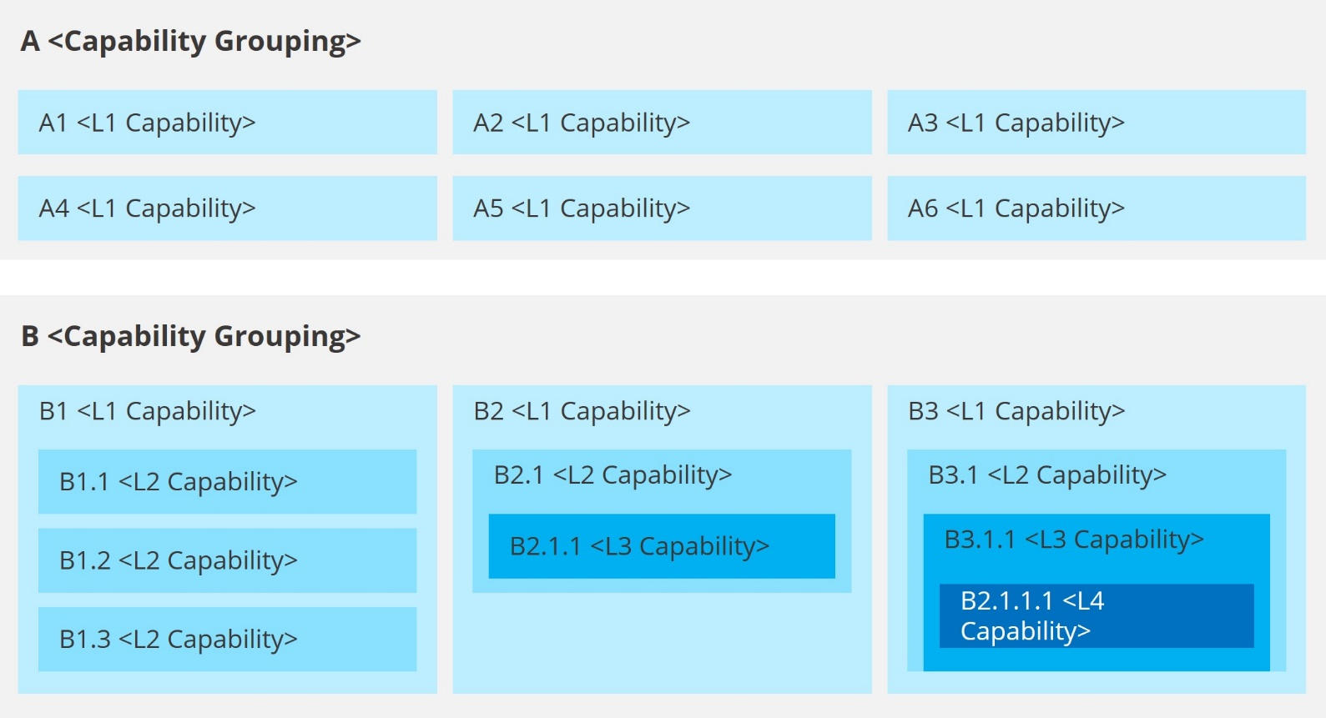

## Conceptual capability architecture diagram description

This section should include a high-level description of the agency’s conceptual capability architecture and its construction.

This section should include:

* high-level description of the conceptual capability architecture diagram
* description of the diagram construction (i.e., capability groups, capability levels etc.)
* direction to detailed capability descriptions section. >

# Conceptual capability architecture overlays

<This section should include an overview on the conceptual capability architecture overlay views included within the artefact.>

## Conceptual capability architecture heatmaps

<This section should include:

* Heat mapping to the conceptual capability architecture (e.g. capability maturity heat mapping, capability). >

## Capability - <Domain> Mapping

<This section should include:

* Mapping of the relationships between the business capabilities and other business and IT architecture domains (e.g. Capability – organisational unit, Capability – value chain mapping, Capability – applications, Capability - information).>

# Detailed capability descriptions

## Level 1 capability descriptions

|  |  |  |  |  |  |
| --- | --- | --- | --- | --- | --- |
| ID | Capability group | L1 capability | Description | Current state maturity | Target state maturity |
| *<Service ID (e.g., A1)>* | *<Capability grouping>* | *<L1 capability>* | *<Include a description of the L1 capability>* | *<Apply Capability Model Maturity Integration (CMMI) to determine current capability maturity level…>* | *< Define the target state capability maturity level>* |
|  |  |  |  |  |  |
|  |  |  |  |  |  |
|  |  |  |  |  |  |

## Level 2 service descriptions

|  |  |  |  |  |  |  |
| --- | --- | --- | --- | --- | --- | --- |
| ID | Capability group | L1 capability | L2 capability | Description | Current state maturity | Target state maturity |
| *<Service ID (e.g., A1.1)>* | *<Capability grouping>* | *<L1 capability>* | *<L2 capability>* | *<Include a description of the L2 capability>* | *<Apply Capability Model Maturity Integration (CMMI) to determine current capability maturity level…>* | *< Define the target state capability maturity level>* |
|  |  |  |  |  |  |  |
|  |  |  |  |  |  |  |
|  |  |  |  |  |  |  |

## Level 3 service descriptions (where necessary)

|  |  |  |  |  |  |  |  |
| --- | --- | --- | --- | --- | --- | --- | --- |
| ID | Capability group | L1 capability | L2 capability | L3 capability | Description | Current state maturity | Target state maturity |
| *<Service ID (e.g., A1.1)>* | *<Capability grouping>* | *<L1 capability>* | *<L2 capability>* | *<L3 capability>* | *<Include a description of the L3 capability>* | *<Apply Capability Model Maturity Integration (CMMI) to determine current capability maturity level…>* | *< Define the target state capability maturity level>* |
|  |  |  |  |  |  |  |  |
|  |  |  |  |  |  |  |  |
|  |  |  |  |  |  |  |  |

## Level 4 service descriptions (where necessary)

|  |  |  |  |  |  |  |  |  |
| --- | --- | --- | --- | --- | --- | --- | --- | --- |
| ID | Capability group | L1 capability | L2 capability | L3 capability | L4 capability | Description | Current state maturity | Target state maturity |
| *<Service ID (e.g., A1.1)>* | *<Capability grouping>* | *<L1 capability>* | *<L2 capability>* | *<L3 capability>* | *<L4 capability>* | *<Include a description of the L4 capability>* | *<Apply Capability Model Maturity Integration (CMMI) to determine current capability maturity level…>* | *< Define the target state capability maturity level>* |
|  |  |  |  |  |  |  |  |  |
|  |  |  |  |  |  |  |  |  |
|  |  |  |  |  |  |  |  |  |

# Artefact examples

Artefact Examples – Remove section upon artefact development

**TOGAF -** Business Capability Map (Conceptual Capability Architecture aligned)

The TOGAF Business Capabilities Guide Capability Decomposition example shows the example capability domain of Human Resource Management decomposed across three levels of capability.

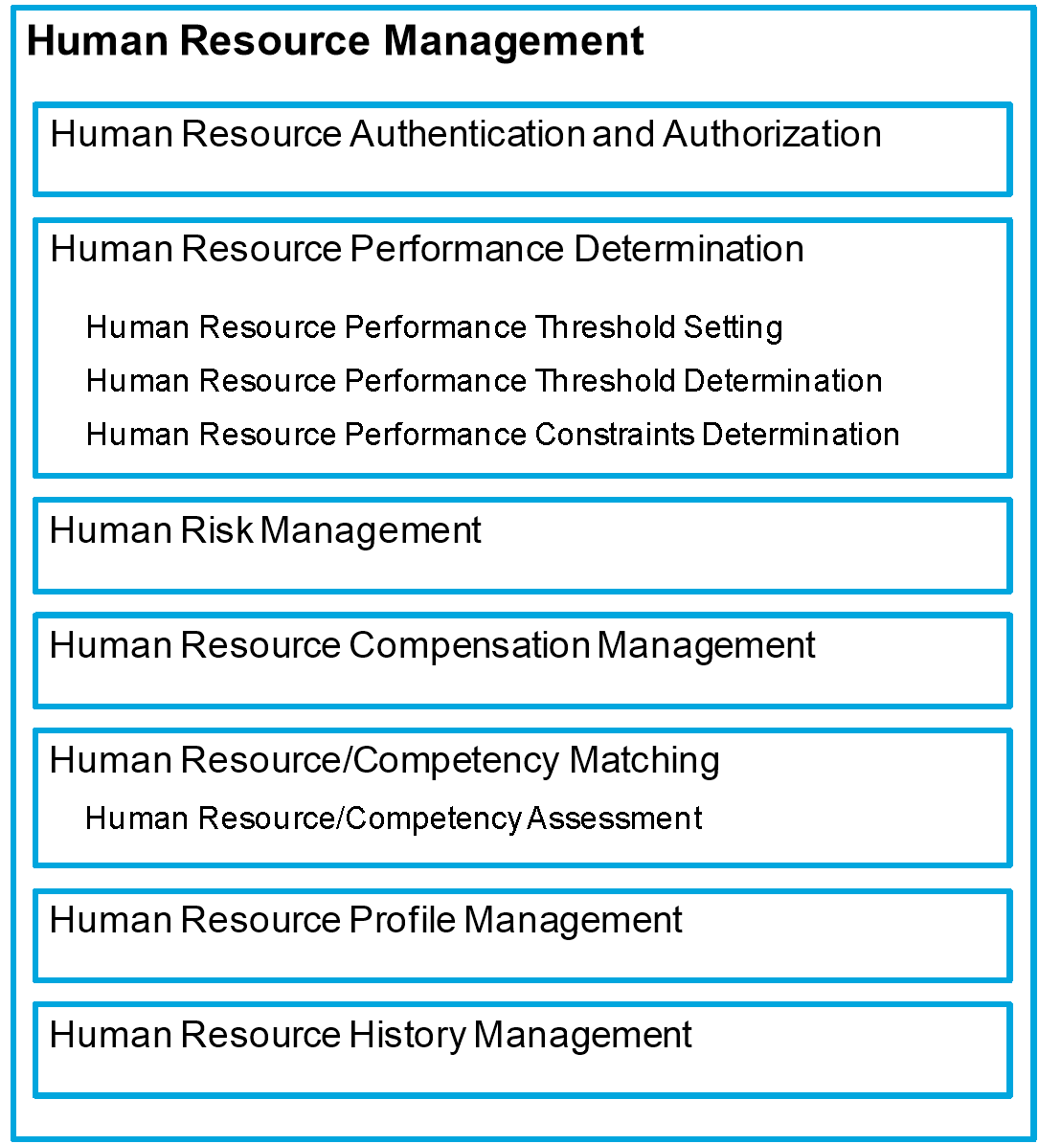

Artefact Examples – Remove section upon artefact development

**DoDAF –** CV-2 Capability Taxonomy (Conceptual Capability Architecture aligned)

The DoDAF Capability Taxonomy presents a hierarchy of capabilities and is used to capture and organise capability functions. Although in a slightly different format, the CV-2 diagram depicts high-level capabilities and any lower-level constituent capabilities in line with the intended Conceptual Capability Architecture format.

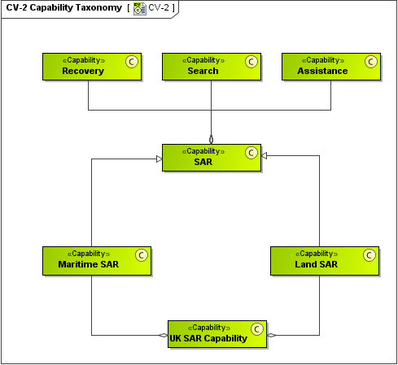

Artefact Examples – Remove section upon artefact development

**TOGAF -** Business Capability Maturity Heat Map (Conceptual Capability Architecture overlays aligned)

The TOGAF Business Capabilities Guide shows an example of a Business Capability Heatmap. This example aligns to the type of artefacts to potentially be developed within section *6.0 Conceptual Capability Architecture Overlays.*

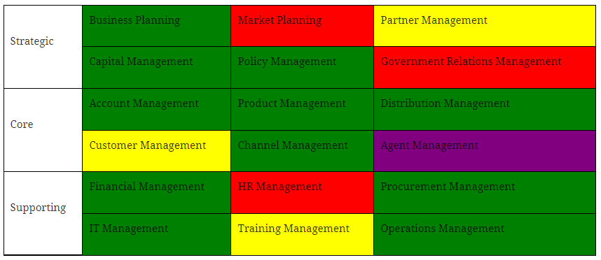

**TOGAF -** Business Capability/Organisation Mapping (Conceptual Capability Architecture overlays aligned)

The TOGAF Business Capabilities Guide shows an example of a Capability/Organisation mapping. This example aligns to the type of artefacts to potentially be developed within section *6.0 Conceptual Capability Architecture Overlays*

