Drupal CMS user guide

For government site (www.forgov.qld.gov.au)

| **Product owner** | Customer Online |
| --- | --- |
| **Site** | [www.forgov.qld.gov.au](http://www.forgov.qld.gov.au) |
| **Version** | 3.4 |
| **Printed date** | 20/08/2019 |

Release details

| **Document owner** | Name: Customer Online  Phone: (07) 3035 4410 | | |
| --- | --- | --- | --- |
| **Status** | Working draft | Consultation draft | Endorsed |
| **Release date** | 15/06/2016 | 23/06/2016 |  |
| **Approved by** |  | | |

Related documents

| Document | Path/URL |
| --- | --- |
| G2G Content author guide | [Request a copy](mailto:gov2gov@dsiti.qld.gov.au) by emailing the Customer Online team. |
| G2G Page model menu | <https://www.qld.gov.au/gov/file/9396/> |

Contents

Introduction 4

1 Request an account 4

2 Roles and user accounts 4

3 Logging in 4

4 Changing your password 4

5 Content types 5

6 Site structure overview 6

7 Create and edit content pages 7

Create a new page 7

Create a standard page 8

Create a case study page 10

Create a product page 12

Creating a section page 16

Create an event page 17

Create a knowledge sharing group page 19

Create a project page 21

Create a news story 22

Create a whole-of-government document 23

Edit an existing page 27

Publish or save a draft 28

Publish or unpublish a page on a future date 29

8 Add/edit components within a page 30

Add a paragraph type 30

Cut and paste text into a content field 34

Add styling to text 35

Add links to text 36

Add a lightbox link to another page 37

Add a lightbox link to a page element 38

Add a lightbox link to an image 39

Add a link to content located on Drupal 40

Add a table of contents 41

Add a Pull quote 41

Insert an image 42

Embed a video 43

Create a Status alert (warning or information) 44

Create Asides 45

Create a process flow diagram 49

9 Upload a file or image 49

10 Logging out 50

11 Support 50

## Introduction

Welcome! This guide describes how to get started using Drupal, the content management system used to publish on the ‘For government’ site (www.qld.gov.au/gov). It covers basic topics such as registering for an account, logging in, changing your account settings, and creating content.

## Request an account

To get an account, you must be a **‘For government’ certified author** and have completed induction and training. Email the Customer Online team ([qssdigitalproducts@dsiti.qld.gov.au](mailto:qssdigitalproducts@dsiti.qld.gov.au)) to request a new account or to enquire about training.

## Roles and user accounts

There are three types of users:

**Anonymous user**—government employees can access secure content (pages that have been made private) by logging in. You must have a qld.gov.au email address, or other approved email address to create a login.

**Content editor/approver**—content authors create and publish content on the ‘For government’ website. To become a content editor/approver you need to complete the ‘For government’ Content Author Training. The Customer Online team will give you access to the CMS related to your area of work.

**Site editor**—Customer Online team members with access to all of the CMS.

## Logging in

To log in:

1. Go to [www.forgov.qld.gov.au/user/login](http://www.forgov.qld.gov.au/user/login).
2. Enter your **username (your email)** and **password**.
3. Click **Log in**.

If you have forgotten your password, click **Request new password** and follow the prompts.

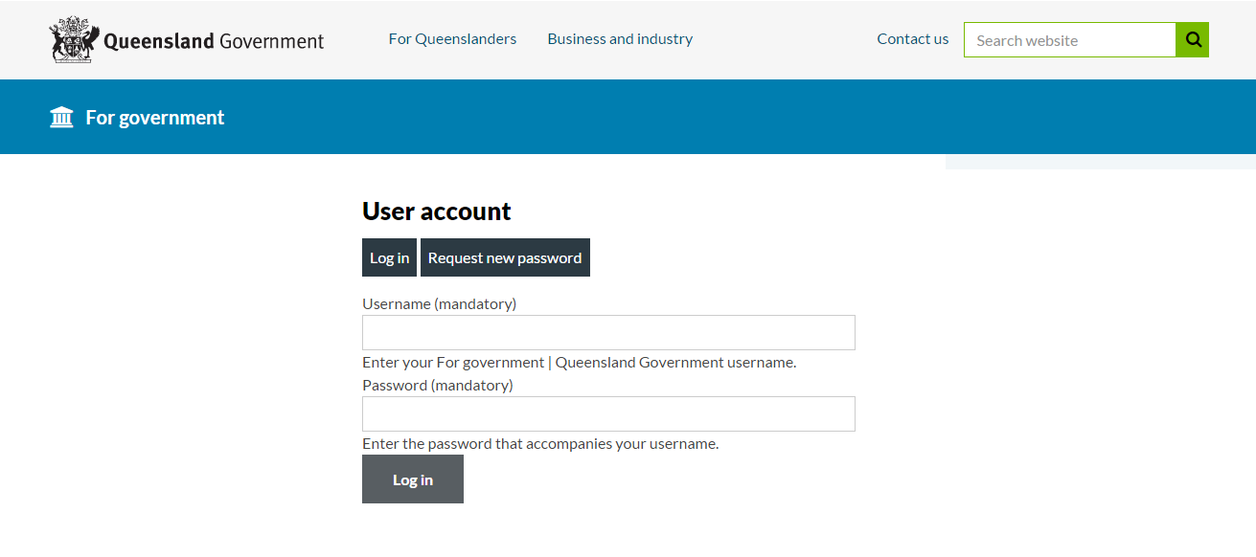

## Changing your password

To change your password:

1. Log in to Drupal.
2. In **My Workbench** under **My Profile**, click **edit my profile**.
3. Enter your current password, new password and confirm.
4. Click **Save**.

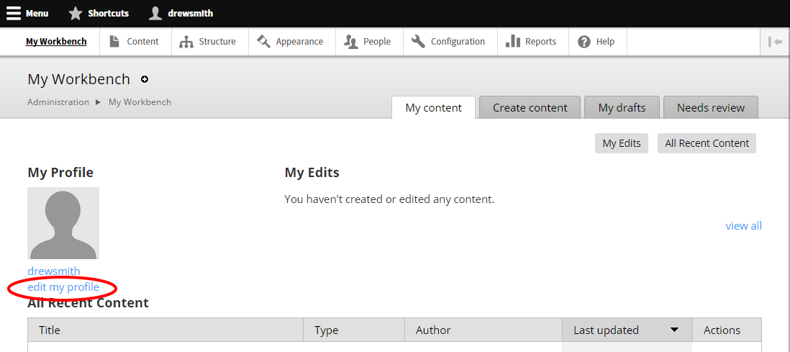

## Content types

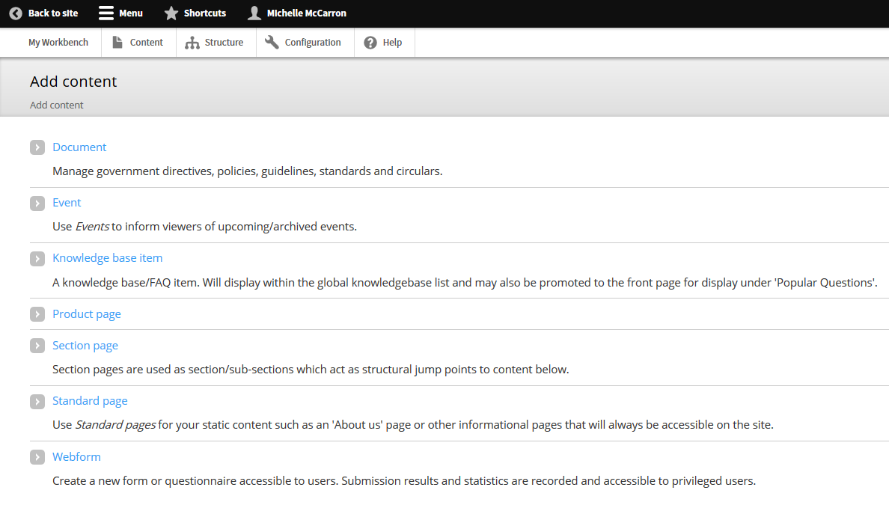

There are several content types within Drupal:

**Document**—Manage government directives, policies, guidelines, standards and circulars.

**Event**—Use Events to inform viewers of upcoming/archived events.

**Knowledge sharing group**—Use to inform visitors of your government working group, community of practice or special interest group.

**News story**—Publish a news story for government employees.

**Product page**—Used to display general, technical, contact and support information for product or services.

**Project**—Use to give visitors an overview of current projects in your organisation.

**Section page**—Used as section/sub-sections that act as structural jump points to content below.

**Standard page**—Use this content type for standard informational content or ‘outcome’ pages.

**Webform**—Create a new form or questionnaire accessible to customers. Submission results and statistics are recorded and accessible to privileged users.

## Site structure overview

The **Main menu** is the sitemap of the entire ‘For government’ site, displaying the hierarchy of pages.

To view the Main menu:

1. Click **Structure** > **Menus** > **list links**

***Tip***: Bookmark the main menu page for easy access.

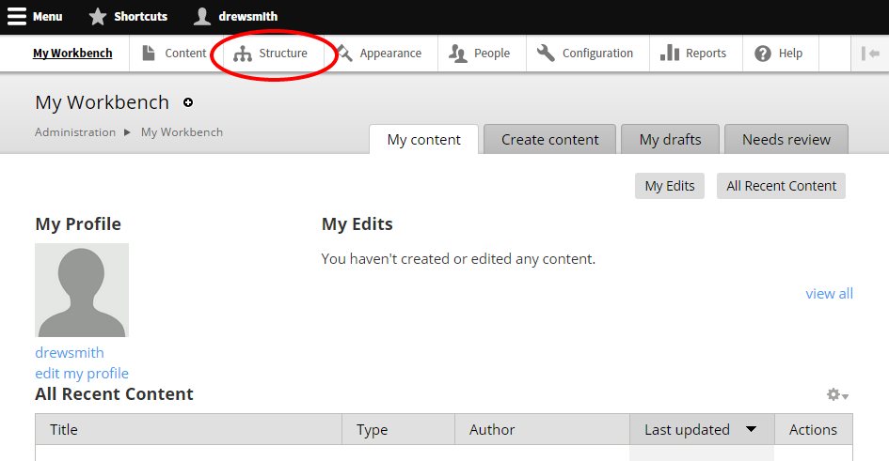

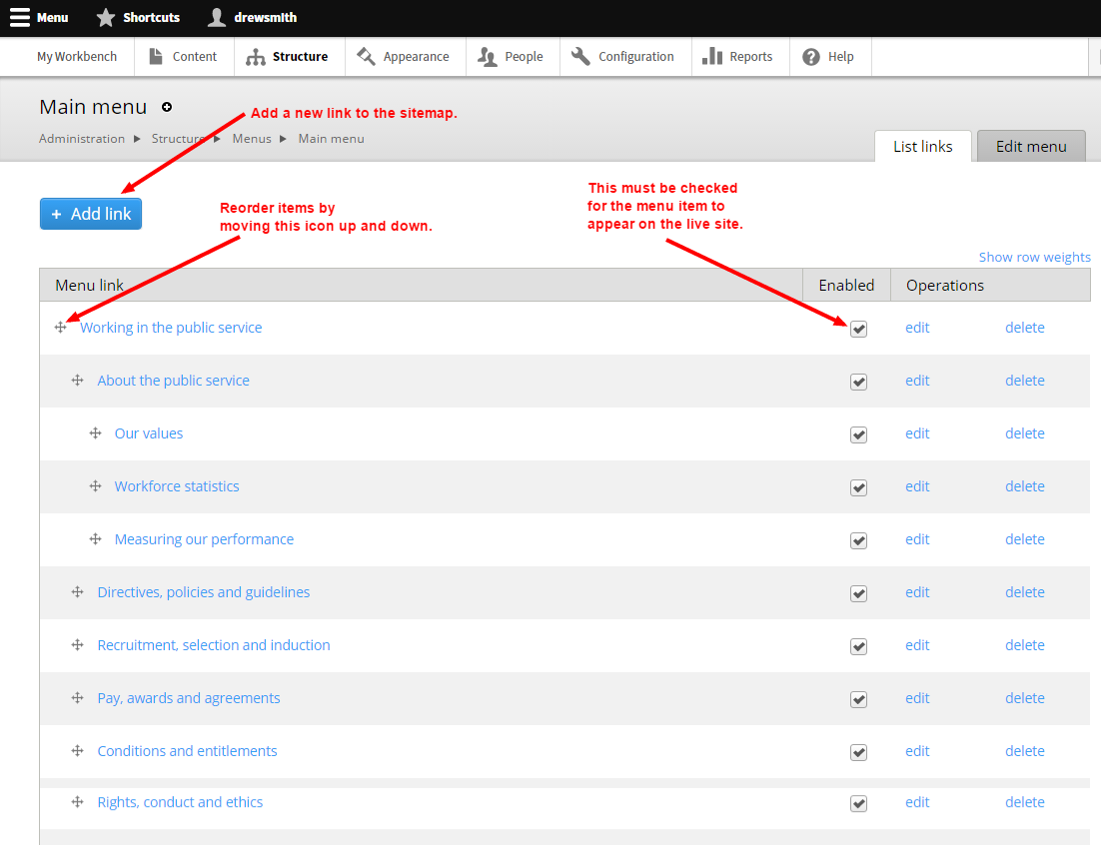

## Create and edit content pages

### Create a new page

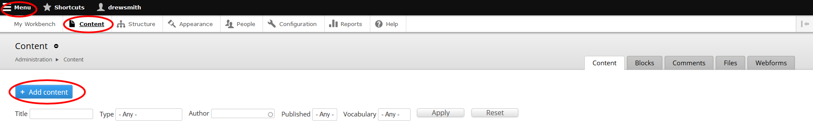

1. Click **Menu** > **Content** > **Add Content**.
2. Select the required page type. Visit [Design and promote For government content](https://www.forgov.qld.gov.au/design-and-promote-government-content) to read more about our Page types to help decide which one is right for your content.

### Create a standard page

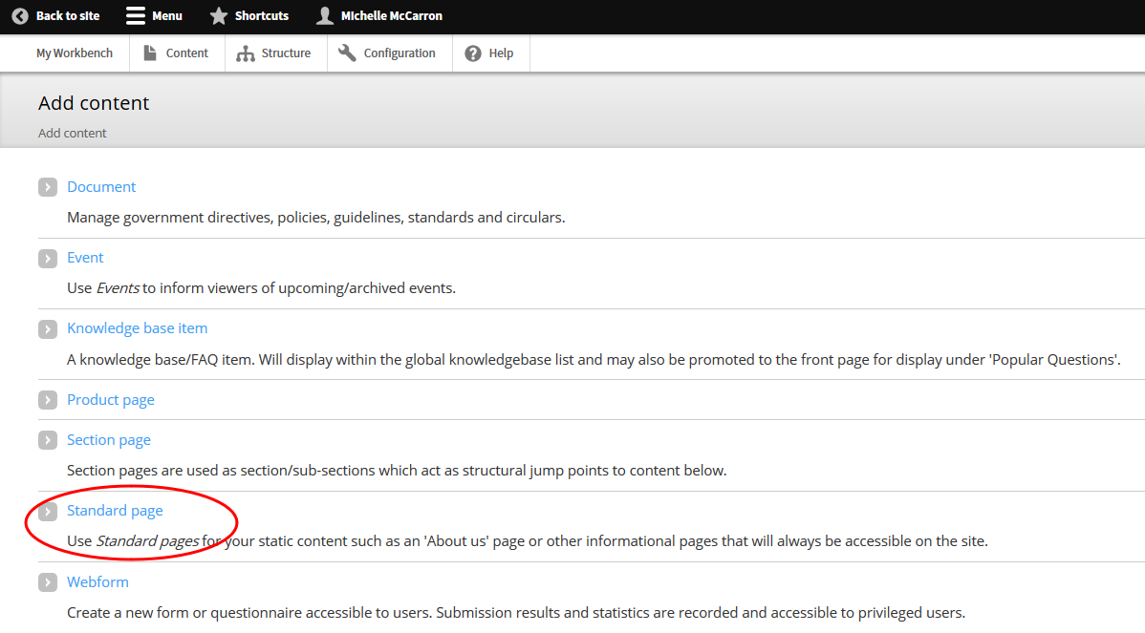

1. Click > **Standard page**.
2. Type a meaningful, customer-centric **Title**.
3. Insert an Image **Icon** by clicking **Browse** (Icons appear on index pages):
   1. Go to the Image location on your computer. Select the image and click **Open**.
   2. Click **Upload** > **Next** > **Add Alt Text** > **Save**.
4. Type a **Summary**.Thisdisplays on the section page where your content will be linked, and in search results.

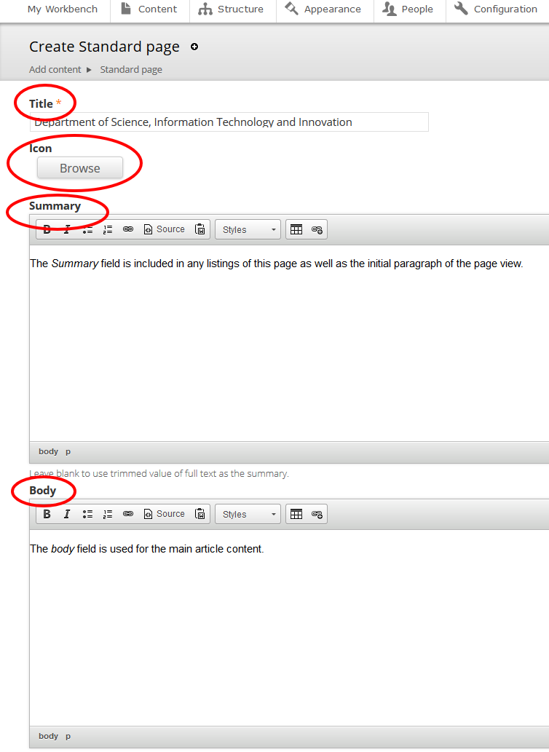

1. Type the **Body**. This is the main part of your article and will be viewable to everyone.   
   **Note:** if you want content viewable to specific agencies, leave the **Body** section blank and refer to the Add a paragraph type section of this document for steps to create agency-specific Forked content.
2. If required, update the **Privacy** setting for the page:
   1. **Default**—inherits setting of page ancestor(s).
   2. **Public**—visible to all
   3. **Private**—Only visible to logged in, registered users.

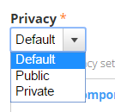

1. Select the appropriate [Creative Commons](https://creativecommons.org/choose) **Licence** for your content. The default *None* applies the least restrictive licence type.
2. Select **Menu Settings** and tick **Provide a Menu Link**.
3. Select a **Parent item** from the drop-down menu**.** This will be a section page,where your content belongs within the IA and will be linked.
4. Select **Meta tags** and update the metadata for your new page as required:
   1. Add Keywords**.**
   2. Add **Creator** (your agency name) under **Dublin Core Basic Tags** > **Creator** in the **Value** field.

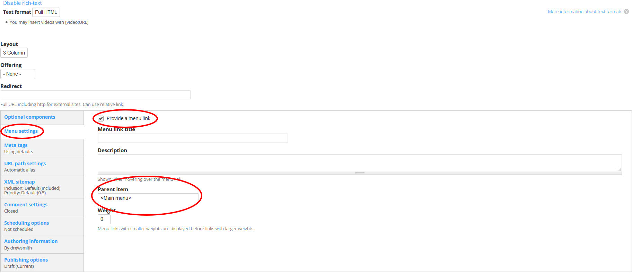

1. Select **Publishing options**:
   1. Select the appropriate **Review frequency** (3/6/12 months or Other) depending on the content’s volatility.
   2. Insert the **Review email** address of the team responsible for the page.
2. **Save** and check how it looks. If the page displays correctly, **publish now** (Change the **Moderation state** to **Published** and **Save**), or schedule for a future date.

### Create a case study page



1. Click > **Standard page**.
2. Complete the steps covered under Create a standard page above.
3. When you complete the **Body** content:
   1. Format all quotes as pull quotes.
   2. Insert and format images as cut-ins.
   3. Embed and format video.

**Note:** if you want content viewable to specific agencies, leave the **Body** section blank and refer to the Add a paragraph type section of this document for steps to create agency-specific Forked content.

1. Select **Optional componenets**.
2. Add an aside to the page to display related case studies:
   1. In the **Aside type** dropdown, choose **Aside** and click **Add new Aside**.
   2. Add a title: Find similar initiatives.
   3. In the **Aside content** field click the **Source button**
   4. Paste the following code

<div class="case-study-tags">.</div>

* 1. Click the **Source button**.

1. Select **Add Preamble**.
2. Insert a background image (this will appear as a header image to the article) by clicking **Browse**. The image must be between 600x90 and 800x800 pixels.
3. Type a meaningful, customer-centric **Subtitle**. This will appear, along with the title of the artilce, superimposed over the background image.  
     
   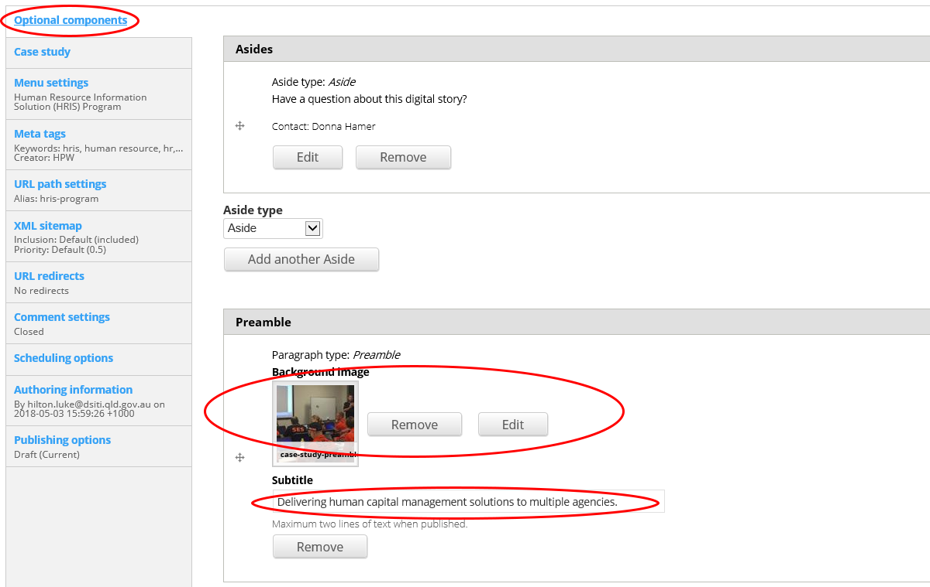
4. Select **Case Study**.
5. Click **Add Case study metadata** and select all fields that apply.
   1. For the **Main priority** and **Main principle** metadata, select from the dropdowns as appropriate, and then select the same priority or principle in the **Priorities** and **Principles** checklists. Add any additional priorities or principles by selecting multiple check boxes.

**Example:** one priority

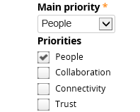

**Example:** multiple priorities

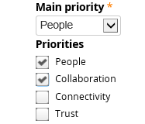

1. Continue with the remainder of the Create a standard page steps.
2. **Save** and check how it looks. If the page displays correctly, **publish now** (Change the **Moderation state** to **Published** and **Save**), or schedule for a future date.

### Create a product page

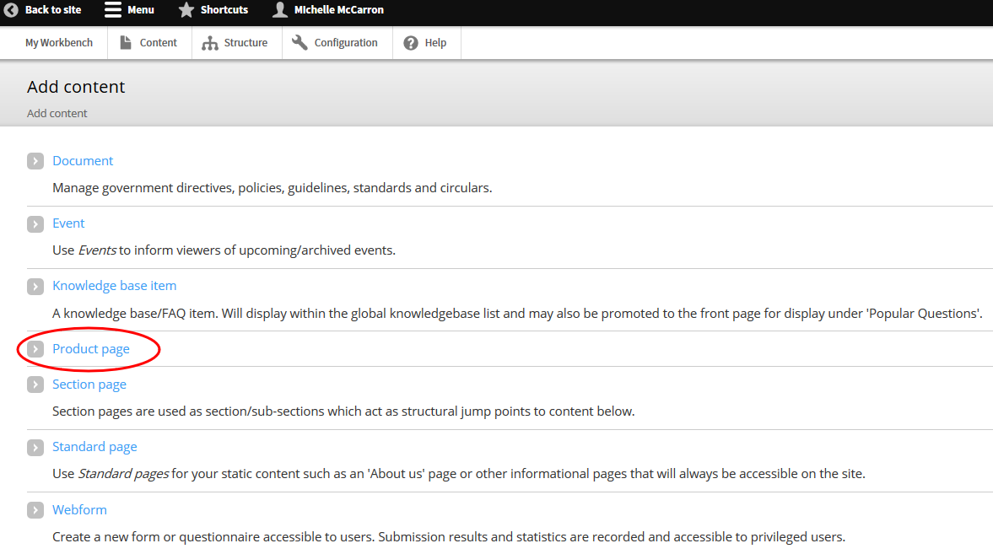

1. Click > **Product page**.
2. Type a meaningful, customer-centric **Title**.
3. Insert an image **Icon** by clicking **Browse** (Icons appear on index pages):
   1. Go to the image location on your computer.
   2. Select the image and click **Open**.
   3. Click **Upload** > **Next** > **Add Alt Text** > **Save**.
4. Type a **Product description** to summarise the page content.
5. Add the **Topic** **title** by searching for the related page.
6. Add the **Outcome** title by searching for the related page.
7. Add a form (if required).
8. Complete the three Product page tabs:
   1. About
   2. Get started
   3. Contact and support
9. Select the appropriate [Creative Commons](https://creativecommons.org/choose) **Licence** for your content. The default *None* applies the least restrictive licence type.
10. Select **Meta tags** and update the metadata for your new page as required:
    1. Add Keywords**.**
    2. Add **Creator** (your agency name) under **Dublin Core Basic Tags** > **Creator** in the **Value** field.
11. Select **Publishing options**:
    1. Select the appropriate **Review frequency** (3/6/12 months or Other) depending on the content’s volatility.
    2. Insert the **Review email** address of the team responsible for the page.
12. **Save** and check how it looks. If the page displays correctly, **publish now** (Change the **Moderation state** to **Published** and **Save**), or schedule for a future date.

#### Add a form

1. Select the **Form** **type** > **Product** **form** **download**.
2. Click > **Add** **new** **Form**.
3. Click> **Browse** > **find** **the** **form**.
4. Click > **Upload**.

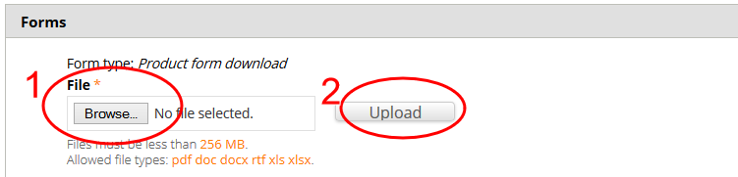

1. Choose agencies who this content relates to or leave it blank for all agencies to view it.
2. **Save** and check how it looks. If the page displays correctly, **publish**.

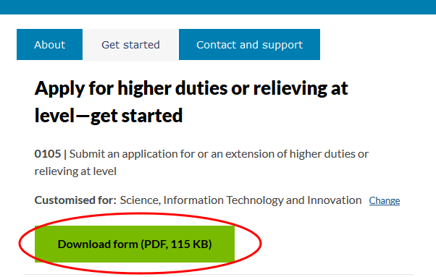

#### Add a generic paragraph to the About tab

1. Select > the **About** tab.
2. Choose **Paragraph** **type** > **Generic** **markup**.
3. Select > **Add new Paragraph**.
4. Type your text into the **Content** field.

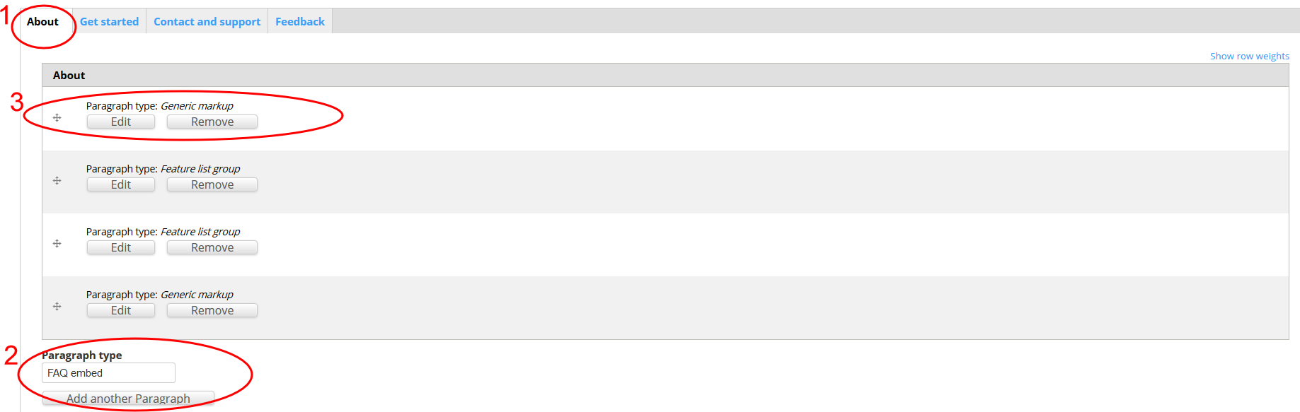

#### Add Features to the About tab

1. Select > **Paragraph** **type** > **Featured list group**.
2. Add **Title** > **Features**.
3. Add > **Feature** **list** **item** > Edit > **Feature list item**.
4. Type a meaningful, customer-centric **Title**.
5. Add an **Image** (Icon to visually represent the title):
   1. To create icons for features:
      1. Go to http://fortawesome.github.io/Font-Awesome/icons/.
      2. Choose an appropriate icon.
      3. Copy the whole name (fa-calendar-plus-o).
      4. Go to http://fa2png.io/.
      5. Copy it into the generator, select colour and size (0b2e4c and 50 x 50).
      6. Click **Generate**.
      7. Click **Download**.
      8. **Upload** the icon file into **About** **page**.
6. Type a **Summary**.

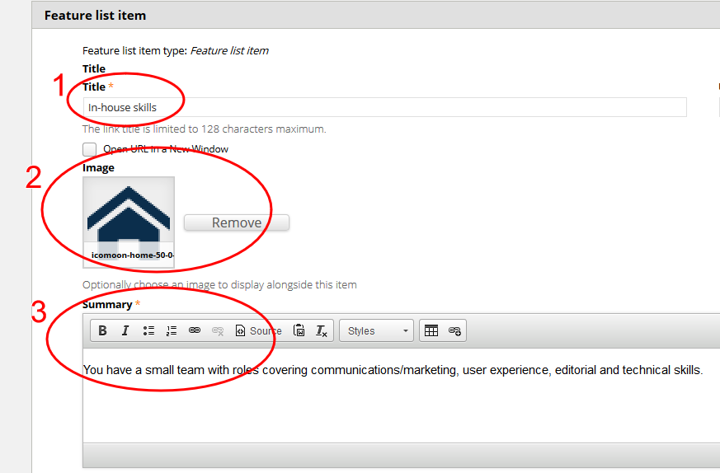

1. Add additional features to the list > **Add another Feature list item**.

#### Add Benefits to the About tab

1. Select > **Paragraph** **type** > **Featured** **list group**.
2. Add **Title** > **Benefit**.
3. Add > **Feature list item** > Edit > **Feature list item**.
4. Add a meaningful and customer-centric **Title**.
5. Add an **Image** (The image used is a Green tick):
   1. Search in Drupal library for the file name fa-icon (fa-check-square-o-40-0-179824-none-1.png). This is fa-check-square-o, in colour 179824 and size 50x50).
   2. Attach the icon.
6. Type a **Summary**.

#### Add a generic paragraph to the Get started tab

1. Select > the **Get** **started** tab.
2. Choose **Paragraph** **type** > **Generic markup**.
3. Select > **Add new Paragraph**.
4. Type your text into the **Content** field.

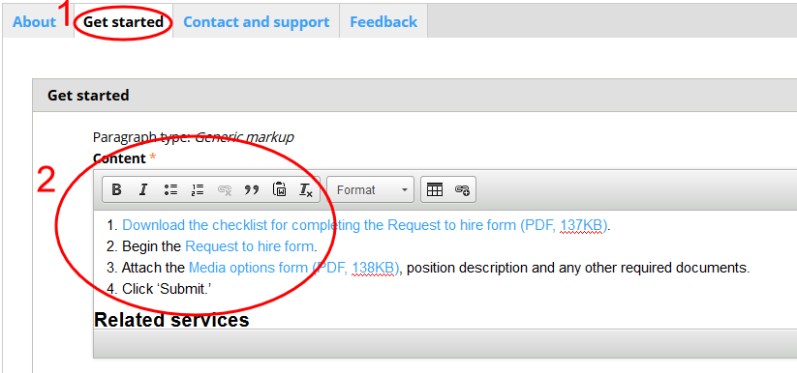

#### Add a generic paragraph to the Contact and support tab

1. Select > the **Contact and support** tab.
2. Choose **Paragraph type** > **Generic markup**.
3. Select > **Add new Paragraph**.
4. Type your text into the **Content** field.
5. Add a Contact heading (using **Styles**).

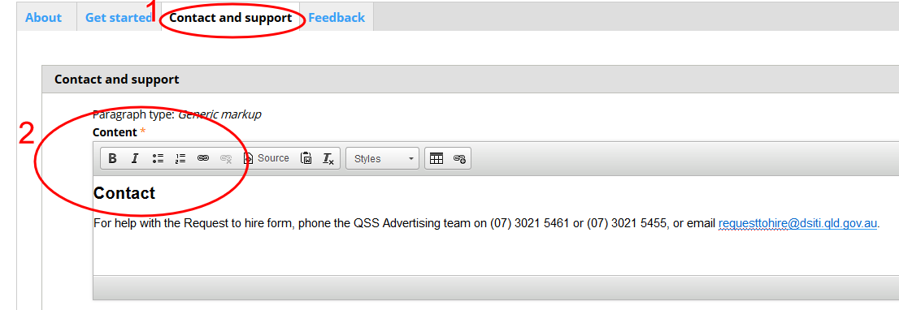

#### Add FAQs to the Contact and support tab

1. Add Paragraph > **Paragraph type** > **FAQ embed** (used to include FAQs).
2. Add **Title** > **Support**.
3. Select > **FAQ embed view** > Select > **Knowledge_base_faq – FAQs** **associated with this content** (this will bring in the FAQs that have been associated with this page).

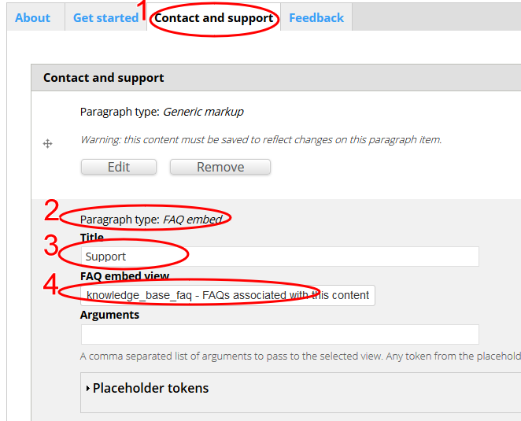

### Creating a section page

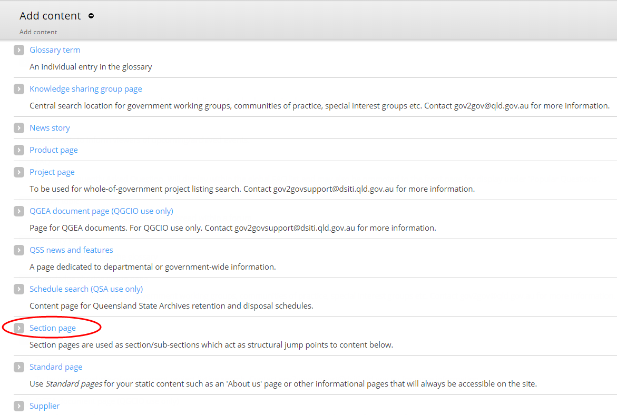

To create a new section page, submit your page request to the Customer Design Experience team for approval. Email [qsscxdesign@dsiti.qld.gov.au](mailto:qsscxdesign@dsiti.qld.gov.au).

The team will ensure the new section page/s are created in consideration to the IA and labelled according to our ‘For government’ principles.

### Create an event page

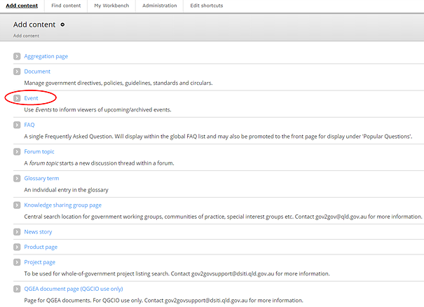

1. Click > **Event**.
2. Enter the **Event information:**
   1. Type a meaningful customer-centric **Title**.
   2. If the event is hosted on an external platform, such as Eventbrite, enter the **Event URL**.  
      **Note:** This will redirect users to the external platform from the search results page, rather than an event page on *For government*.

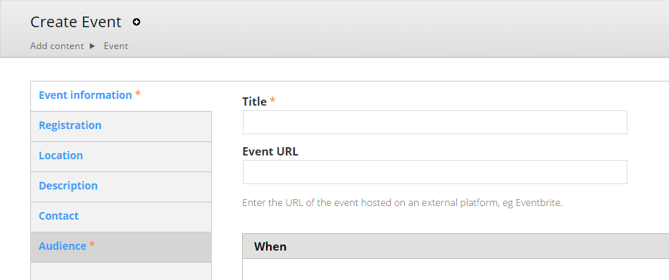

* 1. Add information about **when** the event will start and finish:
     1. Untick the **Show End Date** checkbox if you don’t want to show when the event will finish.
     2. Select **Add another item** if the event will occur more than once.
  2. Enter an **RSVP date** and **cost**, if any.

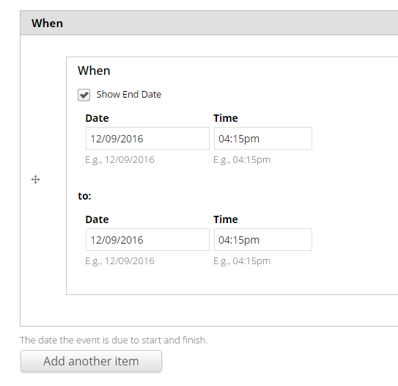

* 1. Insert a **feature image** (559px x 176px) by clicking **Browse** (optional):
     1. Go to the image location on your computer. Select the image and click **Open**.
     2. Click **Upload** > **Next** > **Add Alt Text** > **Save**.

1. Tick the **Open registration** checkbox if you want to manage registrations using the CMS.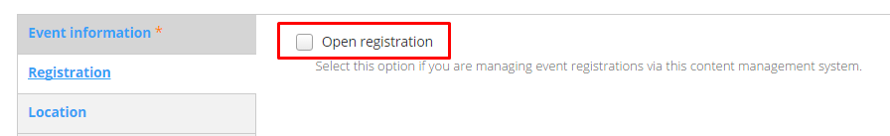
2. Type a **location** for the event. You can also display a **map** on the event page by entering an **Address**.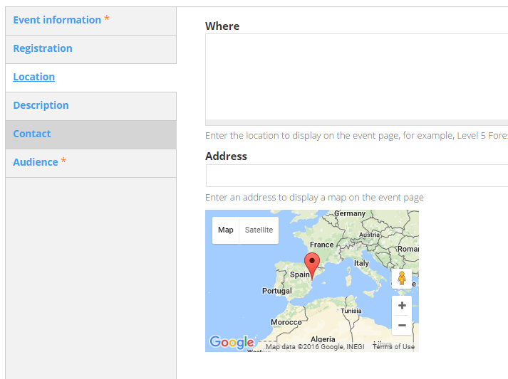
3. Type a **Summary** and **Description** of the event. The summary will appear in event search results and in the calendar appointment for the event (if the CMS is used for registrations). You can leave the **Summary** blank to use a trimmed version of the description text.
4. Type **Contact** details for the event organiser.
5. Select the appropriate **Audience** setting from the drop-down lists.
6. If required, update the **Privacy** setting for the event:
   1. **Default**—inherits setting of page ancestor(s).
   2. **Public**—visible to all
   3. **Private**—Only visible to logged in, registered users.

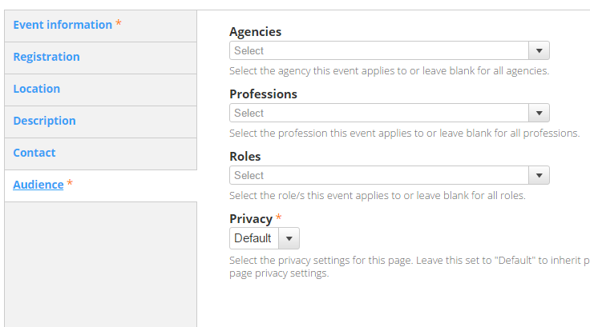

1. Select the appropriate [Creative Commons](https://creativecommons.org/choose) **Licence** for your content. The default *None* applies the least restrictive licence type.
2. Select **Meta tags** and update the metadata for your new page as required:
   1. Add Keywords**.**
   2. Add **Creator** (your agency name) under **Dublin Core Basic Tags** > **Creator** in the **Value** field.
3. Select **Publishing options**:
   1. Select the appropriate **Review frequency** (3/6/12 months or Other) depending on the content’s volatility.
   2. Insert the **Review email** address of the team responsible for the page.
4. **Save** and check how it looks. If the page displays correctly, **publish now** (Change the **Moderation state** to **Published** and **Save**), or schedule for a future date.

### Create a knowledge sharing group page

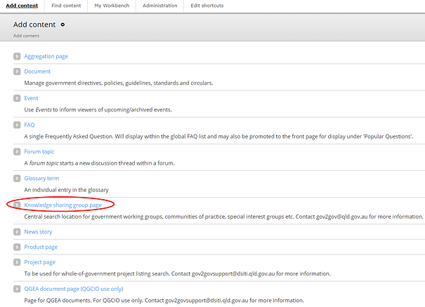

1. Click > **Knowledge sharing group page**.
2. Type a meaningful, customer-centric **Title** and **Summary**, and select the **Lead agency** from the drop-down list.
3. Select **About the group.** Type a **Description** of the group, and select **Topics** from the topic list.
4. Select **Attendees**. Describe who the group is intended for, including any restrictions on membership.
5. Select **Outcomes**. Explain the intended outcomes from the group.
6. Select **Meeting frequency** for the group and when the next meeting will occur. You can add a link to an **Event** page for the group’s next meeting.
7. Select **Contacts** and complete the contact information for the group’s organiser.
8. Select **Associated information** and add a link to an external site or *For government* page where the associated information is hosted.  
   **Note:** if you’re creating a page for this purpose, use a **standard page** that is not attached to the site IA and only host recent documents (meeting agendas, minutes, actions etc.).
9. You can also add asides to the page, including a **Related Events** listing.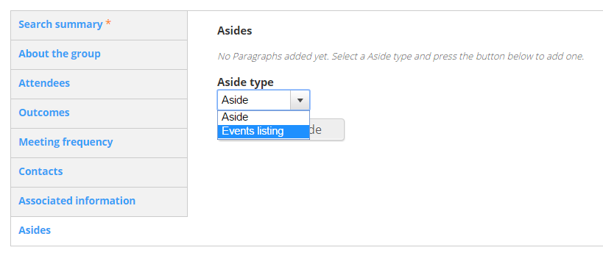
10. If required, update the **Privacy** setting for the page:
    1. **Default**—inherits setting of page ancestor(s).
    2. **Public**—visible to all
    3. **Private**—Only visible to logged in, registered users.



1. Select the appropriate [Creative Commons](https://creativecommons.org/choose) **Licence** for your content. The default *None* applies the least restrictive licence type.
2. Select **Meta tags** and update the metadata for your new page as required:
   1. Add Keywords**.**
   2. Add **Creator** (your agency name) under **Dublin Core Basic Tags** > **Creator** in the **Value** field.
3. Select **Publishing options**:
   1. Select the appropriate **Review frequency** (3/6/12 months or Other) depending on the content’s volatility.
   2. Insert the **Review email** address of the team responsible for the page.
4. **Save** and check how it looks. If the page displays correctly, **publish now** (Change the **Moderation state** to **Published** and **Save**), or schedule for a future date.

### Create a project page

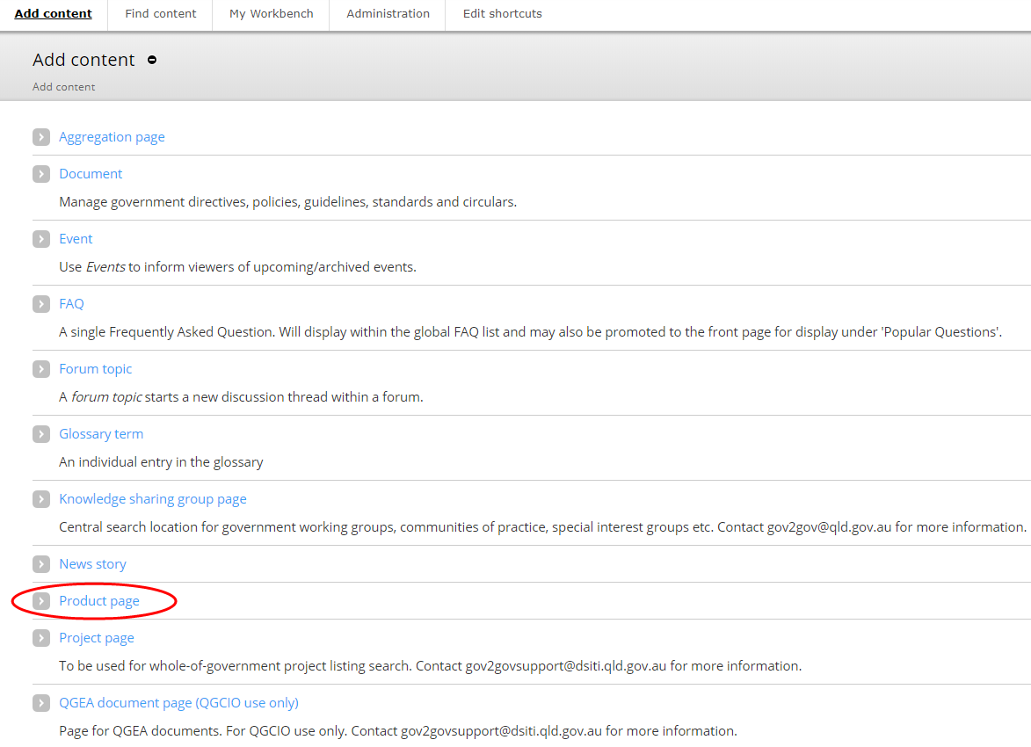

1. Click > **Project page**.
2. Enter the **Project Information**:
   1. Type a meaningful, customer-centric **Title**.
   2. Select the relevant **Categories** and **Lead agency** from the lists.
   3. Enter the project’s **Start date** and expected **End date**.
3. Select **Project details**:
   1. Type a **Summary**—a short description of the project (maximum 250 characters) that will display in project search results.
   2. Type a longer description of the project in the **About the project** field. This will display on the project’s page.
   3. Select the **Agencies involved** from the list.
   4. Type a brief description of how agencies will benefit from the project in the **Benefits** field.
   5. Type dates for upcoming key milestones in the **Key** **milestones** field. Examples include testing and go-live dates. If entered, you must review these dates regularly to ensure they are current.
4. Select **Project phase** and type, using a maximum of 150 characters, the stage of the project. If entered, you must review the phase regularly to ensure information is current.
5. Select **Supporting material** (if any):
   1. Up to 5 supporting **Documents** can be uploaded.
   2. Add **Links** to intranets, external websites or the **ICT Dashboard**.
6. Select **Contact** and add the contact information for the project team.
7. You can also add asides to the page, including a **Related Events** listing.
8. If required, update the **Privacy** setting for the page:
   1. **Default**—inherits setting of page ancestor(s).
   2. **Public**—visible to all
   3. **Private**—Only visible to logged in, registered users.



1. Select the appropriate [Creative Commons](https://creativecommons.org/choose) **Licence** for your content. The default *None* applies the least restrictive licence type.
2. Select **Meta tags** and update the metadata for your new page as required:
   1. Add Keywords**.**
   2. Add **Creator** (your agency name) under **Dublin Core Basic Tags** > **Creator** in the **Value** field
3. Select **Publishing options**:
   1. Select the appropriate **Review frequency** (3/6/12 months or Other) depending on the content’s volatility.
   2. Insert the **Review email** address of the team responsible for the page.
4. **Save** and check how it looks. If the page displays correctly, **publish now** (Change the **Moderation state** to **Published** and **Save**), or schedule for a future date.

### Create a news story

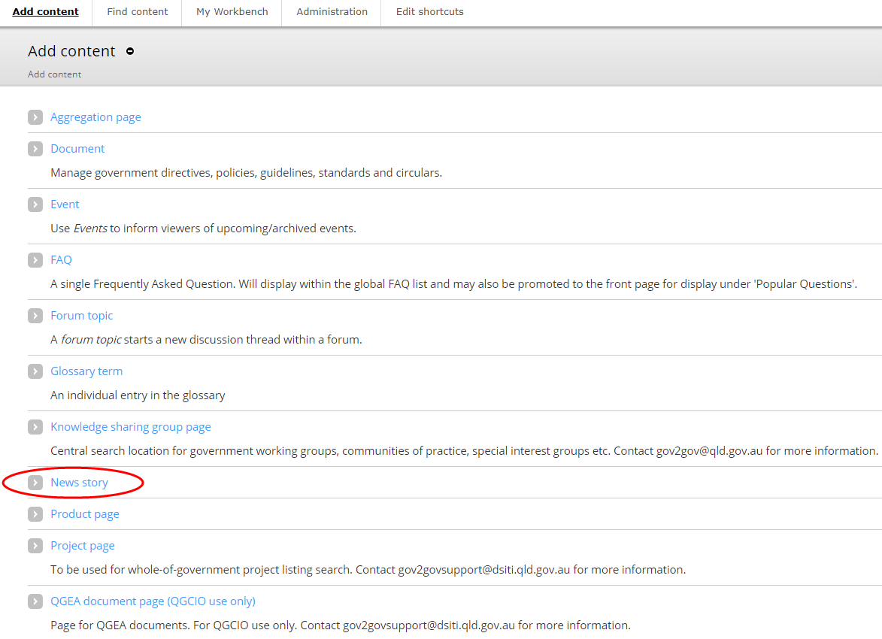

1. Click > **News story**.
2. Add a meaningful, customer-centric **Title**.
3. Select the most relevant **Category** from the drop-down list.

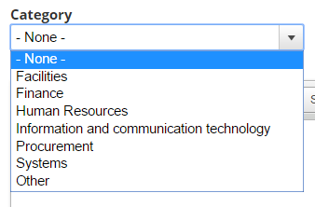

1. Type a **Summary—**a short description of the article (maximum 250 characters) that will display in search results.
2. Type the **Body** of the artilce—the main content of the article.  
   **Note:** if you want content viewable to specific agencies, leave the **Body** section blank and refer to the Add a paragraph type section of this document for steps to create agency-specific Forked content.
3. Type **Contact** details for further information and enquiries.
4. Select the appropriate [Creative Commons](https://creativecommons.org/choose) **Licence** for your content. The default *None* applies the least restrictive licence type.
5. Select **Meta tags** and update the metadata for your new page as required:
   1. Add Keywords**.**
   2. Add **Creator** (your agency name) under **Dublin Core Basic Tags** > **Creator** in the **Value** field
6. Select **Publishing options**:
   1. Select the appropriate **Review frequency** (3/6/12 months or Other) depending on the content’s volatility.
   2. Insert the **Review email** address of the team responsible for the page.
7. **Save** and check how it looks. If the page displays correctly, **publish**.

### Create a whole-of-government document

Use these instructions to publish to [Search for directives, policies and guidelines](https://www.forgov.qld.gov.au/directives-policies-and-guidelines). A whole-of-government document can fall into one of the following categories:

1. Directive
2. Policy
3. Standard
4. Guideline
5. Circular

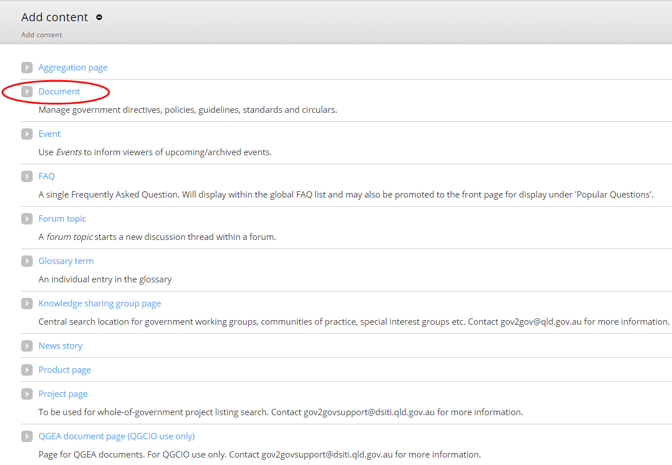

1. Click > **Document**.
2. Add a meaningful, customer-centric **Title**.
3. Select the **Document type**.
4. Where applicable, add the **Directive number** (if it’s a directives or circular).
5. Where applicable, add a Supersede (if the new directive of curcular replaces an older version/s).
   1. Search using the directive/circular number.
   2. Click on the displayed match.
   3. Click **Add another item** to add additional Supersedes.
6. Select the **Category.**

**Note:** All PSC and IR documents belong in the **HR and Industrial relations category**

1. Select the **Responsible agency.**

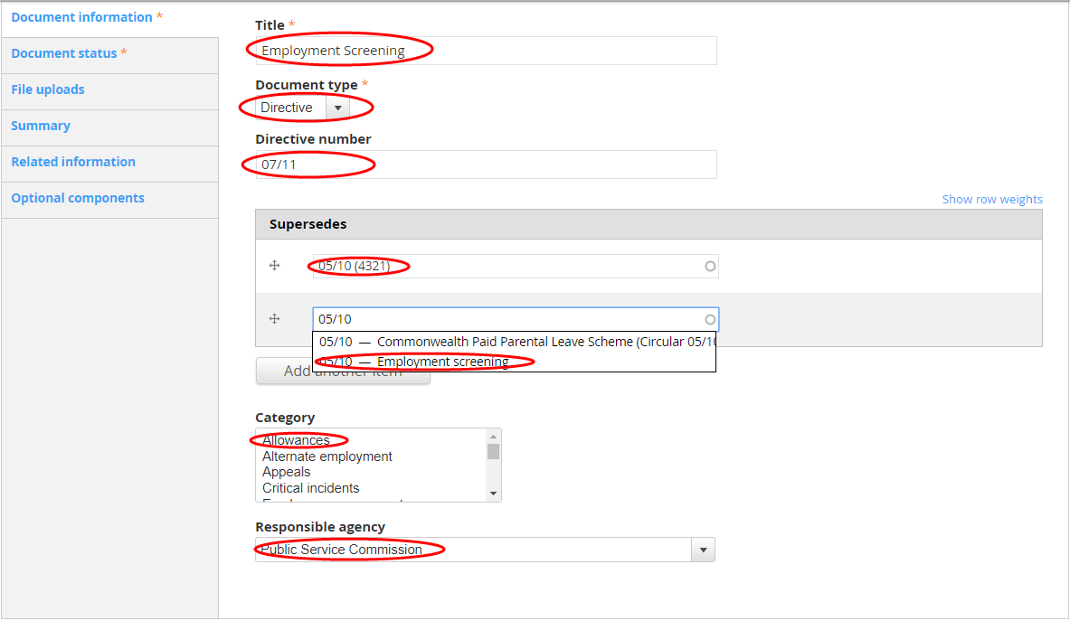

1. Select **Document satus**. The default status is **Current**.

**Note:** If you are creating a document that supersedes another, you will need to edit the superseded document and change the status of that document to **Superseded**. You will also need to add an **End Date**.

1. Add an **Effective date**.  
   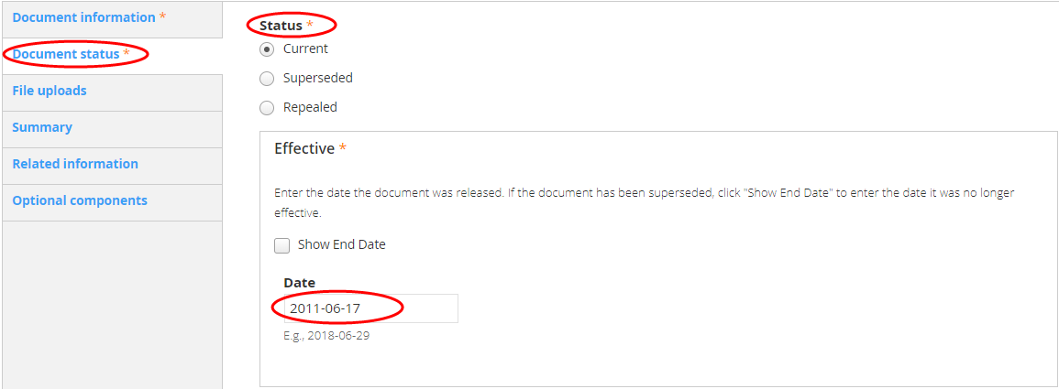
2. Select **File uploads.**
3. Upload a PDF and DOC version of your document. If the documents are over 1MB, you’ll need to split these into smaller less than 1MB documents. Then upload the split documents via **Split PDF version** and **Split DOC version**.
4. Add a thumbnail if you want to override the auto-generated thumbnail.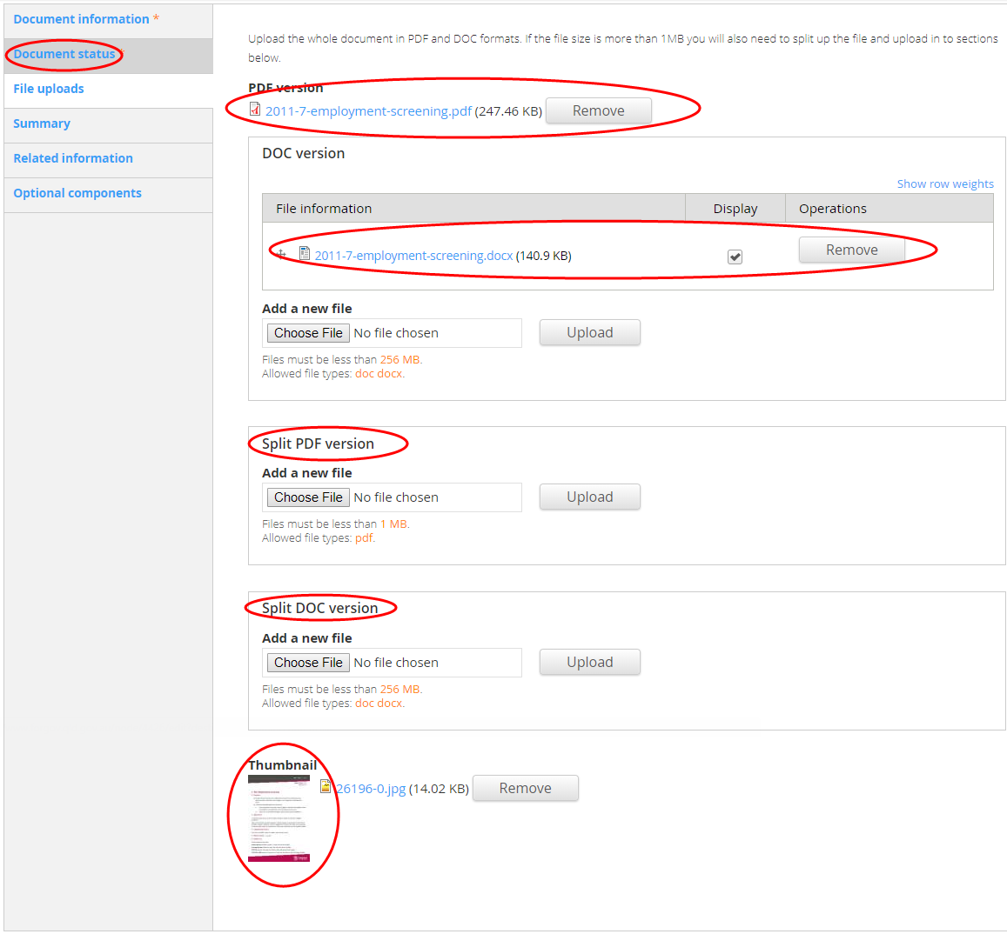
5. Select **Summary**. This will display in search results and on the documents html page that is generated once the document is published. It should be as short as possible; only the first 197 charactes (including spaces) will display in the search result.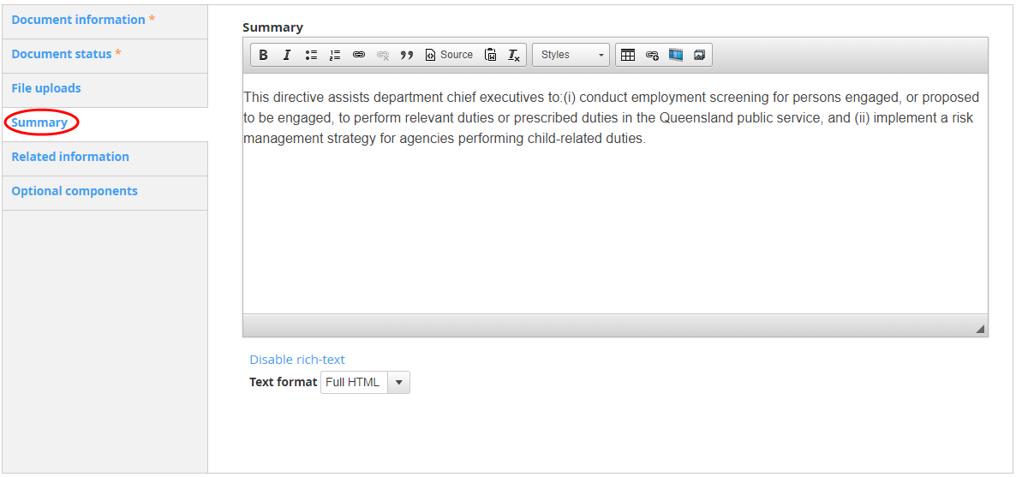
6. Select **Related information** if there are additional online resources that support the policy or directive, or if the document refers directly to exisiting online content.
   1. Add the **Title** and **URL.** If the content is on *For government*, click **Search** and find the content. Click **Insert link**.
   2. Add Related documents. Click Browse and upload, link or attach the document/s as applicable.
7. Select **Optional components** and add a status alert and/or asides where applicable.
8. If required, update the **Privacy** setting for the page:
   1. **Default**—inherits setting of page ancestor(s).
   2. **Public**—visible to all
   3. **Private**—Only visible to logged in, registered users.



Select the appropriate [Creative Commons](https://creativecommons.org/choose) **Licence** for your content. The default *None* applies the least restrictive licence type.

1. Select **Meta tags** and update the metadata for your new page as required:
   1. Add Keywords**.**
   2. Add **Creator** (your agency name) under **Dublin Core Basic Tags** > **Creator** in the **Value** field
2. Select **Publishing options**:
   1. Select the appropriate **Review frequency** (3/6/12 months or Other) depending on the content’s volatility.
   2. Insert the **Review email** address of the team responsible for the page.
3. **Save** and check how it looks. If the page displays correctly, **publish now** (Change the **Moderation state** to **Published** and **Save**), or schedule for a future date.

### Edit an existing page

You can edit an existing page by either finding the page in the content listing within the Drupal content area or navigating the site to your page and selecting **New** **draft** or **Edit** **draft** (providing you’re logged in).

#### Edit by content listing

1. Select **Content** from the **Menu** toolbar.
2. Find the **Title** of your page and click **Edit** on the right hand side of the screen.  
   ***Tip***: If you can’t see your page immediately, use the search filters at the top of the content listing.

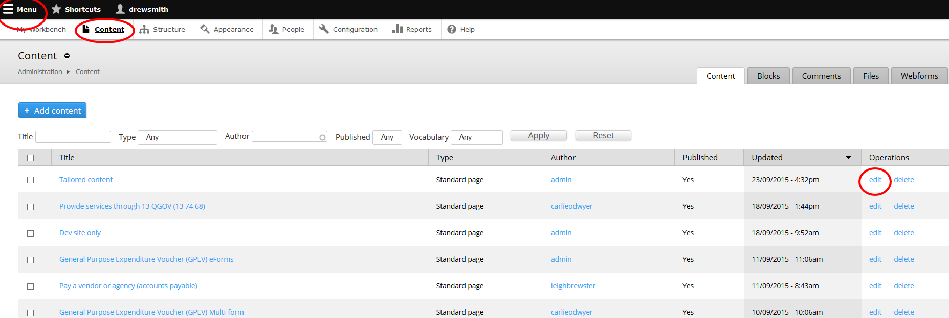

#### Edit by navigating to a page

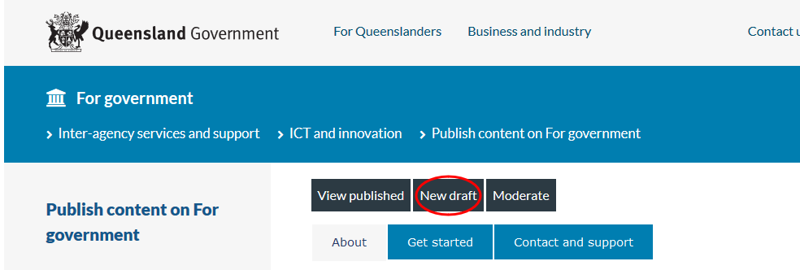

1. While logged in, navigate to the page you want to edit.
2. If your page **Moderation** **State** is **Published**, you can edit by clicking on **New** **Draft**.

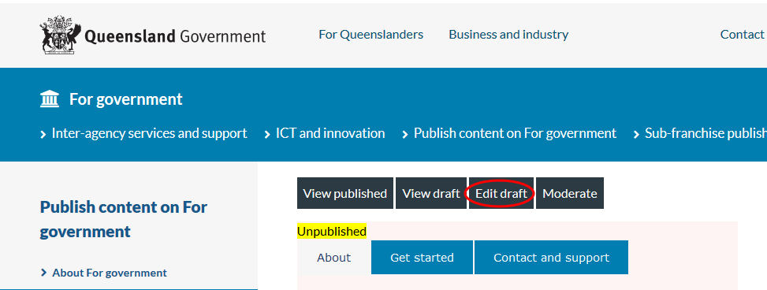

1. If your page **Moderation** **State** is listed as **Draft** **(Current)** or **Needs** **Review**, you can edit by clicking on **Edit** **Draft**.

### Publish or save a draft

Once you have created or edited a page:

1. Select **Publishing options**:
   1. If you are editing the page, write a brief **Log message** to explain the changes you have made to the page (new pages auto-populate with you name).
   2. Enter the current date as the **Last Reviewed**.
   3. Select the appropriate **Review frequency** (3/6/12 months or Other) depending on the content’s volatility.
   4. Add a **Review email** address of the team responsible for the page (or update where applicable).
2. **Save** and check how it looks. If the page displays correctly, **publish now** (Change the **Moderation state** to **Published** and **Save**), or schedule for a future date.

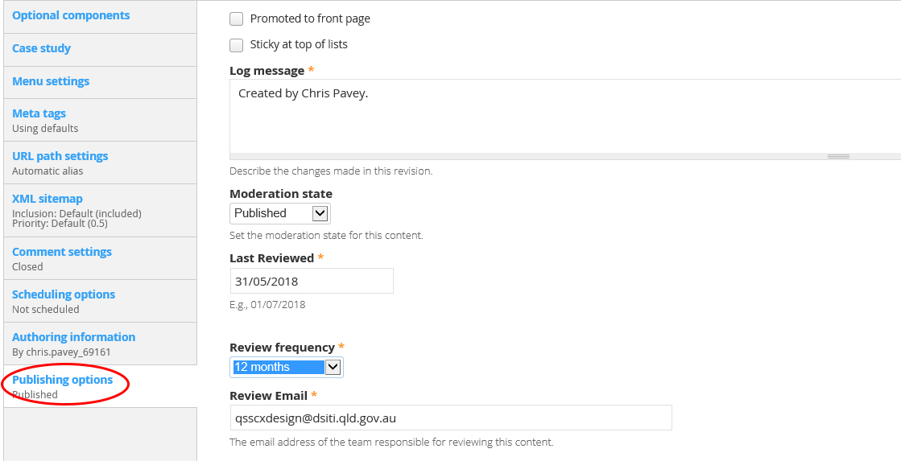

### Publish or unpublish a page on a future date

1. Select **Scheduling options** (not currently available for News story page).
2. Click into the **Publish on Date** field and select the date to publish.
3. Click into the **Time** fied and type the time to publish.
4. Click into the **Unpublish on Date** field and select the date to unpublish (where applicable).
5. Click into the **Time** fied and type the time to unpublish (where applicable).
6. Click **Save** to save your page or **Preview** to preview your new page.

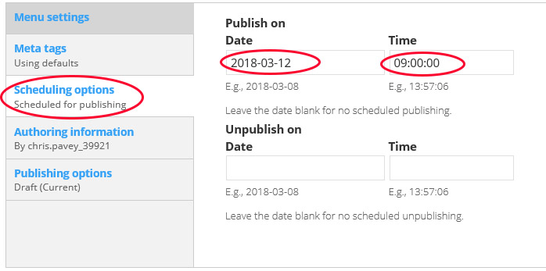

#### Unpublish (and publish a new version where applicable) on a future date

1. Select **Scheduling options** (not currently available for News story page).
2. Click into the **Unpublish on Date** field and select the date to unpublish the current version.
3. Click into the **Time** fied and type the time to unpublish.
4. Click into the **Publish this revision on Date** field and select the date to publish a new version (where applicable).
5. Click into the **Time** fied and type the time to publish a new version (where applicable).
6. Click **Save** to save your page or **Preview** to preview your new page.

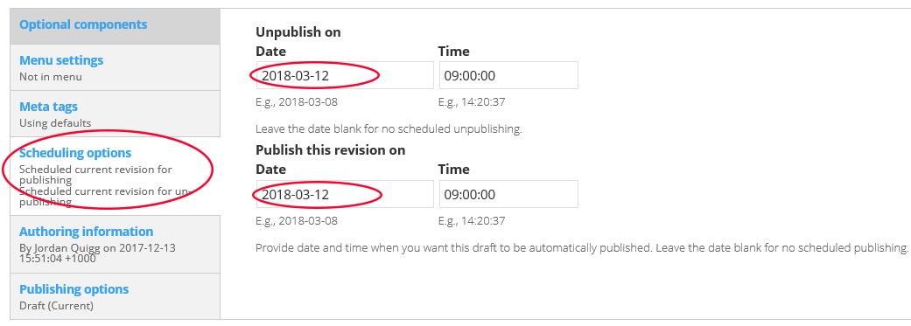

## Add/edit components within a page

### Add a paragraph type

Some pages such as News story and Standard page have text fields built into their templates to complete. However, they also have additional pararaph types that can be added under **Optional componenets**, and customised to particula agencies. Other page types, such as the Product page don’t have these text fields built in, and require you to add paragraphs to build the page.

There are 6 paragraph types to choose from:

1. FAQ embed—used to associate FAQs with product pages.
2. Feature list group—used to create features and benefits in product pages.
3. Forked content—used to customise content to agencies.
4. Generic markup—used for general content.
5. Product comparison group—used in outcome pages to compare products.
6. View—used to add downloadable documents search functionality (See the Customer Online team for implementation advice).

#### FAQ embed

Create the FAQ as you would a standard content page.

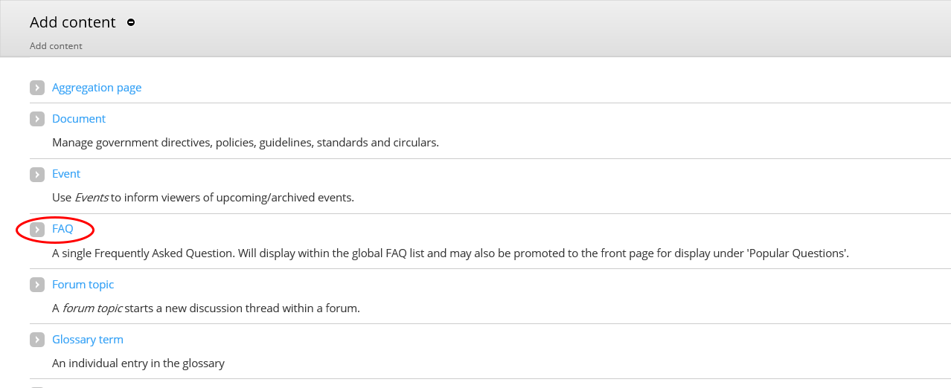

1. Click > **FAQ.**
2. Type the **Question**.
3. Type the **Answer.**
4. Type the name of the page you want the FAQ attached to in the **Associated pages field**.
   1. Add multiple pages by adding a comma and then add the additional pages.

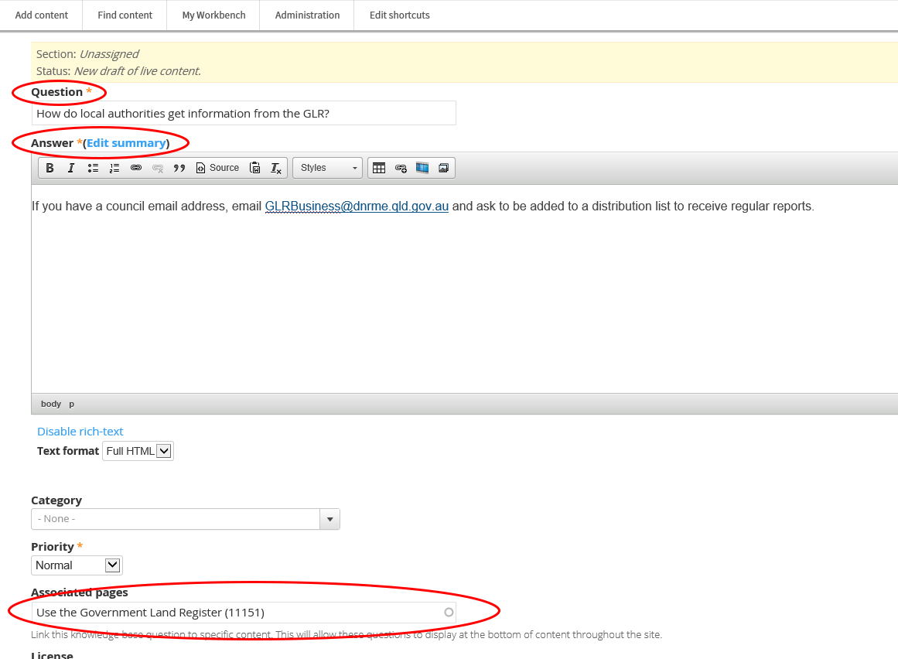

1. Select **Meta tags** and update the metadata for your new page as required:
   1. Add Keywords**.**
   2. Add **Creator** (your agency name) under **Dublin Core Basic Tags** > **Creator** in the **Value** field.



1. Select **Publishing options**:
   1. Select the appropriate **Review frequency** (3/6/12 months or Other) depending on the content’s volatility.
   2. Insert the **Review email** address of the team responsible for the page.
2. **Save** and check how it looks. If the page displays correctly, **publish**.

If you’re creating or editing a product page and need to attach the FAQ to that page, see Add FAQs to the Contact and support tab.

If the page that the FAQ is attached to is already published and has FAQs on it, view the page and make sure your new FAQ appears in the list.

#### Create forked content

Forked content allows you to customise the information on a page to suit different agencies. You can choose to fork all content, or only certain elements of a page (for example an aside).

1. Select the **optional** **component** tab in left hand side menu.
2. Select **Optional** **component** **type**.
3. Select Forked content > **Add new Optional component** or **Add another Optional component**.

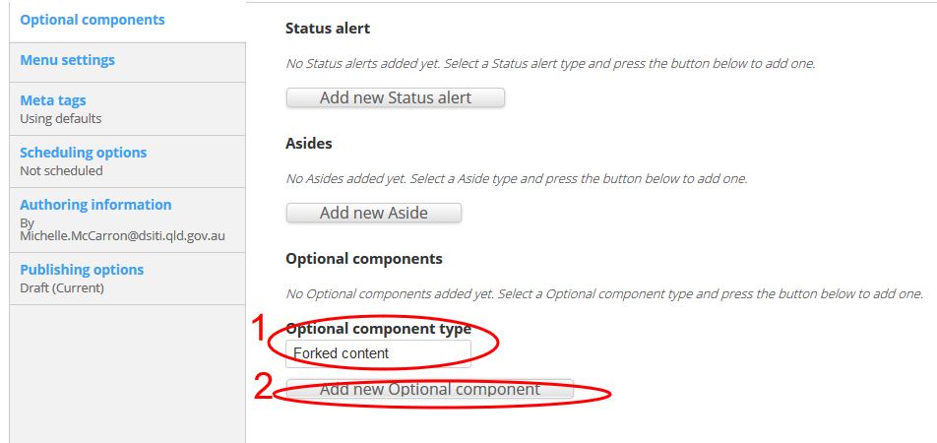

1. Select > **Add new Fork**.

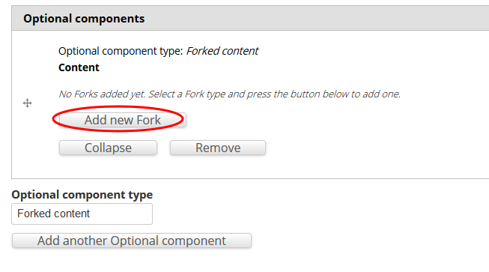

1. Type content in the **content** field.
2. Select the agencies that should view the new content. Leave blank if the content applies to all.

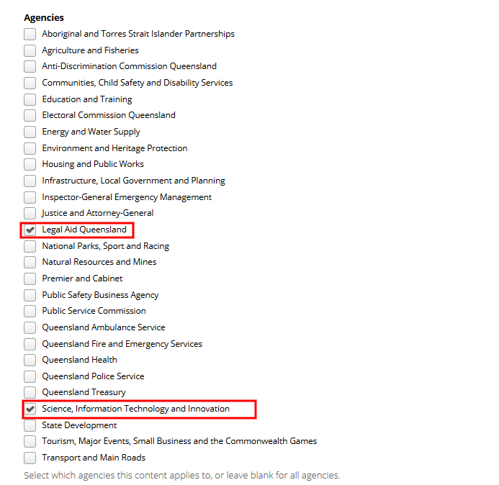

1. Repeat these steps until content has been created for all agencies.

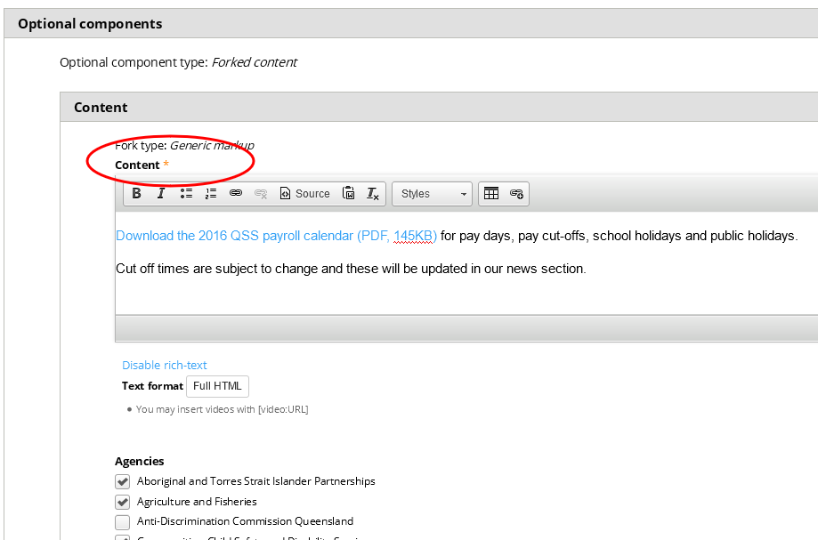

1. **Save** and check how it looks. If the page displays correctly, **publish**.

#### Add a generic paragraph

1. Choose **Paragraph** **type** > **Generic** **markup**.
2. Select > **Add new Paragraph**.
3. Type your text into the **Content** field.



1. Select the agencies that should view the new content. Leave blank if the content applies to all.



1. Repeat these steps until content has been created for all agencies.

### Cut and paste text into a content field

Cutting and pasting directly from Microsoft Word can result in unnecessary Microsoft formatting code being copied over into Drupal. You can use Notepad to clean text or use *www.html-cleaner.com* to clean HTML.

#### Cleaning Word text in Notepad

(to remove unnecessary Microsoft Word formatting)

1. Highlight text in word document.
2. Copy text (Ctrl + C) from the Word document.
3. Open Notepad.
4. Paste (Ctrl + V) into Notepad.
5. Select text in Notepad.
6. Copy text (Ctrl + C) from Notepad.
7. Paste (Ctrl + V) into the content section in Drupal.

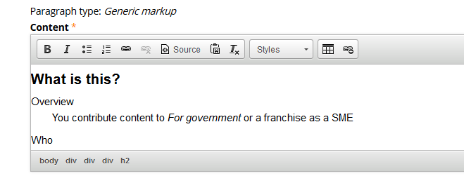

#### Cleaning Word text using www.html-cleaner.com

1. Highlight text in the Word document.
2. Copy text (Ctrl + C) from the Word document.
3. Go to [www.html-cleaner.com](http://www.html-cleaner.com/).
4. Set up cleaning preferences (use default).

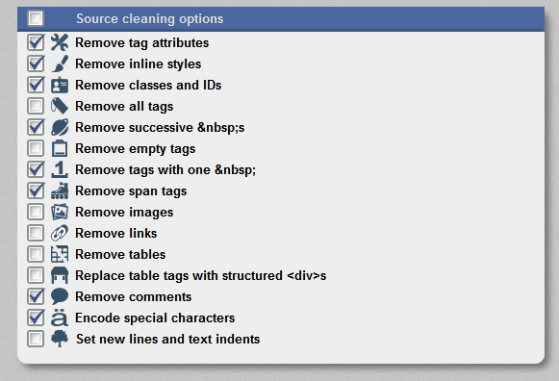

1. Paste text into html-cleaner (Either side—if a change is made to one side the other side will be updated).

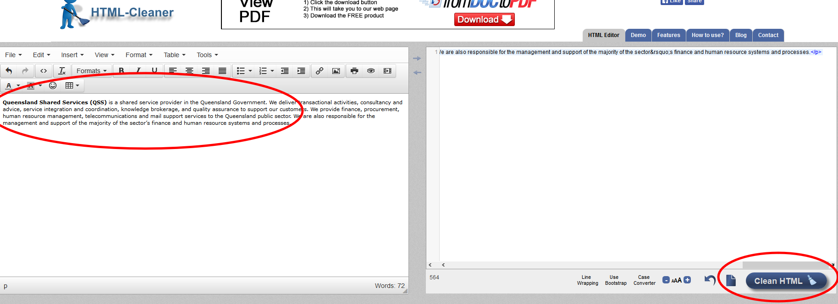

1. Select **Clean** **HTML** (this will clean any unnecessary Word formatting from text).
2. Copy and paste clean text into Drupal and the correct formatting should be retained (headings, bolding, etc).

### Add styling to text

1. Highlight the text.
2. Select an option from the content toolbar:
   1. B—Bold
   2. I—Italics
   3. Unordered list—Insert or remove bullet points
   4. Ordered list—Insert or remove numbered bullet points
   5. Numerical point— Insert or remove numbered list
   6. Heading 2— Select from the **Format** drop-down list.
   7. Heading 3—Select from the **Format** drop-down list.
3. For more styling options:
   1. Select **Text** **format** > **Rich text** to change the Styles drop down to a **Format** drop-down list.
   2. Select the format required from the **Styles** drop-down menu.

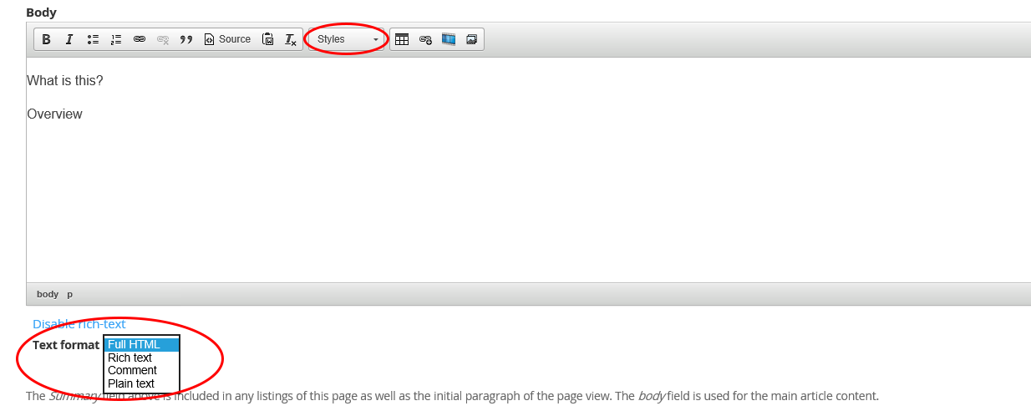

### Add links to text

1. Highlight the text.
2. Select the **link** icon.

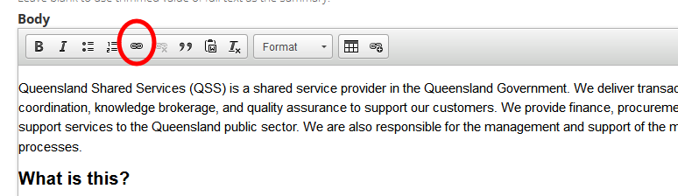

1. Under link info > choose the **Link** **type**:
   1. URL—web address.
   2. Email—email address.
   3. Link to anchor in text—linking within the page.
   4. Other—modal URL or page element (div) ID.
2. Enter the link target information.
3. Click **OK**.

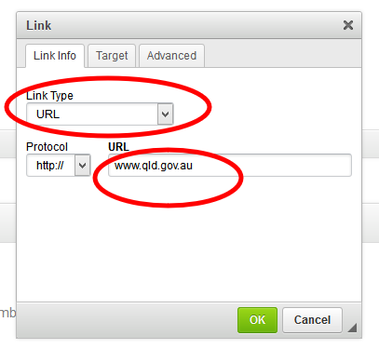

### Add a lightbox link to another page

Links can be styled as a lightbox to open content from another page while remaining on the current page. This is beneficial for web forms in particular, as you can show the user other information without losing the fields they have already completed.

1. Create a link in your content (as above). Under **Protocol**, select **other**. In the URL field, enter **/modal/** followed by the address of the page you want to show in the lightbox. Select **OK**.

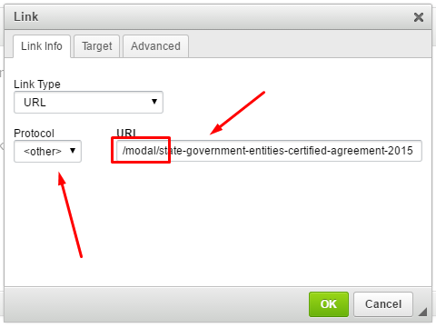

1. Highlight the link text. Click the **Styles** drop-down menu and select **Lightbox**.

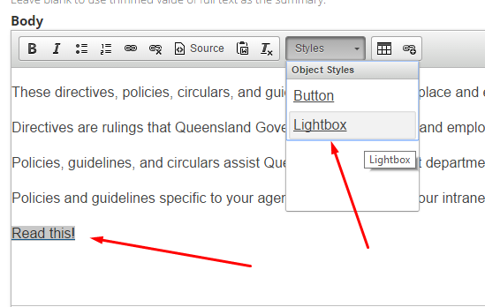

1. **Save** and check how it looks. If the page displays correctly, **publish**.

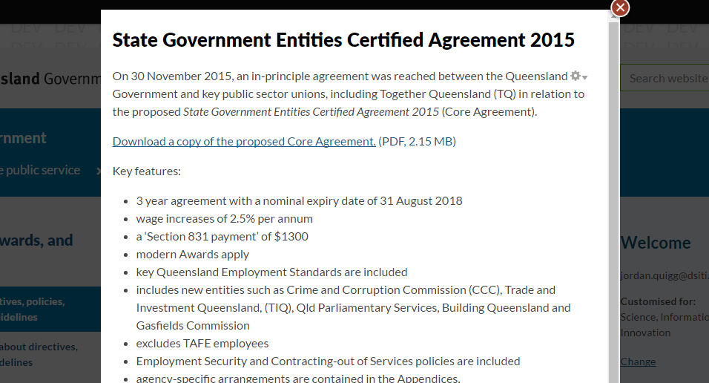

### Add a lightbox link to a page element

1. Inspect the element you want to show in the lightbox (right click and select **Inspect** **element**), and note the div ID.

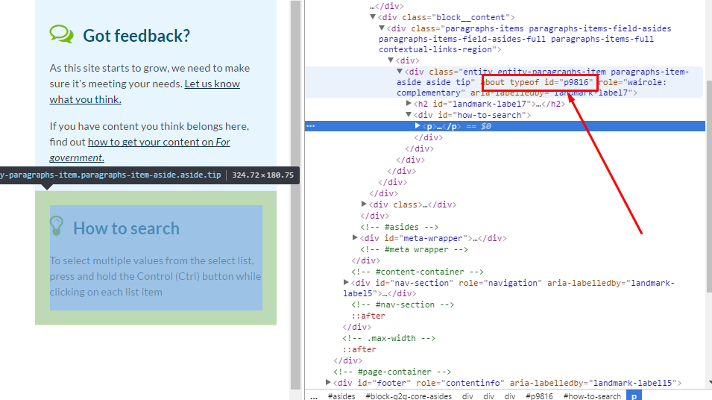

1. Create a link in your content (as above). Under **Protocol**, select **other**.
2. Enter the link target:
   1. If the element is on the same page, enter the hash symbol (#) followed by the target div ID.

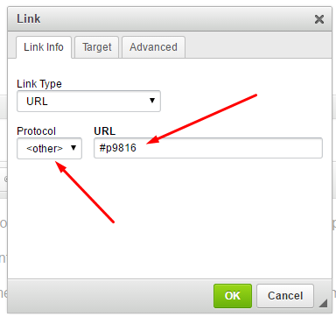

* 1. For an element from a different page, enter the page URL followed by ‘/#’ and the target div ID.

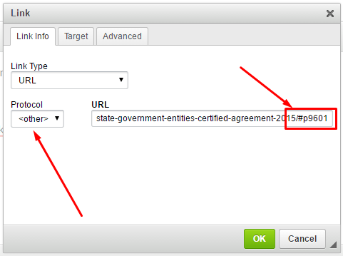

1. Click **OK**.
2. Highlight the link, click the **Styles** drop-down menu and select **Lightbox**.
3. **Save** and check how it looks. If the page displays correctly, **publish**.

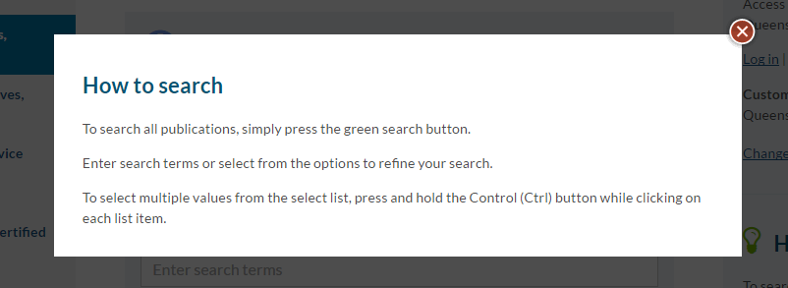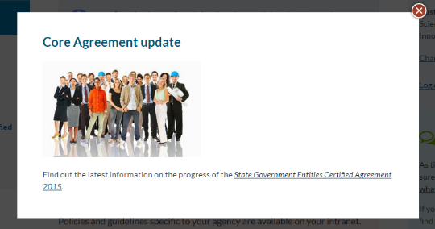

### Add a lightbox link to an image

Links can be styled as a lightbox to display a large image while remaining on the current page. This is beneficial for large images that will extend your content too far down a page if you included them in the body.

1. Add an image via the CMS
2. Insert and then highlight the text or image you want to create a lightbox link from.
3. Select the **link** icon.
4. Under **Protocol**, select **other**. In the URL field, enter **/sites/default/files/** followed by image file name (e.g. example-alert-message.png). Select **OK**.

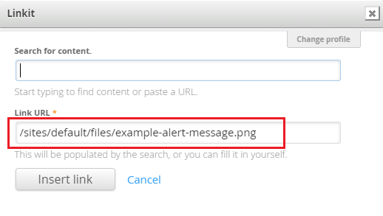

1. Highlight the link text or image. Click the **Styles** drop-down menu and select **Lightbox**.
2. **Save** and check how it looks. If the page displays correctly, **publish**.

### Add a link to content located on Drupal

1. Highlight the text.
2. Select the **link** **to** **content** icon.

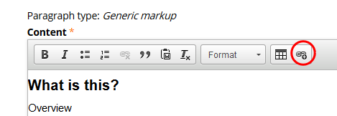

1. A **Linkit** window will open up.

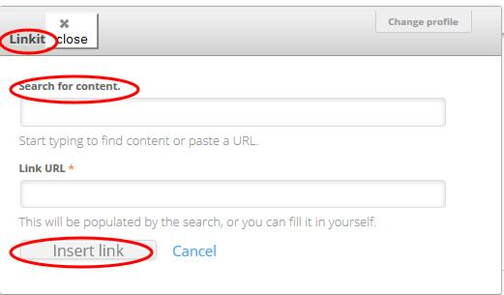

1. In **Search** **for** **content** field type the name of the page/document to link to.
2. The **Link** **URL** field will automatically be populated.
3. Select **Insert** **link**.
4. The link will be inserted into the highlighted text.

### Add a table of contents

You can insert a table of contents to improve navigation on long pages. This will reformat your page by:

* Inserting a numbered list in the body and left navigation, with links to all **Heading 2**s on your page.
* Numbering all **Heading 2**s within your page.
* Collapsing text between **Heading 2**s (fade out over 4 lines) and adding a **Read more** link.

1. Add the text **[TOC title]** to the body at the point where you would like the table of contents located.
   1. Replace **title** with a heading for your table of contents.

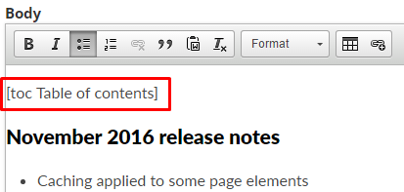

1. **Save** and check how it looks. If the page displays correctly, **publish**.

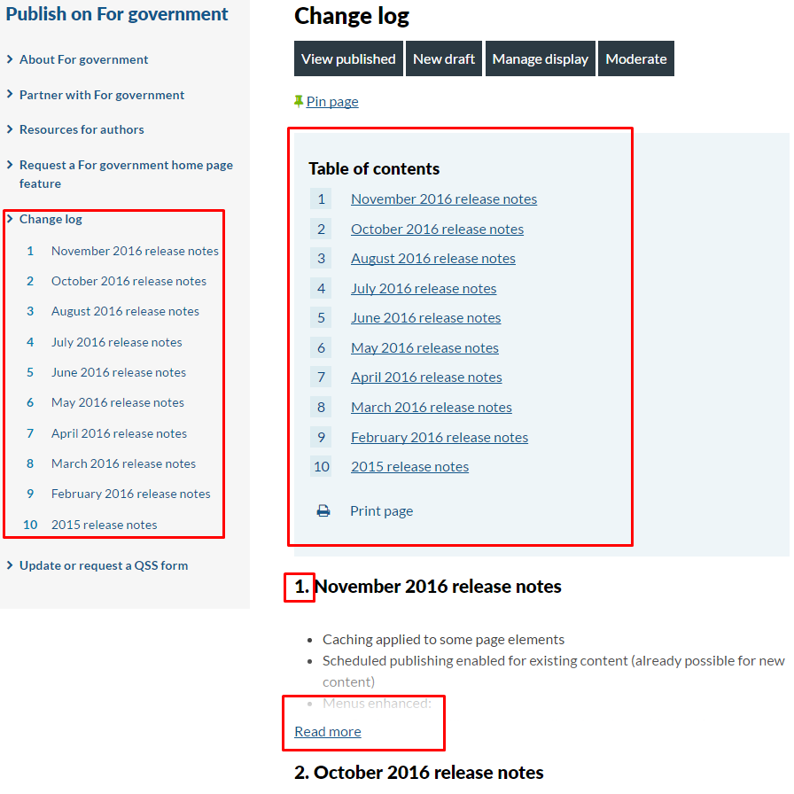

### Add a Pull quote

1. Highlight the quote.
2. Click the **quote** icon.
3. Click the **Styles** drop down and click **Pull quote**.

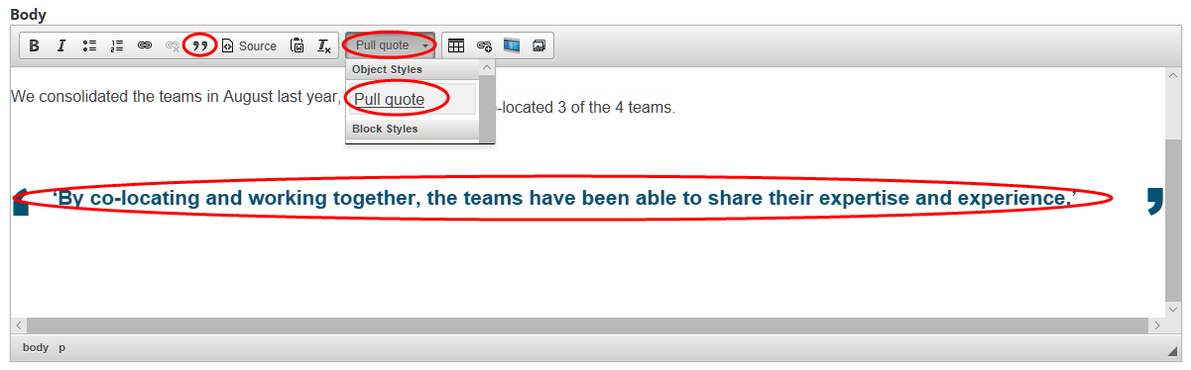

1. Add the quote’s attribute:
   1. Click **Source**.
   2. Find the html for the quote <blockquote class=”pull-quote”>quote here…</blockquote>.
   3. Before <blockquote class=”pull-quote”> add the html <div class=”figure”>.
   4. After </blockquote> add the html <div class=”figcaption”>attributate here…</div></div>
   5. Click **Source** to return to text-view.

### Insert an image

There are 2 ways to insert an image into the body of your content:

* Small image: Add through the image button. You can align this image left or write with text wrapped around it.
* Large image: Add through the Source button. You can resize this image and align it as needed to the page, but you can’t wrap text around it.

#### Small image

1. When editing a page, place the cursor where you would like to insert your image—place it on its own line.
2. Select the **Add media** icon.

A screenshot of a cell phone

Description generated with very high confidence

1. Select your image by:
   * **Upload**—Browse and upload the image. Choose **Public local files served by the webserver**. Edit the name (if required). Add **Alt Text** and **Title Text**.
   * **Web**—Type the File URL. Choose **Public local files served by the webserver**. Edit the name (if required). Add **Alt Text** and **Title Text**.
   * **Library**—Search for the image using the file name.
2. Click **Submit**.
3. To wrap the text, highlight the image and select the **Styles** dropdown and click:
   * **Image cut-in right—**Aligns the image to the right with text wrapping to the left
   * **Image cut-in left**—Aligns the image to the left with text wrapping to the right.

**Note:** If you want to change your image from one position to the other, you will need to click the **Source** button and manually remove the code before applying the new position.

#### Large image

1. When editing a page, place the cursor where you would like to insert your image—place it on its own line.
2. Select the **Link to content** button.

A screenshot of a cell phone

Description generated with very high confidence

1. Search for your content using the title of the image. Select it when it displays.

**Note:** You’ll need to have uploaded the image to the CMS before searching for it.

1. Click **Insert link**.
2. Click the **Source** button.
3. Find the hyperlink you’ve just created in the source code:

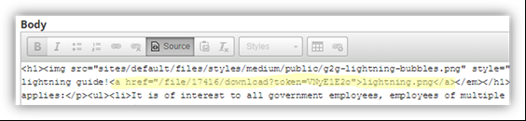

1. Change the **<a href>** element to **<img src>**. Delete the image name and the **</a>** element.

**Example**

Original:<p><a href="/file/17416/download?token=VNyE1E2o">lightning.png</a></p>

Updated:<p><img src="/file/17416/download?token=VNyE1E2o”></p>

1. To adjust the size of your image and alignment, type the **style** attribute and add, **height**, **width** and/or **align**.

**Example**

<p><img src="/file/17416/download?token=VNyE1E2o” style="width:100%;algin:centre;”></p>

### Embed a video

You can embed videos on the following page types:

* Standard page
* Event page
* Knowledge sharing group page
* Project page
* News page

1. **Upload** your video on a separate hosting platform (such as *YouTube* or *Vimeo*).  
   **Note:** **Do not** upload your video file to the *For government* CMS.
2. When editing a page, place the cursor where you would like to insert your image—place it on its own line.
3. Select the **Video filter** button.

A screenshot of a cell phone

Description generated with very high confidence

1. Copy and paste the video URL into the **Video URL** field.
2. Click **Insert**.

#### Add a video transcript

1. **Place the cursor** after the video and click the **Source** button.

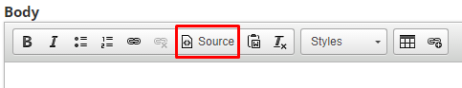

1. **Insert** the following code snippet beneath the video, where you want the show/hide transcript to appear:

<div class="video-transcript">

**[Insert video transcript text]**

</div>

1. **Save** the page and check how it looks. If the page displays correctly, **publish**.

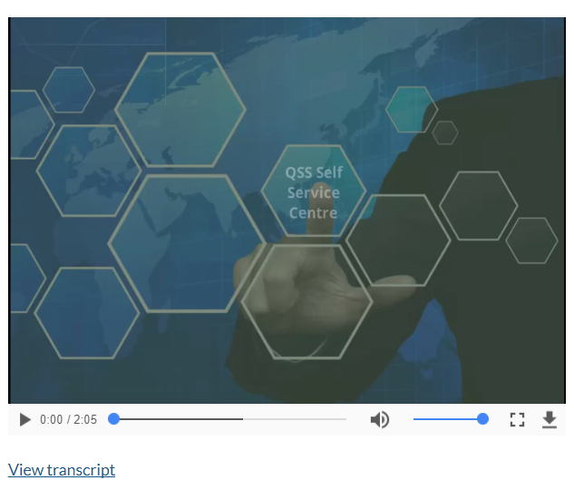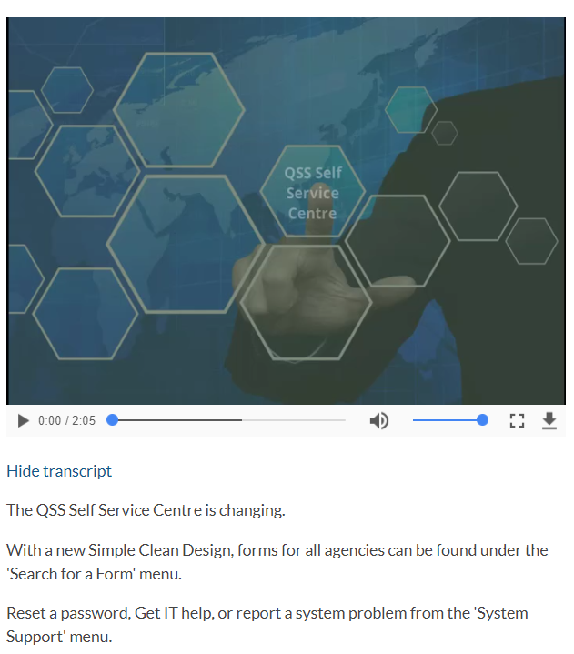

### Create a Status alert (warning or information)

1. Select > **New** **draft** to edit the content page.
2. Scroll down to the **Status** **alert** section.
3. Select > **Add new Status alert**.

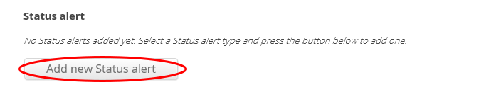

1. In the **Status** **alert** section:
   1. Add a **title**.
   2. Add your content into the **body**.

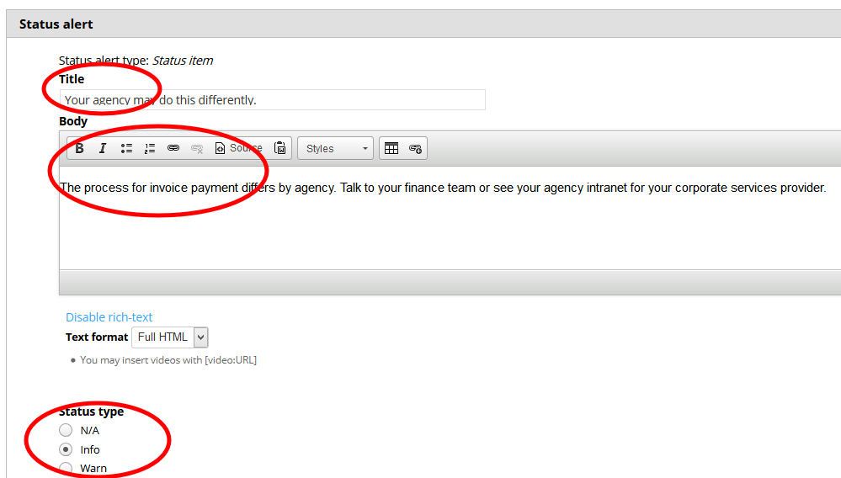

1. Select the **Status** **type**:
   1. Info—Information that may be helpful to the visitor.
   2. Warn—Warning the visitor of something they need to do or be aware of before continuing.



1. **Save** and check how it looks. If the page displays correctly, **publish**.

### Create Asides

Asides are content located on the right hand side of a standard content page. They should contain content that is secondary to the main body content on the page.

1. Select the **optional component** tab in left hand side menu.
2. Select **Add new Aside**, **Add another Aside** or **Edit** existing aside.

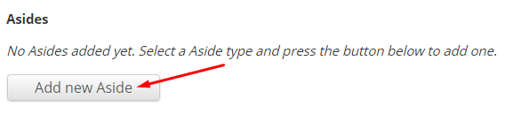

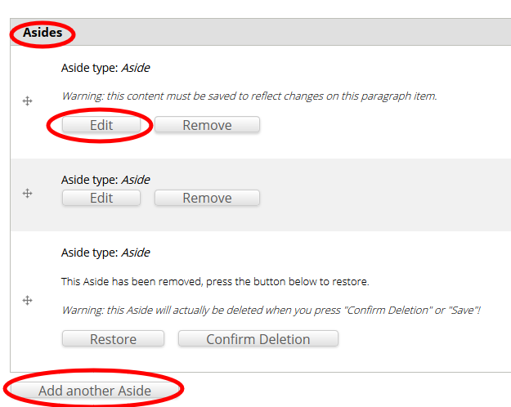

1. Add a **Title**.
2. Choose an **Aside** **style** from the drop-down menu:
   1. Default—suitable for most types of aside content (most common).
   2. Contact—only used for phone numbers, email addresses or physical addresses.
   3. Emergency contact—for emergency contact details only (000, SES).
   4. Tip—Useful (but not critical) information that may help a visitor.
   5. Events—for highlighting names and dates of events.
   6. Feedback—a way for a visitor to provide feedback to a business area.
   7. Sponsors—for highlighting third party sponsors.
   8. Beta—for indicating that a feature is in beta-testing mode.
3. Enter aside content.

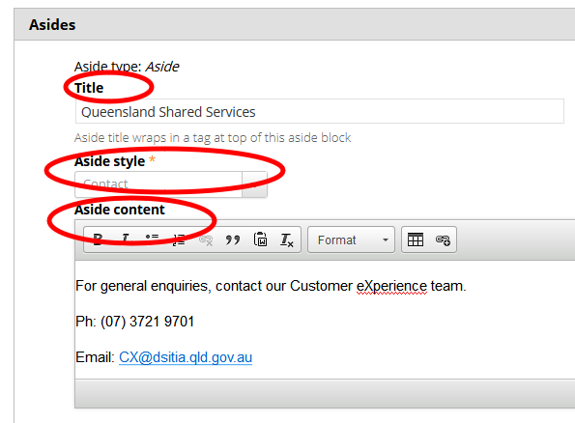

1. **Save** and check how it looks. If the page displays correctly, **publish**.

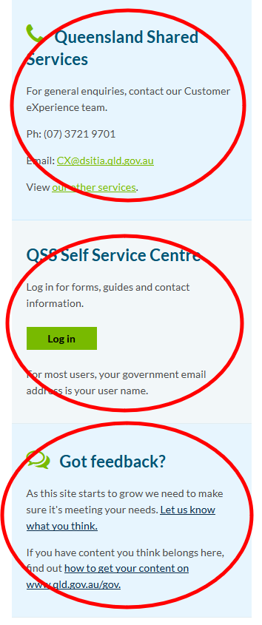

#### Create a Google Maps aside

1. Open [Google Maps](https://www.google.com.au/maps/).
2. Go to the address.
3. In the top left, click Menu .
4. Click **Share or embed map**.  
     
   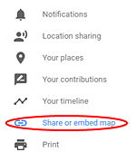
5. Click **Embed a map**.
6. To the left of the text box, click the Down arrow and select **Custom size**.

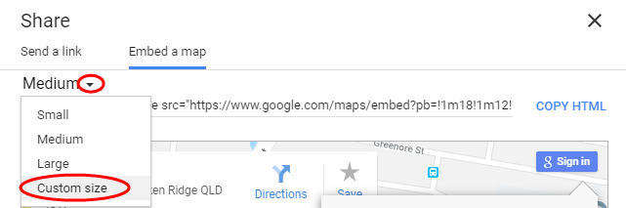

1. Enter 285 x 285 in the dimensions boxes
2. Copy the HTML provided and paste it into the aside. (Remember to change the aside text format to ‘Full HTML’ as you’ll need to paste it in ‘source’ view).

The code will look something like:  
  
<iframe src="<https://www.google.com/maps/embed?pb=!1m18!1m12!1m3!1d3539.9044078468046!2d153.02599731584957!3d-27.472235223389852!2m3!1f0!2f0!3f0!3m2!1i1024!2i768!4f13.1!3m3!1m2!1s0x6b915a1b1fd2fd07%3A0x95d1e60f49ab2d39!2s53+Albert+St%2C+Brisbane+City+QLD+4000!5e0!3m2!1sen!2sau!4v1527127426820>" width="285" height="285" frameborder="0" style="border:0" allowfullscreen></iframe>

#### Create a Feature slider aside

You can add a Feature slider aside to a Section page.

1. Select **Asides** from the menu.
2. Click **Add new Slider**.

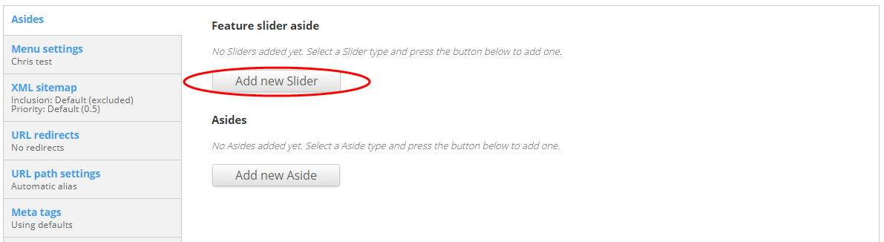

1. Add a meaningful **Title** for the aside **Feature.**
2. Click **Add new Slider item**.
3. Add a meaningful **Title** for the Slider item.
4. Add a **Summary** for the Slider item.
5. Click **Browse** to add an image. **Choose a File** and **Upload** an image, or select an existing image from the Library.
6. Add a link to the content the slider promotes (leave blank if there isn’t further content to link to).
7. Select the agencies the slider should be viewable to (leave blank if it should be seen by everyone).
8. Add additional sliders as required.
9. Select the agencies the aside should be viewable to (leave blank if it should be seen by everyone).
10. **Save** and check how it looks. If the page displays correctly, **publish**.

### Create a process flow diagram

You can use process flow diagrams to display high-level steps for undertaking a task or set of tasks. These are most effective on ‘Outcome’ pages.

1. **Edit** the content page.
2. Scroll down to the **Body** field.
3. Insert H2 ‘Process overview’.
4. Create an **ordered** **list** using the tool bar.
5. To add a sub-step use an **unordered** **list** between the main numbered lists.
6. End on a numerical ordered list.

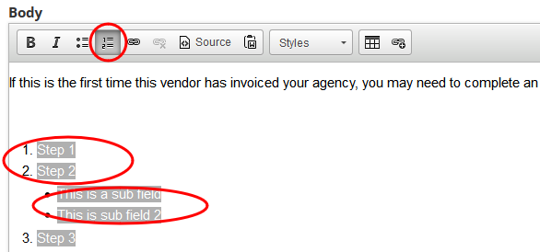

1. **Save** and check how it looks. If the page displays correctly, **publish**.

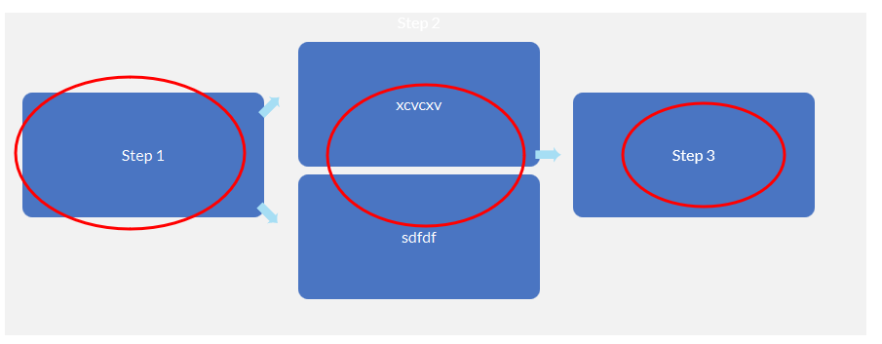

## Upload a file or image

1. 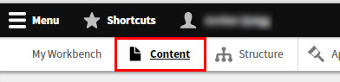In the CMS menu, open the **Content** list, then select the **Files** tab.
2. Click the **Add file** button.

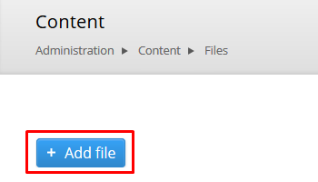

1. To upload your file either:
   1. Click **Choose file** and **navigate** to the file location on your computer.
   2. **Drag and drop** the file into the box next to the Choose file button.

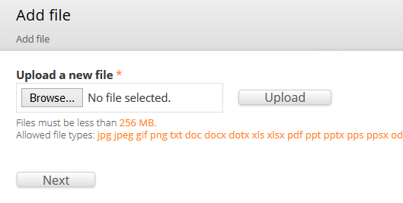

**Note:** Take note of the allowed file types (extensions) and maximum size.

1. Click **Upload** then/or **Next**.
2. Select whether the image will be **Public** or **Private** and click **Next**.

* If you are uploading a document or video, your file will appear at the top of the files list.
* If you are uploading an image, update the **Name**, **Alt text** and **Title text** for the image and click **Save**. Your image will appear at the top of the files list.

**Note:** You must enter Alt text for informative images (non-decorative).

## Logging out

To log out of Drupal:

1. Click your **Username** in the top Toolbar menu.
2. Click **Log** **out**.

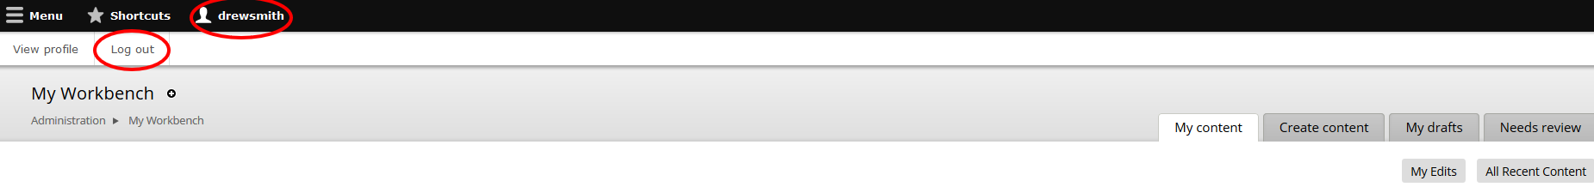

## Support

|  |
| --- |
| Drupal support |
| Contact the Customer Online team:  Ph: (07) 3035 4410  Email: [qsscxdesign@dsiti.qld.gov.au](mailto:qsscxdesign@dsiti.qld.gov.au) |