Architecture governance model

<Agency/Responsible entity>

Date

|  |  |
| --- | --- |
| Security classification |  |
| Owner |  |
| Contact details |  |
| Division/Unit |  |
| Document status |  |

Document history

|  |  |  |  |  |  |
| --- | --- | --- | --- | --- | --- |
| Version | Date | Status | Key changes | Author/s | Reviewer/s |
| 0.0.1 |  |  |  |  |  |
|  |  |  |  |  |  |

Endorsements

|  |  |  |  |
| --- | --- | --- | --- |
| Name | Position | Signature | Date |
|  |  |  |  |
|  |  |  |  |
|  |  |  |  |
|  |  |  |  |
|  |  |  |  |

Glossary

|  |  |
| --- | --- |
| Term | Definition |
| Architecture governance forum | A meeting in which architecture related issues are discussed. Forums will typically include the following:   * whole-of-government governance boards * agency governance boards * design authorities * working parties. |
| Architecture governance model | A model which defines an organisation's practice of monitoring and directing architecture-related work. The model may include the governance structure, bodies and reporting lines across an organisation.  Note: align with TOGAF Architecture Governance (TOGAF Chapter 44) as required. |
| Governance interaction | The lines of interaction between governance forums that define the channels and boundaries of decision making across an agency. Defined governance interactions ensure that issues can be brought to the appropriate level of responsibility for adequate resolution |

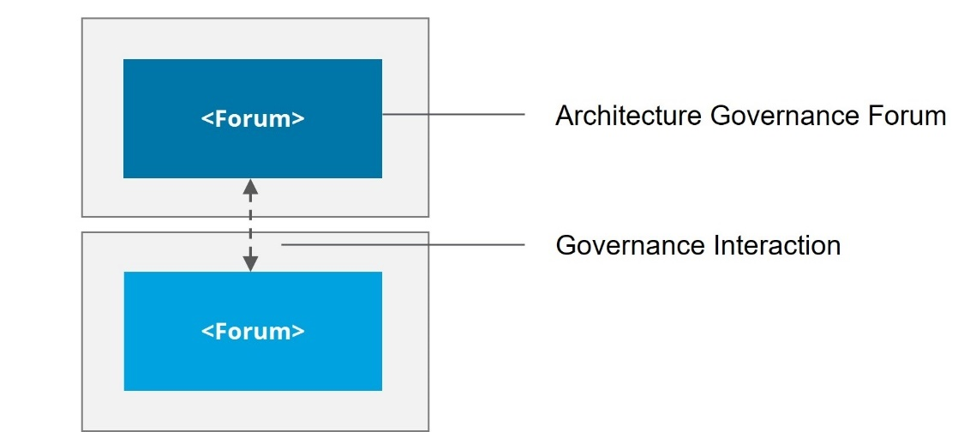

Architecture governance illustrative diagram

Table of Contents

1 Introduction 6

2 Model context and inputs 6

2.1 Agency enterprise architecture charter 6

3 Architecture governance model overview 6

3.1 Architecture governance model diagram 7

3.2 Architecture governance model diagram description 8

4 Forum descriptions 9

5 RACI matrix 10

5.1 RACI matrix - <Matrix responsibility area> 11

Template context – remove this section upon development of the artefact

**Artefact description**

An agency’s architecture governance model defines the agency's practice of monitoring and directing architecture-related work. The model may include the governance structure, bodies and reporting lines across an agency.

**Template purpose**

The purpose of this template is to:

* provide agencies with a centralised definition of what an architecture governance model is
* provide consistent artefact requirements for agencies to follow
* provide the template for agencies to efficiently develop an architecture governance model in a consistent format.

This template is intended to deliver on the purpose through the provision of the following artefact template. However, if an alternative file type/format better aligns with agency circumstances, the following artefact formats may also be employed, given they align with the content, glossary definitions and artefact format requirements outlined within this document:

* publication (e.g. PowerPoint, Word).

**Template instructions**

* This template includes instructional text to guide artefact content. Such text is either enclosed within angled brackets (</>) and/or greyed out. Upon artefact development, this text should be removed and replaced with text specific to the agency context.
* Any **red** text or shapes indicate template elements or sections to be removed upon artefact development.

# Introduction

< The purpose of this section is to introduce the architecture governance model and provide a high-level overview of the subsequent artefact sections.

This section should include:

* a high-level overview of the agency architecture governance model
* a high-level overview of this document sections:

Model context and inputs

Architecture governance model glossary

Architecture governance model overview

Forum descriptions

RACI matrices. >

# Model context and inputs

<The purpose of this section is to provide context around the agency architecture governance model and the agency documents (e.g., artefacts, strategies, plans) that have been leveraged to inform the model.

This section should include:

* an overview of the architecture governance model context within the agency
* any agency documents that have been leveraged to inform the model.

Additional input sections may be added below where required and the section may expand across multiple pages where required. The input section/s outlined below act as a guide to the inputs which may be discussed, however, do not act as mandatory content headings. >

## Agency enterprise architecture charter

<This section should outline how the agency artefact has been leveraged or aligned to throughout development of the architecture governance model, including:

* the nature by which the artefact has been leveraged to inform the model
* how the model has been informed by the artefact. >

# Architecture governance model overview

< This section should include an overview of the architecture governance model diagram.

This section should include an overview of the architecture governance model diagram section (i.e., architecture governance model diagram and diagram description).>

## Architecture governance model diagram

< This section should include the architecture governance model diagram. The partial format example/template and associated guide below may be leveraged to develop the artefact and deleted from the artefact file afterwards.>

Architecture governance model diagram guide – Remove upon development of the artefact

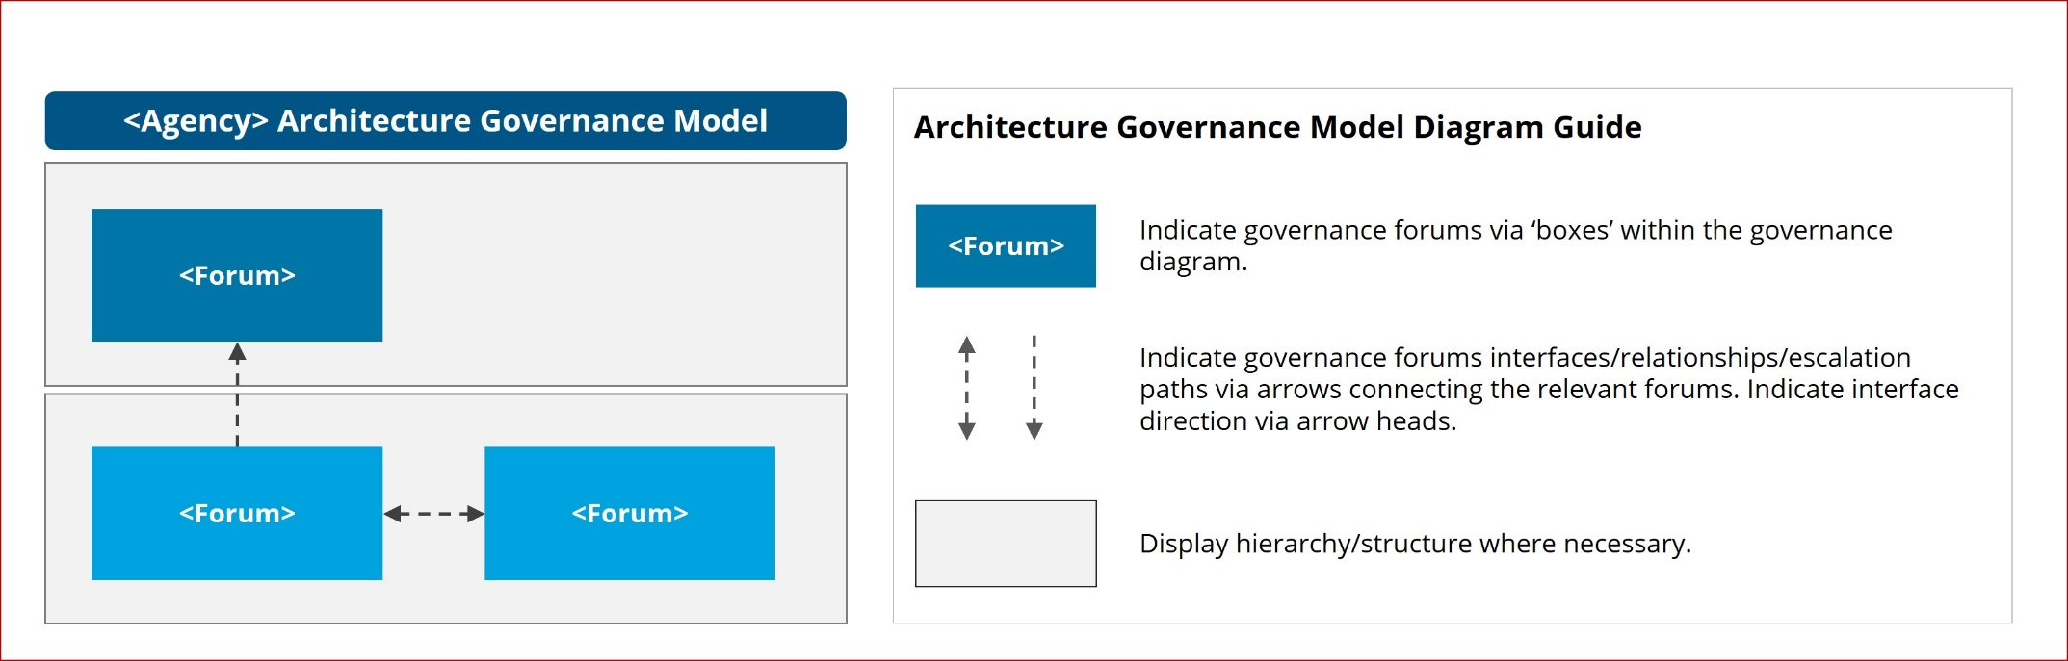

## Architecture governance model diagram description

<This section should include a high-level description of the agency’s architecture governance model and its construction.

This section should include:

* high-level description of the architecture governance model diagram
* a description of the diagram construction (i.e., governance forums, interactions etc.). >

# Forum descriptions

|  |  |  |  |  |
| --- | --- | --- | --- | --- |
| Forum | Forum description | Forum interactions | Membership | Cadence |
| *<A1 Forum>* | *< Description of governance forum and its primary purpose/s>* | *< Description of the nature of relationships with other governance forums (i.e. escalation paths)…>* | *< Outline forum membership >* | *<Outline forum cadence>* |
| *<A2 Forum>* |  |  |  |  |
|  |  |  |  |  |
|  |  |  |  |  |

# RACI matrix

<The purpose of this section is to outline the input and decision rights of each governance forum in terms of associated responsibilities.

This section should include a RACI (responsible, accountable, consulted, informed) matrix for each set of key responsibilities across the agency.

There may be N number of matrices within this section depending on the number of responsibility areas within the agency. For example, a service or application grouping may form the focus of a matrix, with the specific headings being populated by the constituent services or applications.

The RACI matrix then provides the format for responsibility comparison with each governance forum, where a RACI level can then be applied to such forum-responsibility relationship.>

## RACI matrix - <Matrix responsibility area>

<Each matrix should be laid out as demonstrated on this page:

* all agency governance forums on the vertical axis
* areas of responsibility with regard to forum decision making along the horizontal axis (within the defined matrix responsibility area/domain)
* RACI key
* intersection boxes where description around forum/activity relationship (i.e. input and decision rights) can be entered.>

|  |  |  |  |  |
| --- | --- | --- | --- | --- |
| Forum | <Responsibility 1> | <Responsibility 2> | <Responsibility 3> | <Responsibility 4> |
| <A1 forum> | *Identify the RACI level applicable to each forum and outline the decision and input remits of the forum – as they relate to the respective responsibility* |  |  |  |
| <A2 forum> |  |  |  |  |
| <A3 forum> |  |  |  |  |
| <A4 forum> |  |  |  |  |



Artefact Examples – Remove section upon artefact development

TOGAF – Architecture Governance Framework – Organisational Structure (Architecture Governance Model diagram aligned)

The TOGAF Architecture Governance Framework – Organisational Structure illustrates an architecture organisation and the major structural elements required for an architecture governance initiative. The diagram may be leveraged to inform agency Architecture Governance Model structure at a high-level but should be tailored to the unique agency context and governance structure.

