ICT Industry Engagement Framework
ICT Strategic Sourcing
March 2016 / Version 1.2
PUBLIC

Document details
Security classification | PUBLIC
Date of review of security classification | March 2016
Authority | Director, ICT Strategic Sourcing
Author | Department of Science, Information Technology and Innovation
Documentation status |  | Working draft |  | Consultation release | ☑ | Final version

Contact for enquiries and proposed changes
All enquiries regarding this document should be directed in the first instance to:
Michael Stoopman
ICT Strategic Sourcing, Department of Science, Information Technology and Innovation
ICTStrategicSourcing@dsiti.qld.gov.au
Acknowledgements
The initial version of the ICT Industry Engagement Framework was developed and updated by Department of Public Works.
Feedback was also received from a number of agencies and the ICT Industry Associations, which was greatly appreciated.
Copyright
ICT Industry Engagement Framework
Copyright © The State of Queensland (Department of Public Works) 2011
Licence
Creative Commons Licence to be added to document prior to approval.
Information security
This document has been security classified using the Queensland Government Information Security Classification Framework (QGISCF) as PUBLIC and will be managed according to the requirements of the QGISCF.

Table of contents
1 Introduction 4
1.1 Purpose 4
1.2 Audience 4
1.3 Scope 4
2 Background 4
3 ICT Industry Engagement Framework 4
3.1 Introduction 4
3.2 Common concepts 6
3.3 Informal Industry Engagement 6
3.4 Industry Engagement - Project Procurement 7
3.5 How to use the industry engagement framework 8

1 Introduction

1.1 Purpose
The ICT Industry Engagement Framework was designed to assist Government agencies when engaging with the members of the ICT Industry. It also outlines the current division of industry engagement responsibilities of the Department of Science, Information Technology and Innovation (DSITI).

1.2 Audience
This document is primarily intended for departmental staff involved in interacting with vendors of the ICT Industry.

1.3 Scope
This document will be of value to all departments and the ICT vendor community.

2 Background
The Queensland Government through its ICT Strategy 2013-17 document outlines the Queensland Government’s information and communication technology priorities and targets to help create more accessible, efficient, and effective services for the benefit of all Queenslanders.

3 ICT Industry Engagement Framework

3.1 Introduction
At the conceptual level the framework consist of the two key elements as indicated in diagram 1 below. The outer circle which represents the informal categories of engagement between the industry and government and an inner diagram which represents the formal process of industry engagement within a project procurement process.

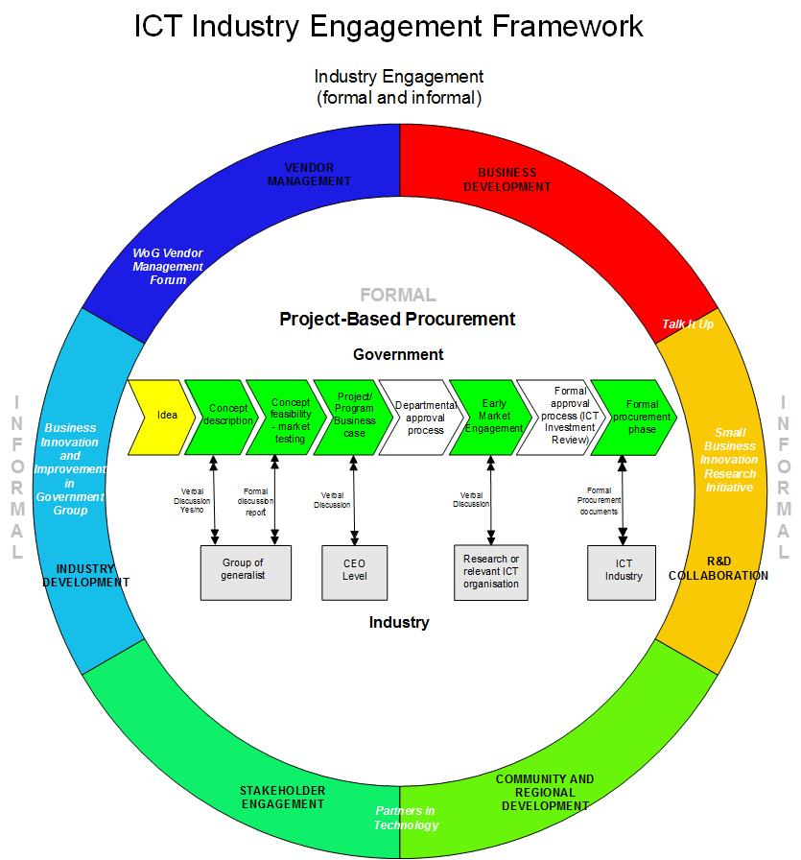

Figure 1 ICT Industry Engagement Framework

3.2 Common concepts
Within the framework there are concepts that apply to both engagement elements. One fundamental concept is common engagement behaviours and beliefs for both government and the ICT vendor community. To help foster this common understanding, an agreed set of principles have been created and jointly endorsed by both the Queensland Government and many of the industry associations on 23 July 2010. The Principles of Engagement have been enhanced by a set of guidelines which are available under Information Standard 13 (IS13): ICT Procurement.

3.3 Informal Industry Engagement
This element of the framework is constructed in a circle to indicate that more than one component could be used at any time in dealings between government and the ICT industry and to permit the inclusion of further categories in the future. Each of the components of the circle is owned by DSITI. The ICT Strategic Sourcing division of DSITI has responsibility for many whole of Government policy or guidelines that relate to the ICT Industry as shown in the categories below:
- Business Development
- Research and Development Collaboration
- Community and Regional Development
- Vendor Management
- Industry Development
- Stakeholder Engagement

3.3.1 Business Development
This category is about how government can support and develop individual businesses. DSITI offer several government services and information about commercial business organisations that support the development of ICT businesses.

3.3.2 Research and Development Collaboration
This category includes how government and industry engage and support each other in research and development.

3.3.3 Community and Regional Development
The scope of this engagement category is around geographical capabilities. This type of engagement varies from rural communities which are typically driven by government who are looking to stimulate their economies to exporting to the pacific region which is driven by ICT vendors wishing to expand their market position.

3.3.4 Vendor Management
This category represents the specific relationship between government or individual departments and a vendor. This is separate to contract management which is part of the formal engagement element.

3.3.5 Industry Development
This is focused on the opportunity to improve the relationship between government and the ICT industry as a whole. Under this category are joint initiatives like the ICT SME Participation Scheme and the Chamber of Commerce and Industry Queensland (CCIQ) QAssure. This category of engagement also includes the relationship between the government and the individual ICT Industry Associations like the Australian Computer Society and CCIQ to name a few. These are long term relationships focused on common strategic activities.

3.3.6 Stakeholder Engagement
This category includes guidelines and processes used to create greater understanding of the purpose of an engagement between government and the ICT industry. It covers communications at a high level and so does not focus on the specifics of departmental oral/written communications standards.

3.4 Industry Engagement - Project Procurement
Within the centre of the diagram is a representation of the formal and structured process of engaging with the ICT Industry. It aligns with the procurement process as outlined in the Government Enterprise Architecture IS13 plus its relationship to the project, program and portfolio methodology.

IS13 covers the complete lifecycle from concept to retirement and disposal. The diagram represents this by indicating the beginning of the process at the idea stage and moving from left to right through a series of separate stages to finish in the formal contract execution. Each of these stages are described in detail in the documentation in IS13. At a procedural level this standard is designed to apply to large scale projects however with the removal of the appropriate steps it can equally be apply to any ICT industry engagement for the procurement of ICT goods and services.

The following details each stage of the process.

3.4.1 Concept description
The concept description stage provides an opportunity for a verbal discussion to take place to describe the proposed concept and gain a level of endorsement to proceed.

3.4.2 Concept Feasibility
To assist the agencies to prepare for the concept feasibility stage, a list of questions have been created. The list starts with concept questions so that agencies can articulate their problems clearly at the first stage:
- What is your core business?
- What is the business problem?
- What is your goal in solving this problem (benefits reporting, customer relations, cost savings)?
- Are you solving a current problem or an anticipated problem?
- Are you planning to extend services or just make existing services more efficient?
- What are your internal and your customers’ future needs?
- Do you think you have special needs? If so, why?
- What existing tools or processes do you currently use to solve this problem?

3.4.3 Project/Program Business Case
The Project/Program Business case provides the substantiation for the Project. It enables the governing body to make an informed decision on whether to continue investing in the project and to give it a level of priority. The development of a business case enables the business to clearly document the business requirements.

3.4.4 Early Market Engagement
From the Queensland Government’s perspective, early engagement with ICT suppliers is an important step in the process. Early engagement, within the bounds of probity, ensures that the buyer makes a fully informed decision so that the right supplier is chosen to provide the right service while maximising buying power and minimising risk. For further information refer to the Better Practice Guide for Early Market Engagement with the ICT Industry.

3.4.5 Formal Approval Process
This stage is described in detail in the documentation in IS13.

3.5 How to use the industry engagement framework
If the framework has never been used then the Principles of Engagement guideline should be read as a first step. If the reader is looking to perform a procurement process then the middle element of the framework applies and IS13: ICT Procurement should be understood and implemented. If however the reader is engaging with the ICT Industry but not intending to procure then the outer circle applied and the category(s) of engagement should be determined and that specific area reviewed and executed.

