Applications roadmap

<Agency/Responsible entity>

Date

|  |  |
| --- | --- |
| Security classification |  |
| Owner |  |
| Contact details |  |
| Division/Unit |  |
| Document status |  |

Document history

|  |  |  |  |  |  |
| --- | --- | --- | --- | --- | --- |
| Version | Date | Status | Key changes | Author/s | Reviewer/s |
| 0.0.1 |  |  |  |  |  |
|  |  |  |  |  |  |

Endorsements

|  |  |  |  |
| --- | --- | --- | --- |
| Name | Position | Signature | Date |
|  |  |  |  |
|  |  |  |  |
|  |  |  |  |
|  |  |  |  |
|  |  |  |  |

Glossary

|  |  |
| --- | --- |
| Term | Definition |
| Applications roadmap | A timeline view of the planned incremental steps taken toward evolving a current application or migrating a suite of applications to a future state suite. |
| Application group | Represents the highest level of application category in the agency (as per agency Conceptual Application Architecture), identified with a label (e.g. A). |
| Contract/licence renewal | Key application contract or license renewal dates. |
| Expected application obsolescence | The expected date of application obsolescence. |
| Others | Any other key dates associated with agency applications. |
| Phase 1: Plan | The phase of planning that must occur before an application is phased-in to the organisation. |
| Phase 2: Phase-in | The phase of gradual implementation of the application across a defined approach. |
| Phase 3: Active | The phase of intended application function and use. |
| Phase 4: Phase-out | The phase of gradual discontinuation of the application across a defined approach. |
| Phase 5: Decommission | The phase of application inactivity due to being identified as unfit for purpose. |
| Roadmap timeframe | The total time horizon over which an Applications Roadmap is displayed. |
| Roadmap increments | The time increments (periods) across which application lifecycles are displayed. Roadmap increment periods allow tracking against expected timeframes. |

Table of Contents

1 Introduction 6

2 Roadmap context and inputs 6

2.1 Conceptual application architecture 6

3 Applications roadmap overview 7

3.1 Applications roadmap diagram 8

3.2 Applications roadmap diagram description 9

4 Detailed application descriptions 10

Template context – remove this section upon development of the artefact

**Artefact description**

An agency’s applications roadmap is a timeline view of the planned incremental steps taken toward evolving a current application or migrating a suite of applications to a future state suite.

**Template purpose**

The purpose of this template is to:

* provide agencies with a centralised definition of what an applications roadmap is
* provide consistent artefact requirements for agencies to follow
* provide the template for agencies to efficiently develop an applications roadmap in a consistent format.

This template is intended to deliver on the purpose through the provision of the following artefact template. However, if an alternative file type/format better aligns with agency circumstances, the following artefact formats may also be employed, given they align with the content, glossary definitions and artefact format requirements outlined within this document:

* spreadsheet (e.g. Excel)
* diagram
* enterprise architecture tool.

**Template instructions**

* This template includes instructional text to guide artefact content. Such text is either enclosed within angled brackets (</>) and/or greyed out. Upon artefact development, this text should be removed and replaced with text specific to the agency context.
* Any **red** text or shapes indicate template elements or sections to be removed upon artefact development.

# Introduction

< The purpose of this section is to introduce the applications roadmap and provide a high-level overview of the subsequent artefact sections.

This section should include:

* a high-level overview of the agency applications roadmap.
* a high-level overview of this document sections:

Roadmap context and inputs

Applications roadmap glossary

Applications roadmap overview

Detailed application descriptions. >

# Roadmap context and inputs

< The purpose of this section is to provide context around the agency applications roadmap and the agency documents (e.g., artefacts, strategies, plans) that have been leveraged to inform the roadmap.

This section should include:

* an overview of the applications roadmap context within the agency
* any agency resources that have been leveraged to inform the roadmap.

Additional input sections may be added below where required and the section may expand across multiple pages where required. The input section/s outlined below act as a guide to the inputs which may be discussed, however, do not act as mandatory content headings. >

## Conceptual application architecture

<This section should outline how the agency artefact has been leveraged or aligned to throughout development of the applications roadmap, including:

* the nature by which the artefact has been leveraged to inform the roadmap.
* how the roadmap has been informed by the artefact. >

# Applications roadmap overview

< This section should include an overview of the applications roadmap diagram.

This section should include an overview of the applications roadmap diagram section (i.e., applications roadmap diagram and diagram description). >

## Applications roadmap diagram

< This diagram should depict the entire suite of existing and future agency applications, against the defined roadmap time horizon. Coloured bars should be used in line with a defined key to depict application lifecycle across the defined phases. Key milestones should be depicted where required across an application lifecycle to show key milestone occurrences. Any milestones or phases added to the roadmap must be defined in the roadmap key.>

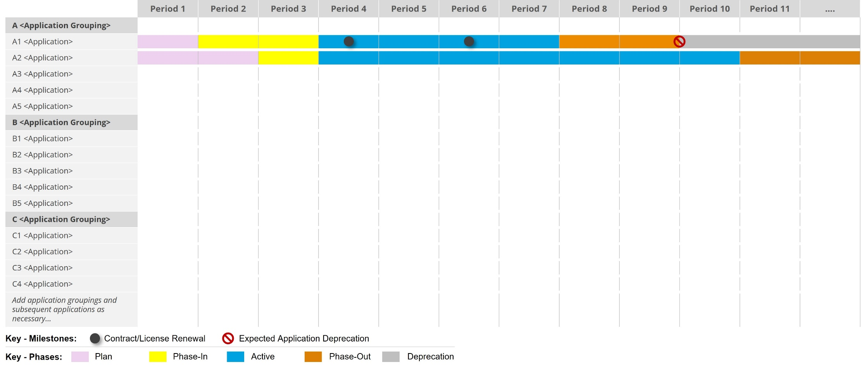

## Applications roadmap diagram description

<This section should include a high-level description of the agency’s applications roadmap and its construction.

This section should include:

* high-level description of the applications roadmap diagram
* a description of the diagram construction (i.e., application phases, key milestones etc.)
* include direction to detailed application descriptions. >

# Detailed application descriptions

|  |  |  |  |  |  |  |  |  |
| --- | --- | --- | --- | --- | --- | --- | --- | --- |
| ID | Application group | Application | Description | Current phases | Timeframe | Key milestones | Costs | Governance activities |
| *< Application ID (where agency application IDs exist>* | *< Application Grouping (as per agency Conceptual Application Architecture, if one exists>* | *< Application name>* | *< Include a description of the application and its core functions …>* | *< Current application lifecycle phase (as per section 3.0)…>* | *< Outline of application timeframes (i.e. planned implementation and obsolesce)…>* | *<Outline key application milestones (e.g. contractual/ licensing>* | *<Outline high-level application costs (e.g. licensing per period costs>* | *< Specific individual designated as the owner for the application…>* |
|  |  |  |  |  |  |  |  |  |
|  |  |  |  |  |  |  |  |  |

Artefact Examples – Remove section upon artefact development

DoDAF - SV-8 Systems Evolution Description (Applications Roadmap Aligned)

The DoDAF SV-8 Systems Evolution Description presents a whole lifecycle view of systems (applications) against a timeline, describing how they change over time.

