Information architecture (diagram)

<Agency/Responsible entity>

Date

|  |  |
| --- | --- |
| Security classification |  |
| Owner |  |
| Contact details |  |
| Division/Unit |  |
| Document status |  |

Document history

|  |  |  |  |  |  |
| --- | --- | --- | --- | --- | --- |
| Version | Date | Status | Key changes | Author/s | Reviewer/s |
| 0.0.1 |  |  |  |  |  |
|  |  |  |  |  |  |

Endorsements

|  |  |  |  |
| --- | --- | --- | --- |
| Name | Position | Signature | Date |
|  |  |  |  |
|  |  |  |  |
|  |  |  |  |
|  |  |  |  |
|  |  |  |  |

Glossary

|  |  |
| --- | --- |
| Term | Definition |
| Information architecture | A structured view of high-level information categories, groupings and entities used across an agency aligned to a business context (e.g., customer, geography).  An information model provides formalism to the description of a problem domain which is agnostic to how data is mapped and implemented in a software. An organisation can have many data models, usually one per system, but should only have one information model which data models will align to. |
| Information asset | Agency information, records and data that are created, collected, received and kept as part of government business |
| Information asset group | A group of information assets aligned to a common rationale that represents the highest level of information in the agency, identified with a label (e.g., A) |
| Level 1 information asset | Sub-divisions of the respective Information Asset Group which provide second-level hierarchy as information super classes or entities, identified with a label (e.g., A1). |
| Level 1 information asset | Sub-classes or entity sub-types encompassed in the decomposition of the respective Level 1 Information Asset, identified with a label (e.g., A1.1). |

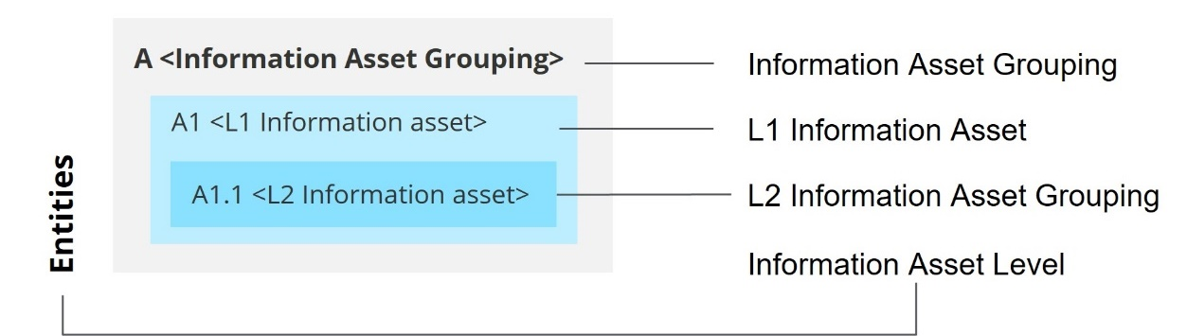

Information architecture illustrative diagram

Table of Contents

1 Introduction 6

2 Architecture context and inputs 6

2.1 Conceptual data architecture 6

3 Information asset grouping rationale 7

4 Information architecture overview 7

4.1 Information architecture diagram 8

4.1.1 Diagram 1 8

4.1.2 Diagram 2 9

4.2 Information architecture diagram description 10

5 Detailed information asset descriptions 11

5.1 Level 1 information architecture descriptions 11

5.2 Level 2 information architecture descriptions 12

Template context – remove this section upon development of the artefact

**Artefact description**

An agency’s information architecture is a structured view of high-level information categories, groupings and entities used across an agency aligned to a business context (e.g., customer, geography).

**Template purpose**

The purpose of this template is to:

* provide agencies with a centralised definition of what an Information Architecture is
* provide consistent artefact requirements for agencies to follow
* provide the template for agencies to efficiently develop an Information Architecture in a consistent format.

This template is intended to deliver on the purpose through the provision of the following artefact template. However, if an alternative file type/format better aligns with agency circumstances, the following artefact formats may also be employed, given they align with the content, glossary definitions and artefact format requirements outlined within this document:

* spreadsheet (e.g. Excel)
* diagram
* enterprise architecture tool.

**Template instructions**

* This template includes instructional text to guide artefact content. Such text is either enclosed within angled brackets (</>) and/or greyed out. Upon artefact development, this text should be removed and replaced with text specific to the agency context.
* Any **red** text or shapes indicate template elements or sections to be removed upon artefact development.

# Introduction

< The purpose of this section is to introduce the information architecture and provide a high-level overview of the subsequent artefact sections.

This section should include:

* a high-level overview of the agency information architecture
* a high-level overview of this document sections:

Architecture context & inputs

Information architecture glossary

Information asset groupings

Information architecture overview

Detailed information asset descriptions. >

# Architecture context and inputs

< The purpose of this section is to provide context around the agency information architecture and the agency documents (e.g., artefacts, strategies, plans etc.) that have been leveraged to inform the architecture.

This section should include:

* an overview of the information architecture context within the agency.
* any agency documents that have been leveraged to inform the architecture.

Additional input sections may be added below where required and the section may expand across multiple pages where required. The input section/s outlined below act as a guide to the inputs which may be discussed, however, do not act as mandatory content headings. >

## Conceptual data architecture

<This section should outline how the agency artefact has been leveraged or aligned to throughout development of the information architecture, including:

* the nature by which the artefact has been leveraged to inform the architecture
* how the architecture has been informed by the artefact. >

# Information asset grouping rationale

<The purpose of this section is to explain the rationale behind groupings within the architecture. Groupings and the associated rationale should be entered to the table template below.>

|  |  |
| --- | --- |
| Grouping | Rationale |
| <Information asset grouping> | *Information assets within the architecture should be grouped around a common rationale or criteria (e.g. common solution, common organisational unit). Describe here the rationale around why information assets have been grouped in this manner…* |
| <Information asset grouping> |  |
| <Information asset grouping> |  |
| <Information asset grouping> |  |
| … |  |
|  |  |

# Information architecture overview

< This section should include an overview of the information architecture diagram.

This section should include an overview of the information architecture diagram section (i.e., information architecture diagram and diagram description).>

## Information architecture diagram

### Diagram 1

< This section should include the information architecture diagram. The partial format example/template below may be leveraged to develop the artefact, and deleted from the artefact file afterwards.>

Information architecture diagram guide – Remove upon development of the artefact

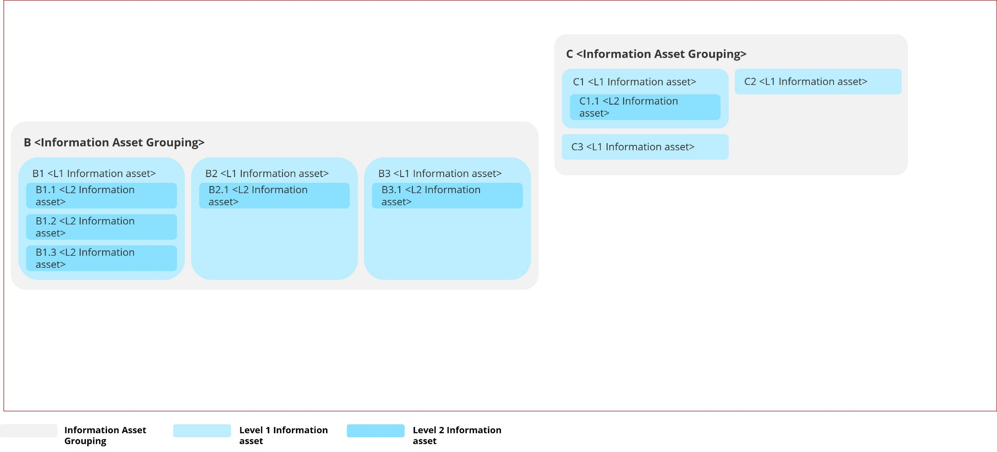

### Diagram 2

<This section should include the information architecture diagram (relationships depicted). The partial format example/template below may be leveraged to develop the artefact and deleted from the artefact file afterwards. Relationship overlays may be depicted for the entire enterprise or for a particular domain - e.g., human resources.>

Information architecture diagram guide – Remove upon development of the artefact

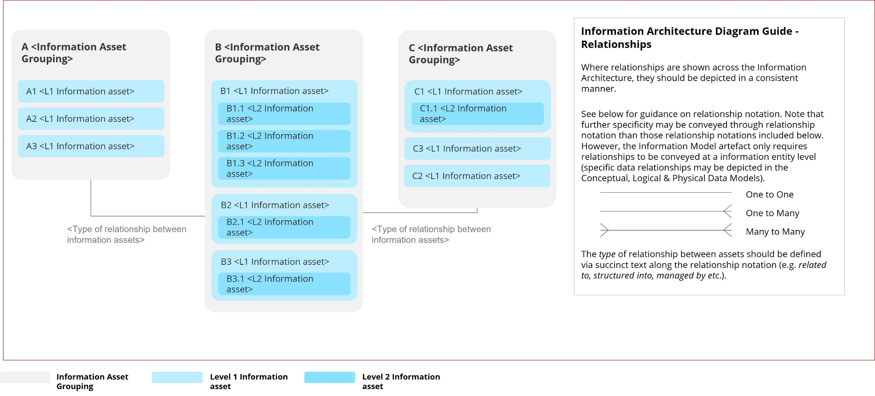

## Information architecture diagram description

This section should include a high-level description of the agency’s information architecture and its construction.

This section should include:

* high-level description of the information architecture diagram.
* a description of the diagram construction (i.e. information asset groups, information assets etc.).
* include direction to detailed information asset descriptions section. >

# Detailed information asset descriptions

## Level 1 information architecture descriptions

|  |  |  |  |
| --- | --- | --- | --- |
| ID | Information asset group | L1 information asset | Description |
| *<Information asset ID (e.g., A1)>* | *<Information asset grouping>* | *<L1 information asset>* | *<Include a description of the L1 information asset>* |
|  |  |  |  |
|  |  |  |  |
|  |  |  |  |

## Level 2 information architecture descriptions

|  |  |  |  |  |
| --- | --- | --- | --- | --- |
| ID | Information asset group | L1 information asset | L2 information asset | Description |
| *<Information asset ID (e.g., A1.1)>* | *<Information asset grouping>* | *<L1 information asset>* | *<L2 information asset>* | *<Include a description of the L2 information asset>* |
|  |  |  |  |  |
|  |  |  |  |  |
|  |  |  |  |  |

Artefact Examples – Remove section upon artefact development

Generic Example – Subject area information model (Information architecture aligned)

The subject area information model example below identifies subject areas within business domains and structures the enterprise data by such business domains.

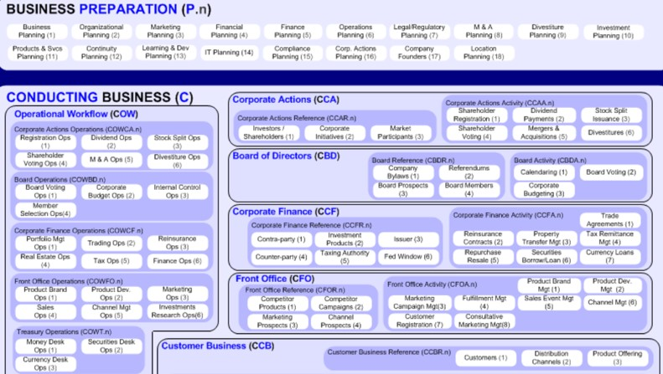

Artefact Examples – Remove section upon artefact development

**TOGAF –** Information Map (Information Architecture (relationships depicted) Aligned)

The TOGAF Information Mapping guide includes the example Information Map included below. The example shows a collection of information concepts and their relationships to one another, across the example of a financial institution.

