Functional model design

<Agency/Responsible entity>

Date

|  |  |
| --- | --- |
| Security classification |  |
| Owner |  |
| Contact details |  |
| Division/Unit |  |
| Document status |  |

Document history

|  |  |  |  |  |  |
| --- | --- | --- | --- | --- | --- |
| Version | Date | Status | Key changes | Author/s | Reviewer/s |
| 0.0.1 |  |  |  |  |  |
|  |  |  |  |  |  |

Endorsements

|  |  |  |  |
| --- | --- | --- | --- |
| Name | Position | Signature | Date |
|  |  |  |  |
|  |  |  |  |
|  |  |  |  |
|  |  |  |  |
|  |  |  |  |

Glossary

|  |  |
| --- | --- |
| Term | Definition |
| Functional model design | A diagram that depicts the functional structure and hierarchy of an agency in terms of its processes and capabilities. |
| Functional grouping | A group of organisational processes and capabilities that share a common rationale (i.e., belong to a common capability group or organisational unit). There may exist functional groupings at multiple levels of the functional structure (i.e., high-level functional grouping with multiple nested functional sub-groupings). |
| Functional relationship | The interactions that occur among functional groupings and between functional groupings and capabilities. |

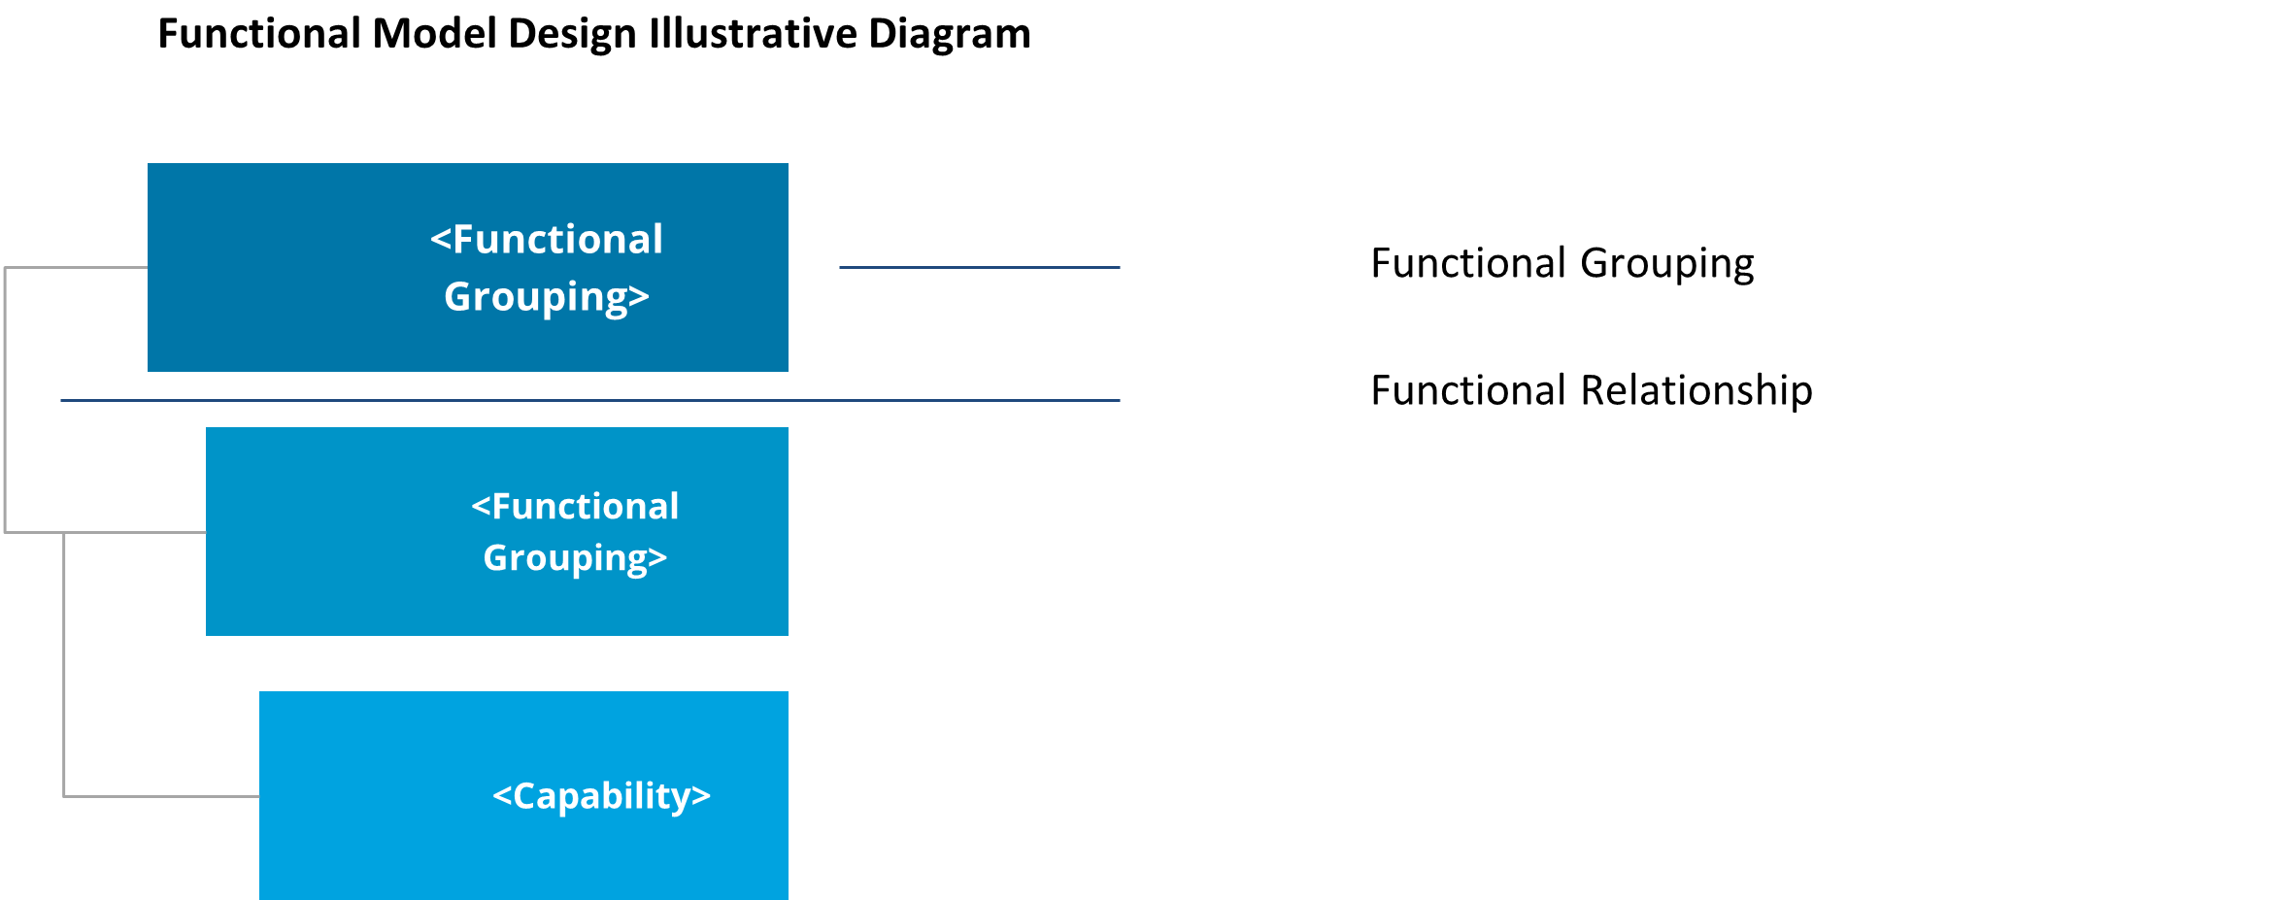

Functional model design illustrative diagram

Table of Contents

1 Introduction 6

2 Model context and inputs 6

2.1 Agency organisational structure 6

2.2 Agency conceptual capability model 6

3 Functional grouping rationale 7

4 Functional model design overview 8

4.1 Functional model design diagram 9

4.2 Enterprise roadmap diagram description 10

5 Functional grouping descriptions 11

Template context – remove this section upon development of the artefact

**Artefact description**

An agency’s functional model design is a diagram that depicts the functional structure and hierarchy of an agency in terms of its processes and capabilities.

**Template purpose**

The purpose of this template is to:

* provide agencies with a centralised definition of what a functional model design is
* provide consistent artefact requirements for agencies to follow
* provide the template for agencies to efficiently develop a functional model design in a consistent format.

This template is intended to deliver on the purpose through the provision of the following artefact template. However, if an alternative file type/format better aligns with agency circumstances, the following artefact formats may also be employed, given they align with the content, glossary definitions and artefact format requirements outlined within this document:

* spreadsheet (e.g. Excel)
* diagram
* enterprise architecture tool.

**Template instructions**

* This template includes instructional text to guide artefact content. Such text is either enclosed within angled brackets (</>) and/or greyed out. Upon artefact development, this text should be removed and replaced with text specific to the agency context.
* Any **red** text or shapes indicate template elements or sections to be removed upon artefact development.

# Introduction

< The purpose of this section is to introduce the functional model design and provide a high-level overview of the subsequent artefact sections.

This section should include:

* a high-level overview of the agency functional model design.
* a high-level overview of this document sections:

Model context and inputs

Functional model design glossary

Functional groupings

Functional model design overview

Functional grouping descriptions. >

# Model context and inputs

< The purpose of this section is to provide context around the agency functional model design and the agency documents (e.g., artefacts, strategies, plans etc.) that have been leveraged to inform the model.

This section should include:

* an overview of the functional model design context within the agency
* any agency resources that have been leveraged to inform the model.

Additional input sections may be added below where required and the section may expand across multiple pages where required. The input section/s outlined below act as a guide to the inputs which may be discussed, however, do not act as mandatory content headings. >

## Agency organisational structure

<This section should outline how the agency artefact has been leveraged or aligned to throughout development of the functional model design, including:

* the nature by which the artefact has been leveraged to inform the model
* how the model has been informed by the artefact. >

## Agency conceptual capability model

<This section should outline how the agency artefact has been leveraged or aligned to throughout development of the functional model design, including:

* the nature by which the artefact has been leveraged to inform the model
* how the model has been informed by the artefact.>

# Functional grouping rationale

< The purpose of this section is to explain the rationale behind groupings within the model. Groupings and the associated rationale should be entered to the table template below.>

|  |  |
| --- | --- |
| Functional grouping | Rationale |
| <Functional grouping> | *<Functions/capabilities within the model should be grouped around a common rationale or criteria (e.g., common organisational unit, common capability grouping). Describe here the rationale around why functions/capabilities have been grouped in this manner. Include reference to the agency organisation structure and conceptual capability model where required…>* |
| <Functional grouping> |  |
| <Functional grouping> |  |
| <Functional grouping> |  |
| …. |  |

# Functional model design overview

<This section should include an overview of the functional model design diagram.

This section should include an overview of the functional model design diagram section (i.e., functional model design diagram and diagram description

## Functional model design diagram

<This section should include the functional model design diagram. The partial format example/template and associated guide below may be leveraged to develop the artefact and deleted from the artefact file afterwards.>

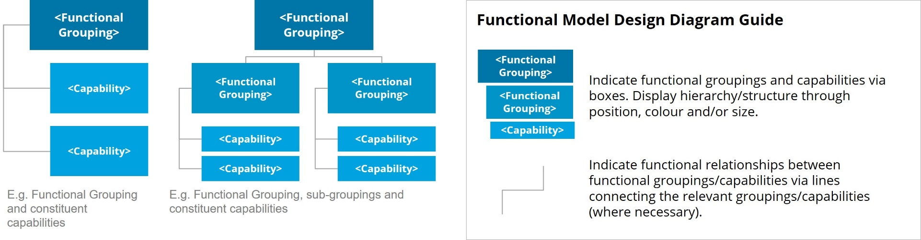

## Enterprise roadmap diagram description

<This section should include a high-level description of the agency’s functional model design and its construction.

This section should include:

* high-level description of the functional model design diagram.
* a description of the diagram construction (i.e. functional groupings, functional relationships etc.). >

# Functional grouping descriptions

|  |  |
| --- | --- |
| Functional grouping | Description |
| *<Functional grouping>* | *<This section should include a description of the functional grouping.*  *This section should cover:*   * *overview of the functional grouping* * *description of the functional grouping constituent processes and capabilities.>* |
| *<Functional grouping>* |  |
| *<Functional grouping>* |  |
| *<Functional grouping>* |  |
| *….* |  |

Artefact Examples – Remove section upon artefact development

TOGAF – Functional Decomposition Diagram (Functional Model Design Aligned)

The TOGAF Functional Decomposition Diagram shows an organisation’s capabilities from a functional perspective and depicts the decomposition of functional groups into functional sub-groups and/or capabilities. The following diagram examples vary in specific format, however, depict the same information.

