Enterprise roadmap

<Agency/Responsible entity>

Date

|  |  |
| --- | --- |
| Security classification |  |
| Owner |  |
| Contact details |  |
| Division/Unit |  |
| Document status |  |

Document history

|  |  |  |  |  |  |
| --- | --- | --- | --- | --- | --- |
| Version | Date | Status | Key changes | Author/s | Reviewer/s |
| 0.0.1 |  |  |  |  |  |
|  |  |  |  |  |  |

Endorsements

|  |  |  |  |
| --- | --- | --- | --- |
| Name | Position | Signature | Date |
|  |  |  |  |
|  |  |  |  |
|  |  |  |  |
|  |  |  |  |
|  |  |  |  |

Glossary

|  |  |
| --- | --- |
| Term | Definition |
| Dependencies | An item of work which relies on the completion of an interrelated item of work. Dependencies define the order by which roadmap initiatives must be sequenced. |
| Enterprise roadmap | A visualisation of an agency’s key events and milestones across a particular time horizon (typically associated with initiatives/programs of work). Presented on a timeline to show evolution from the agency’s current state to target state. |
| Initiative (i.e., program of work) | A campaign to transform and improve an agency transformation area, in line with agency strategic direction. |
| Roadmap increments | The time increments (periods) across which roadmap initiatives are displayed. Roadmap increment periods allow tracking against expected timeframes. |
| Roadmap timeframe | The total time horizon over which an enterprise roadmap is displayed. |
| Strategic horizon | A defined time period by which an agency plans future initiatives within. |
| Transformation area | A targeted area for transformation, in line with agency strategic direction. |

Table of Contents

1 Introduction 6

2 Roadmap context and inputs 6

2.1 Agency vision and mission 6

2.2 Agency strategic direction 6

2.3 Agency portfolio view 6

3 Enterprise roadmap overview 7

3.1 Enterprise roadmap diagram 8

3.2 Enterprise roadmap diagram description 9

4 Detailed roadmap initiative descriptions 11

4.1 Transformation area 11

Template context – remove this section upon development of the artefact

**Artefact description**

An agency’s enterprise roadmap is a visualisation of the agency’s key events and milestones across a particular time horizon (typically associated with initiatives/programs of work). An enterprise roadmap is presented on a timeline to show evolution from the agency’s current state to target state.

**Template purpose**

The purpose of this template is to:

* provide agencies with a centralised definition of what an enterprise roadmap is
* provide consistent artefact requirements for agencies to follow
* provide the template for agencies to efficiently develop an enterprise roadmap in a consistent format.

This template is intended to deliver on the purpose through the provision of the following artefact template. However, if an alternative file type/format better aligns with agency circumstances, the following artefact formats may also be employed, given they align with the content, glossary definitions and artefact format requirements outlined within this document:

* spreadsheet (e.g., Excel)
* diagram
* project management tool.

Instructions for use of this template

* This template includes instructional text to guide artefact content. Such text is either enclosed within angled brackets (</>) and/or greyed out. Upon artefact development, this text should be removed and replaced with text specific to the agency context.
* Any **red** text or shapes indicate template elements or sections to be removed upon artefact development.

# Introduction

<The purpose of this section is to introduce the enterprise roadmap and provide a high-level overview of the subsequent artefact sections.

This section should include:

* a high-level overview of the agency enterprise roadmap
* a high-level overview of the document sections:

Roadmap context and inputs

Enterprise roadmap glossary

Enterprise roadmap overview

Detailed roadmap initiative descriptions >

# Roadmap context and inputs

<The purpose of this section is to provide context around the agency enterprise roadmap and the agency documents (e.g., artefacts, strategies, plans) that have been leveraged to inform the roadmap.

This section should include:

* an overview of the enterprise roadmap context within the agency
* any agency documents that have been leveraged to inform the roadmap.

<Additional input sections may be added below where required and the section may expand across multiple pages where required. The input section/s outlined below act as a guide to the inputs which may be discussed, however, do not act as mandatory content headings. >

## Agency vision and mission

<This section should outline how the agency artefact has been leveraged or aligned to throughout development of the enterprise roadmap, including:

* the nature by which the artefact has been leveraged to inform the roadmap
* how the roadmap has been informed by the artefact. >

## Agency strategic direction

<This section should outline how the agency artefact has been leveraged or aligned to throughout development of the enterprise roadmap, including:

* the nature by which the artefact has been leveraged to inform the roadmap
* how the roadmap has been informed by the artefact. >

## Agency portfolio view

<This section should outline how the agency artefact has been leveraged or aligned to throughout development of the enterprise roadmap, including:

* the nature by which the artefact has been leveraged to inform the roadmap
* how the roadmap has been informed by the artefact. >

# Enterprise roadmap overview

<This section should include an overview of the enterprise roadmap diagram.>

This section should include an overview of the enterprise roadmap diagram section (i.e., enterprise roadmap diagram and diagram description). >

## Enterprise roadmap diagram

<This diagram should depict the entire portfolio of agency initiatives against the defined roadmap timeframe. Coloured bars should be used to depict initiative timeframes. Key milestones should be depicted where required across an initiative to show key milestones occurrences. Any milestones added to the roadmap must be defined in the roadmap key. Key dependencies should be depicted where required to show interrelated items of work.>

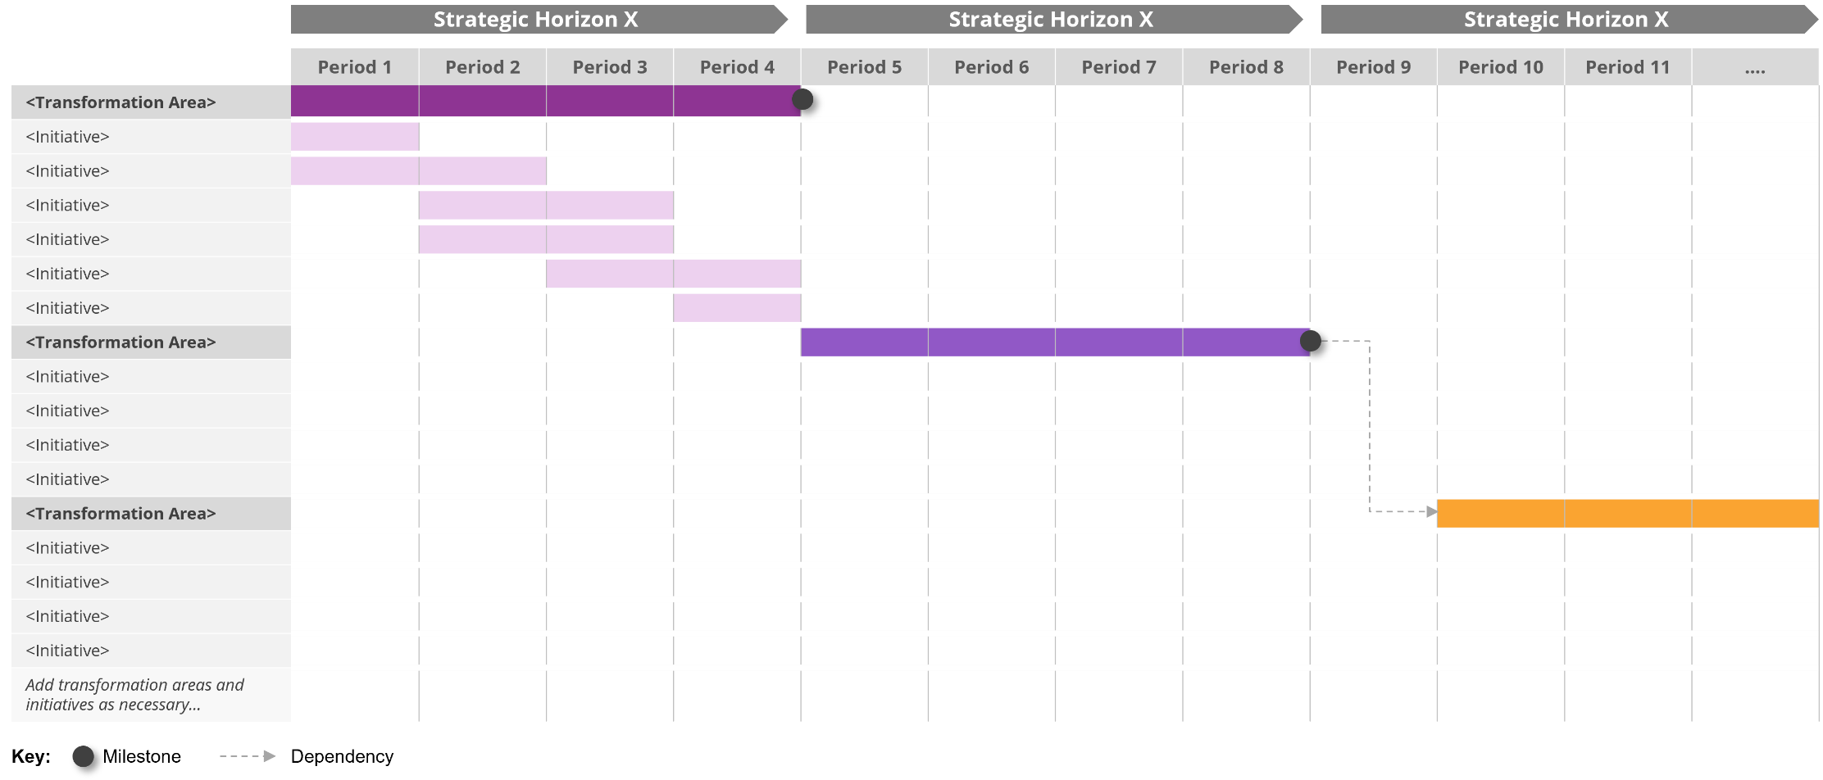

## Enterprise roadmap diagram description

This section should include a high-level description of the agency’s enterprise roadmap and its construction.

This section should include:

* high-level description of the enterprise roadmap diagram
* a description of the diagram construction (i.e., roadmap timeframes, initiative milestones etc.)
* include direction to detailed roadmap initiative descriptions. >

Artefact example – remove section upon development

**Microsoft Office –** Roadmap (Enterprise Roadmap Aligned)

The example roadmap below shows an organisation’s planned initiatives over a defined timeframe, structuring initiatives in terms of broader development/transformation areas and depicting any key milestones.

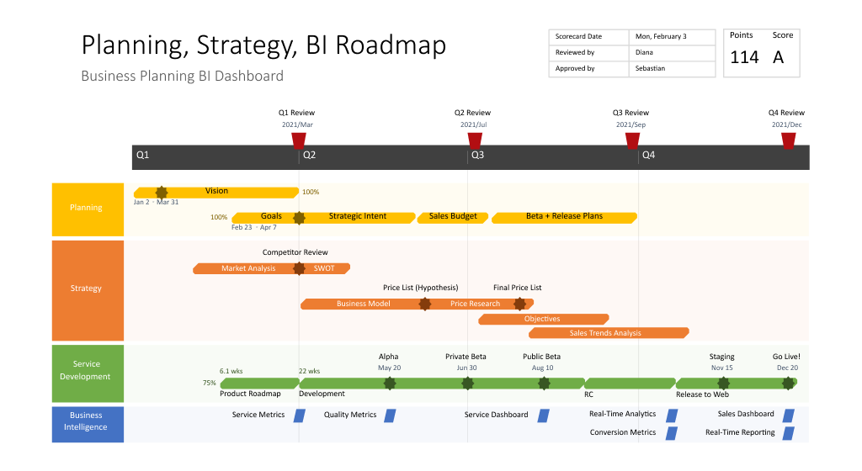

# Detailed roadmap initiative descriptions

## Transformation area

*<Description of the area>*

|  |  |  |  |  |  |  |
| --- | --- | --- | --- | --- | --- | --- |
| Initiative | Description | Timeframe | Key milestones | Dependencies | Costs | Governance activities |
| *<Initiative (i.e., Program of Work)>* | *<Description of the initiative including a high-level overview of the associated project streams…>* | *<Define the expected initiative timeline…>* | *<Define the key milestones across the expected initiative timeframe…>* | *<Outline the key initiative dependencies…>* | *<Outline the high-level costs involved with the initiative…>* | *<Outline the key governance and assurance activities/milestones that must over the initiative timeframe (e.g. assurance* *gating)…>* |
|  |  |  |  |  |  |  |
|  |  |  |  |  |  |  |

<copy the table for each transformation area>