Conceptual service architecture

<Agency/Responsible entity>

Date

|  |  |
| --- | --- |
| Security classification |  |
| Owner |  |
| Contact details |  |
| Division/Unit |  |
| Document status |  |

Document history

|  |  |  |  |  |  |
| --- | --- | --- | --- | --- | --- |
| Version | Date | Status | Key changes | Author/s | Reviewer/s |
| 0.0.1 |  |  |  |  |  |
|  |  |  |  |  |  |

Endorsements

|  |  |  |  |
| --- | --- | --- | --- |
| Name | Position | Signature | Date |
|  |  |  |  |
|  |  |  |  |
|  |  |  |  |
|  |  |  |  |
|  |  |  |  |

Glossary

|  |  |
| --- | --- |
| Term | Definition |
| Conceptual service architecture | A structured view of the internally and externally consumed services provided across an agency |
| Level 1 service* | Indicates the next level of services after a Service Group and represents a group of services, identified with a label (e.g. A1). |
| Leve 2 service* | Indicates the next level of decomposition after a Level 1 Service, identified with a label (e.g. A1.1) |
| Level 3 service* | Indicates the next level of decomposition after a Level 2 Service, identified with a label (e.g. A1.1.1). |
| Level 4 service* | Indicates the next level of decomposition after a Level 3 Service, identified with a label (e.g. A1.1.1.1). |
| Service | Services provided by government agencies or their partners with intent to address citizen and community needs (demand). |
| Service group | A group of services aligned to a common rationale that represents the highest level of service in the agency, identified with a label (e.g. A). |

* The number of levels of decomposition is limited only by the degree necessary to communicate the information required by the intended audience or to enable the agency to make informed decisions about service gaps.

Service Grouping

L1 Service

L2 Service

**A <Service Grouping>**

A1 <L1 Service>

A1.1 <L2 Service>

A1.1.1 <L3 Service>

A1.1.1.1 <L4 Service>

L3 Service

L4 Service

Conceptual service architecture illustrative diagram

Table of Contents

1 Introduction 4

2 Architecture context and inputs 4

2.1 Agency Vision and Mission 4

2.2 Agency Business Model Design 4

3 Conceptual service architecture glossary 5

3.1 Conceptual service architecture illustrative diagram 5

4 Service grouping rationale 6

5 Conceptual service architecture overview 6

5.1 Conceptual service architecture diagram 7

5.2 Conceptual service architecture diagram description 8

6 Conceptual service architecture overlays 9

6.1 Service - <Domain> Mapping 9

7 Detailed service descriptions 10

7.1 Level 1 service descriptions 10

7.2 Level 2 service descriptions 11

7.3 Level 3 service descriptions (where necessary) 12

7.4 Level 4 service descriptions (where necessary) 13

Template context – remove this section upon development of the artefact

**Artefact description**

An agency’s conceptual service architecture is a structured view of the internally and externally consumed services provided across the agency and its partners.

**Template purpose**

The purpose of this template is to:

* provide agencies with a centralised definition of what a conceptual service architecture is
* provide consistent artefact requirements for agencies to follow
* provide the template for agencies to efficiently develop a conceptual service architecture in a consistent format.

This template is intended to deliver on the purpose through the provision of the following artefact template. However, if an alternative file type/format better aligns with agency circumstances, the following artefact formats may also be employed, given they align with the content, glossary definitions and artefact format requirements outlined within this document:

* spreadsheet (e.g. Excel)
* diagram
* enterprise architecture tool

**Template instructions**

This template includes instructional text to guide artefact content. Such text is either enclosed within angled brackets (</>) and/or greyed out. Upon artefact development, this text should be removed and replaced with text specific to the agency context.

Any **red** text or shapes indicate template elements or sections to be removed upon artefact development.

# Introduction

<The purpose of this section is to introduce the conceptual service architecture and provide a high-level overview of the subsequent artefact sections.

This section should include:

* A high-level overview of the agency conceptual service architecture.
* A high-level overview of this document sections:

Architecture context and inputs

Conceptual service architecture glossary

Service groupings

Conceptual service architecture overview

Conceptual service architecture overlays

Detailed service descriptions. >

# Architecture context and inputs

<The purpose of this section is to provide context around the agency conceptual service architecture and the agency documents (e.g., artefacts, strategies, plans etc.) that have been leveraged to inform the architecture.

This section should include:

* an overview of the conceptual service architecture context within the agency
* any agency documents that have been leveraged to inform the architecture.

Additional input sections may be added below where required and the section may expand across multiple pages where required. The input section/s outlined below act as a guide to the inputs which may be discussed, however, do not act as mandatory content headings. >

## Agency vision and mission

<This section should outline how the agency artefact has been leveraged or aligned to throughout development of the conceptual service architecture, including:

* the nature by which the artefact has been leveraged to inform the architecture
* how the architecture has been informed by the artefact. >

## Agency business model design

<This section should outline how the agency artefact has been leveraged or aligned to throughout development of the conceptual service architecture, including:

* the nature by which the artefact has been leveraged to inform the architecture
* how the architecture has been informed by the artefact.

# Service grouping rationale

<The purpose of this section is to explain the rationale behind groupings within the architecture. Groupings and the associated rationale should be entered to the table template below.>

|  |  |
| --- | --- |
| Grouping | Rationale |
| <Service grouping> | *<Services within the architecture should be grouped around a common rationale or criteria (e.g. common organisational unit). Describe here the rationale around why services have been grouped in this manner…>* |
| <Service grouping> |  |
| <Service grouping> |  |
| …. |  |

# Conceptual service architecture overview

<This section should include an overview of the conceptual service architecture diagram.

This section should include an overview of the conceptual service architecture diagram section (i.e., conceptual service architecture diagram and diagram description.)>

## Conceptual service architecture diagram

<This section should include the conceptual service architecture diagram. The partial format example/template below may be leveraged to develop the artefact and deleted from the artefact file afterward.>

Conceptual service architecture diagram guide - remove upon development of the artefact

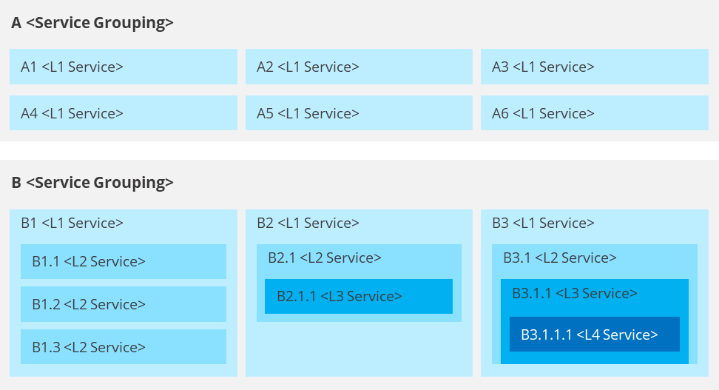

## Conceptual service architecture diagram description

This section should include a high-level description of the agency’s conceptual service architecture and its construction.

This section should include:

* high-level description of the conceptual service architecture diagram
* a description of the diagram construction (i.e., service groups, service levels etc.)
* include direction to detailed service descriptions section. >

# Conceptual service architecture overlays

<This section should include an overview on the conceptual service architecture overlay views included within the artefact.>

## Service - <domain> mapping

<This section should include mapping of the relationships between the services and other business and IT architecture domains (e.g. Service – Organisational unit mapping.>

# Detailed service descriptions

## Level 1 service descriptions

|  |  |  |  |
| --- | --- | --- | --- |
| ID | Service group | L1 service | Description |
| <Service ID (e.g., A1)> | <Service grouping> | <L1 service> | <Include a description of the L1 service> |
|  |  |  |  |
|  |  |  |  |
|  |  |  |  |

## Level 2 service descriptions

|  |  |  |  |  |
| --- | --- | --- | --- | --- |
| ID | Service group | L1 services | L2 services | Description |
| <Service ID (e.g., A1.1)> | <Service grouping> | <L1 service> | <L2 service> | <Include a description of the L2 service> |
|  |  |  |  |  |
|  |  |  |  |  |
|  |  |  |  |  |

## Level 3 service descriptions (where necessary)

|  |  |  |  |  |  |
| --- | --- | --- | --- | --- | --- |
| ID | Service group | L1 services | L2 services | L3 services | Description |
| <Service ID (e.g., A1.1.1)> | <Service grouping> | <L1 service> | <L2 service> | <L3 service> | <Include a description of the L3 service> |
|  |  |  |  |  |  |
|  |  |  |  |  |  |
|  |  |  |  |  |  |

## Level 4 service descriptions (where necessary)

|  |  |  |  |  |  |  |
| --- | --- | --- | --- | --- | --- | --- |
| ID | Service group | L1 services | L2 services | L3 services | L4 services | Description |
| <Service ID (e.g., A1.1.1.1)> | <Service grouping> | <L1 service> | <L2 service> | <L3 service> | <L4 service> | <Include a description of the L4 service> |
|  |  |  |  |  |  |  |
|  |  |  |  |  |  |  |
|  |  |  |  |  |  |  |

Artefact Examples – Remove section upon artefact development

**DoDAF -** SvcV-1 Services Context Description (Conceptual Service Architecture Aligned)

The DoDAF Services Context Description outlines the composition of services within an enterprise. Although in a slightly different format, the SvcV-1 diagram depicts high-level services and any lower level constituent services in line with the intended conceptual service architecture format.

