# **Transfer List and Metadata Requirements**

# What is metadata and why is it important?

Capturing relevant contextual information is vital to successful preservation. Metadata is defined as **the information that describes and explains records**. When records contain appropriate metadata, we can better understand what they are, why they were created and how best to manage them. Metadata also makes information easier to locate, retrieve and access.

When transferring permanent records to QSA, Agencies need to do their part by providing the mandatory metadata elements (at a minimum) for these records.

# Transfer List

As part of the transfer process Agencies must complete a transfer list and submit it via the Agency Portal, ArchivesGateway. The transfer list updates the previous template for transfers and is used by the Agency to list the records (**both physical and digital**) that it plans to transfer to QSA and to provide the required metadata. Providing metadata at the point of transfer will ensure that records remain findable, understandable, authenticated, and trustworthy.

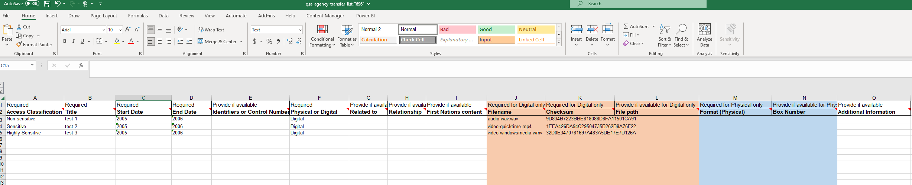

Figure 1: Example of a transfer list for digital records

Agency Users can download the transfer list template from the ArchivesGateway Transfers screen.

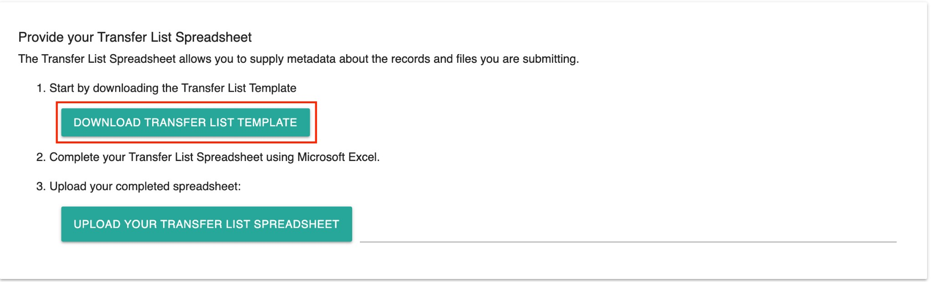

The transfer list template is divided into *required* and *provide if available* (optional)fields. Agencies may already be familiar with many of the fields in the template from the transfer process for physical records. However, additional fields have now been included to accommodate the transfer of digital records. It is important to note that the transfer list will not validate and cannot be submitted if any of the required fields are not completed.

For further information on the main metadata fields in the transfer list and how they should be populated, please refer to the table below:

## Key metadata fields in the Transfer List

| Metadata Column | Explanation | Applies to which Format? | Required or Provide if available? |
| --- | --- | --- | --- |
| Access Classification | Outlines the sensitivity of the record, which in turn determines the appropriate level of access. Agencies will be able to select the one of the following classifications:   * Non-sensitive * Sensitive * Highly sensitive   For more information about please refer to the Access Classification Labels fact sheet available here | Both physical and digital records | Required |
| Title | The official title of the record (what the record is called). Remember to spell out in full any acronyms used. | Both physical and digital records | Required |
| Start Date | The date the record was first captured, created, or registered. For physical records, please provide the content date.  Can be populated in the following formats: YYYY; MM/YYYY; or DD/MM/YYYY. | Both physical and digital records | Required |
| End Date | The date the record was last modified, finalised, or closed. For physical records, please provide the content date.  Can be populated in the following formats: YYYY; MM/YYYY; or DD/MM/YYYY. | Both physical and digital records | Required |
| Identifiers or Control Numbers | A unique value assigned to a record that helps to distinguish it from other records. These numbers can either be generated by an application (e.g. an EDRMS container or document ID) or be imposed by an internal process (e.g. a departmental filing system). | Both physical and digital records | Provide if available |
| Physical or Digital | Specifies if the record is physical or digital. Agencies can select the appropriate option from the drop-down list provided in the cell.  **Note:** for hybrid records, use a row for each component (physical or digital) and populate all columns relating to that component. | Both physical and digital records | Required |
| Related to | Identifies the known relationships between records that an Agency is transferring. This field aims to build a better understanding of how one record relates to another, or if a record is part of another (either within the same transfer or as a component of an existing item at QSA). | Both physical and digital records | Provide if available |
| Relationship type | Specifies the type of relationship with the record(s) identified in the “Related to” column. Agencies can select the appropriate relationship type from the drop-down list provided in the cell.  For ease and clarity, four options have been made available:   * Hybrid * Contained within * Is copy of * Associated | Both physical and digital records | Provide if available |
| First Nations Content | Select “yes” if the record contains information relating to Aboriginal and/or Torres Strait Islander people(s). Further information about this content can be added in the “Additional Information” field. | Both physical and digital records | Provide if available |
| Filename | The base name and file extension of the digital file that indicates how systems have distinctively identified it and the type of format it sits on.  **Examples:**   * Minutes.docx * PORTSMOT1022.JPG   This column, in conjunction with the checksum column will verify that the files agencies are transferring to QSA are the correct and valid files. The transfer list will validate this information in the spreadsheet against the files that are uploaded to the cloud storage area to ensure the listing in the transfer list and the files themselves match. | Digital records only | Required |
| Checksum | A computer-generated string of numbers and letters serving as the ‘digital fingerprint’ of a file. Checksums are monitored when conducting fixity and integrity checks on digital files to ensure they remain unchanged during preservation activities.  Checksums are generated and validated using standard algorithms known as hash functions, and there are many different types. QSA requires MD5. This information, in conjunction with the filename column will verify that the files agencies are transferring to QSA are the correct and valid files.  For more information about checksums please refer to the Checksums fact sheet available here | Digital records only | Required |
| File Path | Born digital records may be arranged within deep and complex folder structures. File paths reflect those structures and retain important contextual information. The creation of file paths can be performed in multiple ways by various software, many of which are open source. | Digital records only | Provide if available |
| Format | The type of physical record being transferred i.e., document, register, map or photographic print (etc). Agencies can select the format of the record from the drop-down list provided in the cell. | Physical records only | Required |
| Box Number | For physical records contained within boxes, please include the number of the box/container. This may be sequential. | Physical records only | Provide if available |
| Additional Information | Use this column to tell us any other information about the record. This includes (but is not limited to):   * the condition of the record e.g., poor, mouldy * bespoke digital formats and the software used to create them * further information about the contents including whether they may be distressing. | Both physical and digital records | Provide if available |

## Hidden Fields

In the transfer list, there are seven fields that are hidden by default. These fields relate to further contextual information that QSA is strongly encouraging Agencies to think about when they describe and manage their records, including series, the creating agency, place, Aboriginal and/or Torres Strait Islander language/group, legislation, and restricted access exceptions. This metadata will help enrich the records being transferred to QSA, enabling all users to better understand the information and the preservation and access decisions that have been made.

To ensure that these fields are populated with the appropriate information, we recommend you consult QSA before completing.

# Generating the correct metadata

Some of the required metadata elements for transfers may already be on hand depending on an Agency’s current records management systems and processes. The good news is a lot of this contextual information can be easily extracted and provided to QSA.

With regards to digital records, it is recommended that Agencies use the export format options of the systems in which their files are stored to extract both the files and their associated metadata. The easiest option is to export all the metadata fields available in the system and then analyse those in collaboration with QSA to decide which fields provide context and assist with discovery.

If you would like any further information or advice, please contact us via email [digitalarchive@archives.qld.gov.au](mailto:digitalarchive@archives.qld.gov.au). We are here to help!